Selenium is a free (open-source) automated testing framework used to validate web applications across different browsers and platforms. multiple programming languages like Java, C#, Python, etc to create Selenium Test Scripts. Selenium Software is not just a single tool but a suite of software

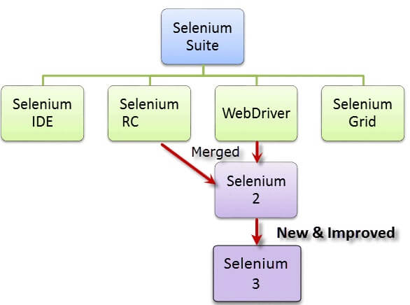

 Selenium 1, by the way, refers to Selenium RC.

IDE > record n playback, avlb in chrome n firefox pulgins, does not support oops n database concepts. Selenium IDE should only be used as a prototyping tool. If you want to create more advanced test cases, you will need to use either Selenium RC or WebDriver.

The Selenium core (JavaScriptRunner)

-Prior to Selenium RC testers using Selenium Core had to install the whole application under test and the web server on their own local computers because of the restrictions imposed by the same origin policy.

Selenium RC / Selenium1

-In RC they created a server that will act as an HTTP proxy to “trick” the browser into believing that Selenium Core and the web application being tested come from the same domain.

This is the first automated [web testing](https://www.guru99.com/web-application-testing.html) tool that allows users to use a programming language they prefer. As of version 2.25.0, RC can support the following programming languages:

[Java](https://www.guru99.com/java-tutorial.html)

[C#](https://www.guru99.com/c-sharp-tutorial.html)

[PHP](https://www.guru99.com/php-tutorials.html)

[Python](https://www.guru99.com/python-tutorials.html)

[Perl](https://www.guru99.com/perl-tutorials.html)

[Ruby](https://www.guru99.com/ruby-on-rails-tutorial.html)

-Selenium Grid is a tool used together with Selenium RC to run [**parallel tests**](https://www.guru99.com/parallel-testing.html) across different machines and different browsers all at the same time. Parallel execution means running multiple tests at once. Utilizes the hub-and-nodes concept.  We run the test on single machine refered as hub, and the execution takes place on different machines refered as nodes.

Selenium WebDriver = It was the first cross-platform testing framework that could control the browser from the OS level. It controls the browser by directly communicating with it. Selenium Webdriver is an open-source collection of APIs which is used for testing web applications. WebDriver is faster than Selenium RC since it speaks directly to the browser uses the browser’s own engine to control it.

A Comparison between Selenium and QTP(now UFT)

Quick Test Professional(QTP) is a proprietary automated testing tool

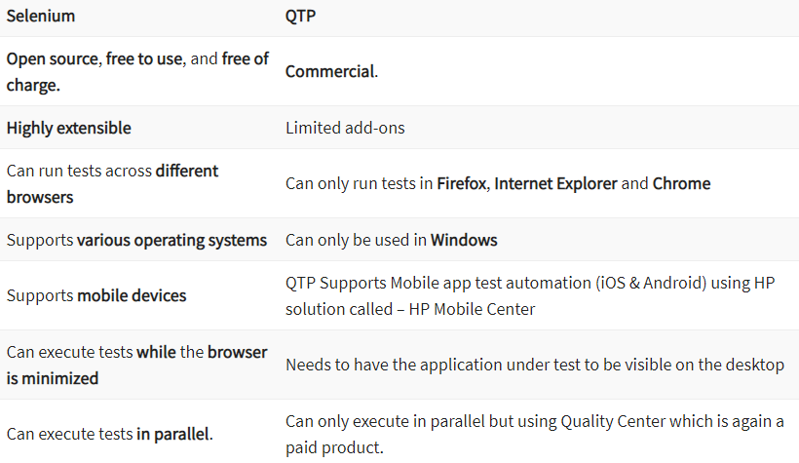

- TO ADD downloaded selenium jar files into eclipse ide

Selenium WebDriver Installation

Selenium installation is a 3-step process:

Step 1: [Install Java SDK](https://www.guru99.com/installing-selenium-webdriver.html#1)  
Step 2: [Install Eclipse](https://www.guru99.com/installing-selenium-webdriver.html#2)  
Step 3: [Install Selenium Webdriver Files](https://www.guru99.com/installing-selenium-webdriver.html#3) (libraries(API’s) and drivers.exe)  
Step 4: [Configure Eclipse IDE with WebDriver](https://www.guru99.com/installing-selenium-webdriver.html#4)

**PROJECT > FOLDERS > PACKAGES > CLASSES**

/* Steps to configure selenium with eclipse

* 1. Create folders (Selenium > drivers & Selenium > jar files) in c drive where u hv installed java

* 2. Now download the zip files of chromedriver(dwnld the same version 101/102/103 as per ur chrome version,

* so 1st chk ur chrome version) and mozilla from the given links

* 3. Extract this zip files from downloads to ur drivers path in c drive

* 4. u will see two applications, chromedriver and geckodriver

* 5. Now download the selenium jar file from the given link and copy paste it into jar files locn in c drive

* 6. now open eclipse > create or select ur project where u want selenium libraries to be installed

* 7. rytclick SeleniumScript project > Build Path > Configure Build Path > Libraries tab > Add external jars

* 8. Browse ur jarfile from ur c drive locn.

* 9. Apply > Apply and close.

* 10. Now u will see Referenced Libraries folder under SeleniumScript project.

* u can directly access the chromedriver exe , follow the steps learned ,

* Ryt click ur prj SeleniumScript > Show in > System Explorer > Paste that exe application chromedriver etc,

* into ur project folder ie SeleniumScript.

* Now come back to eclipse and refresh ur SeleniumScript project by ryt clk.

* There at the bottom u will see chromedriver and other .exe applications

* Now in the path u can directly paste " .\\ appln.exe " which shows appln.exe is at root path

*/

Locators > uniquely identifies webelements on webpage. This r mthds of By class.

-If multiple elements have same values of locators then it will locate the 1st element ie it will select the first value in the page with matching criteria.

-8 TYPES of attributes

-ID

-NAME & CLASSNAME >

-LinkText -> <a>…</a> anchor tags , actual hyperlink will be present.

- partial linkText > same has link text, used to click the links whose partial text is always fix, “Welcome john”…………so we can use partialLink as Welcome, that will click the link for any name that appears there.

-cssSelector > Cascading Style sheet use to design webpags dynamically > combn of tags & attributes

> // tag and id >> css => tagname#valueofId

// wd.findElement(By.cssSelector("input#txtUsername")).sendKeys("admin");

// tag and attribute >> css=> tagname[attribute=valueOfattribute]

wd.findElement(By.*cssSelector*("input[placeholder=Username]")).sendKeys("Admin");

wd.findElement(By.*cssSelector*("input[type=password]")).sendKeys("admin123");

// tag and classname >> css => tagname.valueOfClassname

wd.findElement(By.*cssSelector*("button.oxd-button oxd-button--medium oxd-button--main orangehrm-login-button")).click();

// tag, attribute & classname >> css => tagname.valueOfClassname[attribute=valueOFattribute]

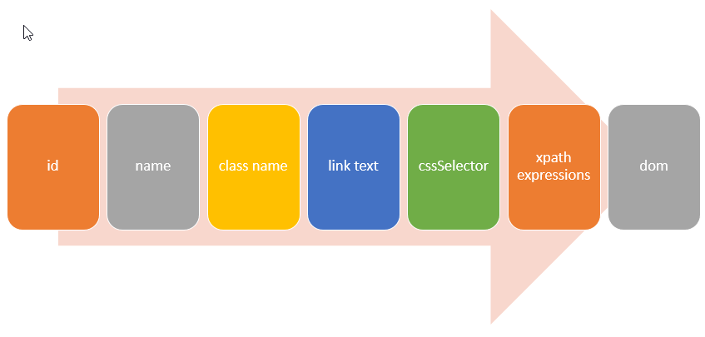

Priority of locators to be used

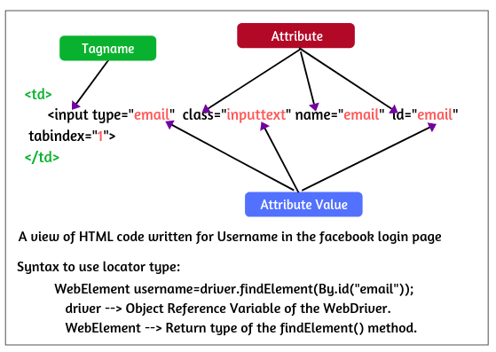

An Iframe stands for Inline Frame, is a web page that is embedded inside another web page or an HTML document embedded inside another HTML document on a web page. <iframe> tag.

A single web page can have any number of iframes (inline frames) to represent a new web page inside the main page of a website. They can be either multiple iframes or nested iframes.

 The developer debugging tool of google chrome can be used to check the availability of iframes.(avlbl on ryt clk)

IFRAME

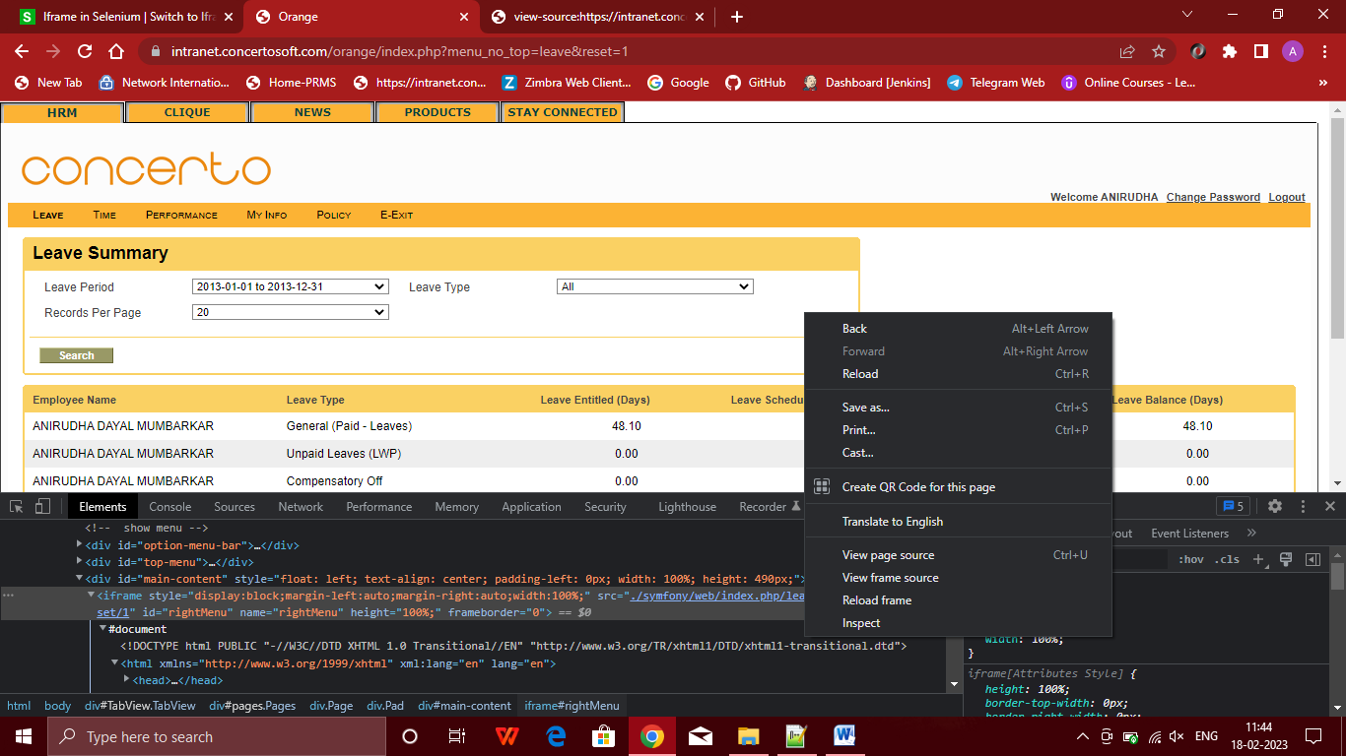

How to find iframe (This Frame, view frame source and reload frame)

Right-click on the web page, click on the option ‘View Page Source’, and press ctrl+F. Now you will see “search” option on the top bar. You can search by writing ‘iframe’ in it.

If you find any tag name with the ‘iframe’, it represents that the page consisting of an iframe.

 The syntax for switching iframes is as follows:

driver.switchTo().frame();

Selenium WebDriver provides three ways to switch over the elements on an iframe.

* By Index
* By Name or Id
* By Web Element

## Switching to Frame by Index:

An index is an attribute for the Iframe through which we can switch to it. Index value of the iframe starts with ‘0’ and goes on to 0,1, 2…

For example, suppose that there are 100 frames on the webpage, you can switch to iframe by using index value, as follows:

driver.switchTo().frame(0);

driver.switchTo().frame(1);

driver.swicthTo().frame(2);

// Locate the total number of iframes on the web page.

int iFrameSize = driver.findElements(By.tagName("iframe")).size();

System.out.println("Toal no of iframes: " +iFrameSize);

// Locate the first iframe and switch driver to first iframe by index value 0.

driver.switchTo().frame(0);

driver.findElement(By.xpath("//input[@itemprop = 'query-input']")).sendKeys("Selenium Jobs");

driver.findElement(By.xpath("//button[@class = 'wpb_button wpb_btn-inverse btn']")).click();

// Now, switch to main web page from iframe by using defaultContent() method.

driver.switchTo().defaultContent();

// Closing first frame.

String getTitleOfMain = driver.getTitle();

System.out.println("Title of main web page: " +getTitleOfMain);

String mainPageURL = driver.getCurrentUrl();

System.out.println("URL of main web page: " +mainPageURL);

// Switch to second iframe by its index value 1.

driver.switchTo().frame(1);

driver.findElement(By.xpath("//input[@value = 'Register with us']")).click();

driver.quit();

}

}

Output:

Total no of iframes: 4

Title of main web page: Selenium IFrame

URL of main web page: https://selenium08.blogspot.com/2019/11/selenium-iframe.html

switch to main web page from iframe by using defaultContent() method.

driver.switchTo().defaultContent();

## Switching to Frame by Name or Id Attribute

Attribute name or id of the frame can be used to locate a frame on a web page. The syntax for switching to the frame on a web page is as follows:

driver.switchTo().frame( String frameName or frameID );

For example:

driver.switchTo().frame("frame_a");

## Switching to Frame using WebElement

It is also possible to switch to the frame by Web Element. The syntax to switch to the frame by WebElement is as follows:

driver.switchTo().frame(WebElement FrameElement);

// Locate second frame (Naukri) by WebElement.

WebElement frameElement = driver.findElement(By.name("iframe_b")); // Here, frame is located by using name attribute.

System.out.println("Switching to second frame from main web page");

driver.switchTo().frame(frameElement); // Passing frameElement as an input parameter to frame().

# Screenshot in Selenium WebDriver

Selenium WebDriver provides a TakesScreenshot interface to capture a screenshot of the webpage when an exception or error occurred during the execution of code.

1. Since TakesScreenshot is an interface. So, we cannot create an object directly. We will have to convert the web driver object to TakesScreenshot.

The syntax to convert the WebDriver object to TakesScreenshot is given below:

 TakesScreenshot scrShot = ((TakesScreenshot)webdriver); //casting

2. Now we will call getScreenshotAs() method to create an image file which is provided by the TakesScreenshot interface to capture the screenshot of the web page displayed in the driver object.

File srcFile = scrShot.getScreenshotAs(OutputType.FILE);

// Create an object of the file to move the image file to the new destination and pass the file path as an argument.

File desFile = new File("./Screenshots/facebook.png"); ….facebook.png is an empty file yet.

3. In the last step, save the file object returned by getScreenshotAs() method using copyFile() method of the FileUtils class. The syntax is given below:

FileUtils.copyFile(SrcFile, DestFile);

Alternate way to copy screenshot using FileHandler class

TakesScreenshot ts = (TakesScreenshot)wd; // HARD NOTE

FileHandler.copy(ts.getScreenshotAs(OutputType.FILE), **new** File("./scrsht"+tm()+ ".png"));//HARD NOTE > scrsht is ur file name

**public** String tm()

{

**return** **new** SimpleDateFormat("yyyy-MM-dd HH-mm-ss").format(**new** Date()); //HARDNOTE

}

/* FileHandler.copy(from file,file to)...

* In 'to file' specify the root node where u want to save the file i.e ".\\"

* then assign the name to that image file i.e > un

* then in last give the file extension as > .png

*

* While typing new File, use cntrl+space for File.

*/

## Take Screenshot for Failed Test cases in Selenium WebDriver

To capture the screenshot in the failed test steps, we will place the entire code in the [*try-catch block*](https://www.scientecheasy.com/2020/09/java-try-catch-block.html/).

Basically, a try block is a block of statements within which exception might occur. A catch block handles the exception thrown by try block. It will execute if an exception occurs within the try block otherwise not.

## What is Cross Browser Testing?

Cross-browser testing in Selenium is a technique to test the functionality of web-application with different multiple web browsers.

It is used to check the compatibility of the application on the different web browsers at the same time (ie in the same script u can test the functionality of ur web appln on different browsers)

Below is the list of a few issues that will help to know why should we perform cross-browser testing.

1. Font size mismatch in multiple browsers.  
2. Different Javascript implementations.  
3. Image orientation.  
4. Browsers incompatibility issue with different OS.  
5. Layout and functionality issues.

To resolve the above issues, we perform cross-browser testing so that more users can access an application on different choice of web browsers.

public class CrossBrowserTesting2

{

// Create WebDriver reference.

WebDriver driver;

@BeforeTest

@Parameters("Browser")

public void setUpBrowser(String Browser) throws Exception

{

if(Browser.equalsIgnoreCase("Firefox"))

{

System.out.println("Running Firefox");

driver=new FirefoxDriver();

} else {

if(Browser.equalsIgnoreCase("chrome"))

{

System.out.println("Running Chrome");

System.setProperty("webdriver.chrome.driver", "C:\chromedriver.exe");

driver= new ChromeDriver();

} else {

throw new Exception("Browser is not correct");

}

driver.manage().timeouts().implicitlyWait(10, TimeUnit.SECONDS);

driver.manage().window().maximize();

}

// Declare @Test annotation.

@Test

public void loginPage()

{

driver.get("https://pixabay.com/accounts/login/");

// Write xpath of the element username.

WebElement userName = driver.findElement(By.xpath("//input[@name = 'username']"));

// Fill user name.

userName.sendKeys("dg8oct@gmail.com");

// Find the xpath of the password.

WebElement password = driver.findElement(By.xpath("//input[@name = 'password']"));

// Fill password password.

sendKeys("deepak986");

WebElement login = driver.findElement(By.xpath("//input[@value = 'Log in']"));

login.click();

driver.close();

}

}

## How to execute Test Case in multiple browsers in Parallel mode?

As you executed the above test case, you will have noticed that the execution of test case on different browsers is happening one by one, not in parallel. That is, the test case is not executing parallel in both browsers.

This is because, in the testng.xml file, “false” is enabled in parallel mode. If you enable it as parallel = “tests”, the test case will be run in parallel mode. As shown in below imgs

Parallel = false

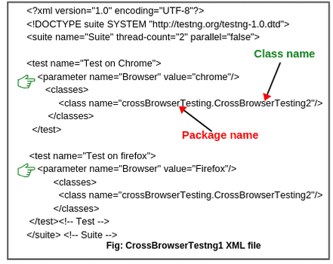

Parallel = tests

<?xml version="1.0" encoding="UTF-8"?>

<!DOCTYPE suite SYSTEM "http://testng.org/testng-1.0.dtd">

<suite name="Suite" thread-count="2" parallel="tests">

<test name="Test on Chrome">

<parameter name="Browser" value="chrome"/>

<classes>

<class name="crossBrowserTesting.CrossBrowserTesting2"/>

</classes>

</test>

<test name="Test on firefox">

<parameter name="Browser" value="Firefox"/>

<classes>

<class name="crossBrowserTesting.CrowserBrowserScript"/>

</classes>

</test><!-- Test -->

</suite> <!-- Suite -->

TestNG

It is an open-source [automation testing](https://www.scientecheasy.com/2020/07/selenium-automation-testing.html/) framework based on JUnit (in Java) and NUnit (in C#).It provides multiple rich features for testing like assertions, reporting, parameterization, parallel test execution, DataProvider feature to perform data-driven testing etc.

Why to use testng with selenium:

1. Selenium WebDriver does not generate detailed test or summary reports.
2. We can execute selective test cases by integrating TestNG with Selenium WebDriver.
3. Using TestNG, we can also execute failed test cases separately.
4. We can organize test cases easily in a proper way. Etc

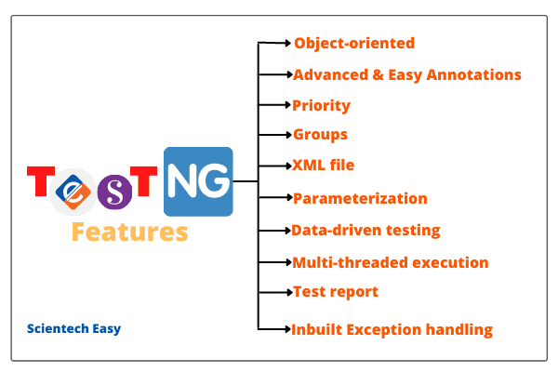

Imp Features: (Adv of using TestNG over Junit)

Priority >Using priority, we can execute test methods in TestNG in a different order.

**Groups/group of groups:** This feature allows us to assign certain test methods into particular named groups. Using this feature, we can execute multiple test cases into a particular group.

**Data-driven testing:** This feature is widely used in test suites that allow users to execute the same test method multiple times based on different sets of data.

**XML file:** An XML file is a file that is used to configure test suites in TestNG using classes, test methods, and packages.

**Multi-threaded /Parallel execution:** Using this feature, we can execute multiple test cases in parallel to reduce the execution time.

Reports : TestNG generates XML, HTML test reports(emailable-report & index) in a readable format.

Easy to understand annotations

You can pass the additional parameters to TestNG annotations.

In the case of TestNG annotations, you do not need to extend any test classes.

Installation done through Eclipse marketplace

After the restart, you can verify that TestNG has been indeed successfully installed or not. For this, click on the Window option in Eclipse > Preferences and see if TestNG is included on the Preferences list.

create a new Java project in Eclipse and add Selenium API and TestNG library to the build path of project.

How to see testng reports

For this, go to Project Explorer window on the left side and right-click on the project name (FirstTestNGProject) in the Project Explorer window and then click on the “Refresh” option.

[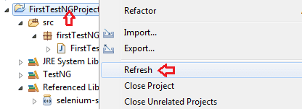](https://www.scientecheasy.com/2020/07/write-testng-test-case.html/)

**Step 2:** Notice that a “test-output” folder has been created in the Project folder. Expand it and look for an index.html file as shown in the screenshot.

This HTML  report file is the result of the most recent test run.

[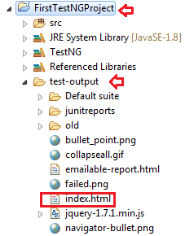](https://www.scientecheasy.com/2020/07/write-testng-test-case.html/)

=================================================

**Annotation in TestNG** is the set of code that controls how method below them has to be executed. i.e. the order of the execution of method below them will be decided by an annotation that you give.

In TestNG,

Test suite > is an XML File made up of one or more tests (Folders)

Tests > Kinds of folders each containing one or more TestNG classes

TestNG class > a Java class that contains at least one TestNG annotation & can contain one or more test methods.

A test method > a Java method annotated by @Test .

## Hierarchy of the TestNG Annotations:

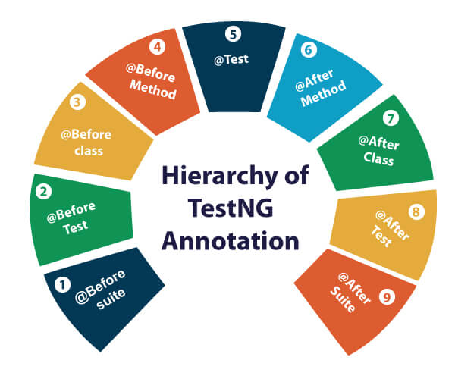

**TestNG executes the test methods in alphabetical order if no priority or dependsOnMethod is used.**

 If priority is not specified, then the default priority will be 0.

|  |  |
| --- | --- |
| **TestNG Annotation** | **Description** |
| [@BeforeSuite](https://www.javatpoint.com/testng-beforesuite-annotation) | The @BeforeSuite annotated method will run before the execution of all the test methods in the suite. |
| [@AfterSuite](https://www.javatpoint.com/testng-aftersuite-annotation) | The @AfterSuite annotated method will run after the execution of all the test methods in the suite. |
| [@BeforeTest](https://www.javatpoint.com/testng-beforetest-annotation) | The @BeforeTest annotated method will be executed before the execution of all the test methods of available classes belonging to that folder. |
| [@AfterTest](https://www.javatpoint.com/testng-aftertest-annotation) | The @AfterTest annotated method will be executed after the execution of all the test methods of available classes belonging to that folder. |
| [@BeforeClass](https://www.javatpoint.com/testng-beforeclass-annotation) | The @BeforeClass annotated method will be executed before the first method of the current class is invoked. |
| [@AfterClass](https://www.javatpoint.com/testng-afterclass-annotation) | The @AfterClass annotated method will be invoked after the execution of all the test methods of the current class. |
| [@BeforeMethod](https://www.javatpoint.com/testng-beforemethod-annotation) | The @BeforeMethod annotated method will be executed before each test method will run. |
| [@AfterMethod](https://www.javatpoint.com/testng-aftermethod-annotation) | The @AfterMethod annotated method will run after the execution of each test method. |
| [@BeforeGroups](https://www.javatpoint.com/testng-beforegroups-annotation) | The @BeforeGroups annotated method run only once for a group before the execution of all test cases belonging to that group. |
| [@AfterGroups](https://www.javatpoint.com/testng-aftergroups-annotation) | The @AfterGroups annotated method run only once for a group after the execution of all test cases belonging to that group. |

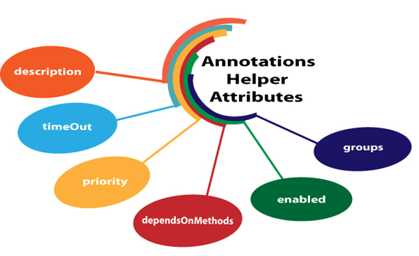

TestNG Attribute example

1.

@Test(description="This is testcase1")

**public** **void** testcase1()

{

System.out.println("HR");

}

2.

dependsOnMethods

When the second test method wants to be dependent on the first test method, then this could be possible by the use of "**dependOnMethods**" attribute. If the first test method fails, then the dependent method on the first test method, i.e., the second test method will not run.

@Test

**public** **void** WebStudentLogin()

{

System.out.println("Student login through web");

}

@Test

**public** **void** MobileStudentLogin()

{

System.out.println("Student login through mobile");

}

@Test(dependsOnMethods= {"WebStudentLogin"})

**public** **void** APIStudentLogin()

{

System.out.println("Student login through API");

}

We know that the **TestNG executes the test methods in alphabetical order if no priority or dependsOnMethod is used so**, in the above program, APIStudentLogin() will execute first. However, we want WebStudentLogin() method to be executed before the execution of the APIStudentLogin() method, so this would only be possible through the "dependsOnMethods" attribute. In the above program, we have specified "dependsOnMethods" attribute in an APIStudentLogin() test method and its value is "WebStudentLogin" which means that WebStudentLogin() method will be executed before the APIStudentLogin() method.

PRIORITY

@Test

**public** **void** mango()

{

System.out.println("I am Mango");

}

@Test(priority=2)

**public** **void** apple()

{

System.out.println("I am Apple");

}

@Test(priority=1)

**public** **void** watermelon()

{

System.out.println("I am Watermelon");

}

the default priority of mango() test method is 0, so it will be executed first.

## enabled

The 'enabled' attribute contains the boolean value. By default, its value is true. If you want to skip some test method, then you need to explicitly specify '**false**' value.

1. @Test(enabled=**false**)

## groups

The 'groups' attribute is used to group the different test cases that belong to the same functionality.

@Test(groups= {"software company"})

Add <groups> and its containts in xml file with include n exclude tags as below

<?xml version="1.0" encoding="UTF-8"?>

<!DOCTYPE suite SYSTEM "https://testng.org/testng-1.0.dtd">

<suite name="Suite">

<test thread-count="5" name="Test">

<groups>

<run>

<include name="common"></include>

<include name="Login1"></include>

<exclude name="OtherFunctions"></exclude>

<exclude name="Login2"></exclude>

</run>

</groups>

<classes>

<class name="assignment.FA_COMBO"/>

<class name="assignment.Dummy_FA"/>

</classes>

</test> <!-- Test -->

</suite> <!-- Suite -->

NO need to specify exclude separately, if u only specify the include tag with groups to be included then only those @tests will be executed

@Test(timeOut=200)

**public** **void** testcase1() **throws** InterruptedException

{

Thread.sleep(500);

System.out.println("This is testcase1");

}

@Test

**public** **void** testcaes2()

{

System.out.println("This is testcase2");

    }

@Test

**public** **void** testcase3()

{

System.out.println("This is testcase3");

}

 inside the testcase1() method, we have Thread.sleep(500) which means that the testcase1() method will be executed after 500 milliseconds, but we have provided timeOUT attribute with the value 200 means that the testcase1() will be failed after 200 milliseconds.

**TestNG Parameters** are the arguments that we pass to the test methods. TestNG Parameters are present in the xml file.

Example

When params value are comman, specify them above all <test> tags in xml file.

**Sum.java**

**package com.javatpoint;**

**import org.testng.annotations.Test;**

**import org.testng.annotations.Parameters;**

**public class Sum**

**{**

**@Test**

**@Parameters({"a","b"})**

**public void add(int c, int d)**

**{**

**int sum=c+d;**

**System.out.println("Sum of two numbers : "+sum);**

**}**

**}**

**Subtract.java**

**package com.javatpoint;**

**import org.testng.annotations.Parameters;**

**import org.testng.annotations.Test;**

**public class Subtract**

**{**

**@Test**

**@Parameters({"a","b"})**

**public void add(int c, int d)**

**{**

**int subtract=c-d;**

**System.out.println("Subtraction of two numbers : "+subtract);**

**}**

**}**

**testng.xml**

**<?xml version="1.0" encoding="UTF-8"?>**

**<!DOCTYPE suite SYSTEM "http://testng.org/testng-1.0.dtd">**

**<suite name="Suite">**

**<parameter name="a" value="5"/>**

**<parameter name="b" value="3"/>**

**<test name="Sum">**

**<classes>**

**<class name= "com.javatpoint.Sum"/>**

**</classes>**

**</test> <!-- Test -->**

**<test name="Subtract">**

**<classes>**

**<class name="com.javatpoint.Subtract"/>**

**</classes>**

**</suite> <!-- Suite -->**

**Second case: When parameters are specific specify them within <test> for each tests**

**Fruits.java**

1. **package com.javatpoint;**
2. **import org.testng.annotations.Test;**
3. **import org.testng.annotations.Parameters;**
4. **public class Fruits**
5. **{**
6. **@Test**
7. **@Parameters("mango")**
8. **public void mango(String m)**
9. **{**
10. **System.out.println("Fruits names are:  ");**
11. **System.out.println(m);**
12. **}**
13. **@Test**
14. **@Parameters("orange")**
15. **public void orange(String o)**
16. **{**
17. **System.out.println(o);**
18. **}**
19. **}**

**Vegetable.java**

1. **package com.javatpoint;**
2. **import org.testng.annotations.Test;**
3. **import org.testng.annotations.Parameters;**
4. **public class Vegetable**
5. **{**
6. **@Test**
7. **@Parameters("Cauliflower")**
8. **public void c(String m)**
9. **{**
10. **System.out.println("Vegetable names are :");**
11. **System.out.println(m);**
12. **}**
13. **@Test**
14. **@Parameters("Ladyfinger")**
15. **public void orange(String l)**
16. **{**
17. **System.out.println(l);**
18. **}**
19. **}**

**Step 3: Now, we create the testng.xml file.**

1. **<?xml version="1.0" encoding="UTF-8"?>**
2. **<!DOCTYPE suite SYSTEM "http://testng.org/testng-1.0.dtd">**
3. **<suite name="Suite">**
4. **<test name="Fruits">**
5. **<parameter name="mango" value="mango"/>**
6. **<parameter name="orange" value="orange"/>**
7. **<classes>**
8. **<class name= "com.javatpoint.Fruits"/>**
9. **</classes>**
10. **</test>**
11. **<test name="Vegetables">**
12. **<parameter name="Cauliflower" value="Cauliflower"/>**
13. **<parameter name="Ladyfinger" value="Ladyfinger"/>**
14. **<classes>**
15. **<class name= "com.javatpoint.Vegetable"/>**
16. **</classes>**
17. **</test>**
18. **</suite> <!-- Suite -->**

**TestNG DataProvider**

It allows the users to write data-driven tests in which we can run multiple times the same test method with different sets of test data.

The sets of test data can be any format. We can pass parameters or complex parameters to the test methods by using data provider as it is not possible to do this from XML using above Parameterised mtd of passing parameters thru testng.xml file.

DataProvider is a method in a class that returns a two-dimensional array of object (Object [ ][ ]) to the test method. The test method will be called m times in m * n type of object array.

Where,

* m ➨ The first array m represents the number of rows(sets of data to be passed)
* n ➨ The second array n represents a column that is the number of parameters in the test data.

This method is annotated with @DataProvider. We can have data providers with different names which can be defined either on a test class or on other classes.

Syntax:

@DataProvider(name = "myTestData")

This annotation has only one string attribute called name. If the name of the data provider is not provided, the data provider’s name will automatically be set to the method’s name(DataProvider method name)

* 1. Syntax:

@Test(dataProvider = "myTestData")

public void methodName(parameters)

{

. . . . . . . . . . .

}

2) If you call the DataProvider method from another class, you will have to add one more attribute dataProviderClass in the @Test annotation. It has the following general form to use.

Syntax:

@Test(dataProvider = "myTestData", dataProviderClass = DataProvidingClass.class)

public void methodName(parameters)

{

. . . . . . . . . . .

}

Where, DataProvidingClass is the name of class in which DataProvider method has been declared.

Example 1 :

{

// Declare Test annotation with attribute dataProvider and value "getData".

@Test(dataProvider = "getData")

public void setData(String name, String rollNo)

{

System.out.println("Name: " +name);

System.out.println("RollNo: " +rollNo);

}

// Declare DataProvider annotation with attribute name and value "getData".

@DataProvider(name = "getData")

// Declare a method whose return type is an array of object.

public Object[ ][ ] dataProviderMethod()

{

// Create an object of an array object and declare parameters 3 and 2.

// 3 represents the number of times your test has to be repeated.

// 2 represents the number of parameters in test data. Here, we are providing two parameters.

Object[ ][ ] data = new Object[3][2];

// 1st row.

data[0][0] = "John";

data[0][1] = "23";

// 2nd row.

data[1][0] = "Sanjana";

data[1][1] = "40";

// 3rd row.

data[2][0] = "Deep";

data[2][1] = "01";

return data;

}

}

Example 2 : (Another way of returning data from dp, no need to specify array size in dp mthd)

public class DataproviderTest2

{

@Test(dataProvider = "getData")

public void setData(String username, String password)

{

System.out.println("Username: "+ username);

System.out.println("Password: " +password);

}

// Here, we are not declaring attribute "name" for DataProvider. So, it will use the name of method or function.

@DataProvider public Object[ ][ ] getData()

{

// You can also return data in this way. Here, we are using an anonymous concept of Java to return data.

return new Object[ ][ ] {

{"DEEPAK"," 1234"},

{"AMIT","12345"},

{"RASHMI", " 123456"}

};

}

}

# Multiple Tests using TestNG XML File

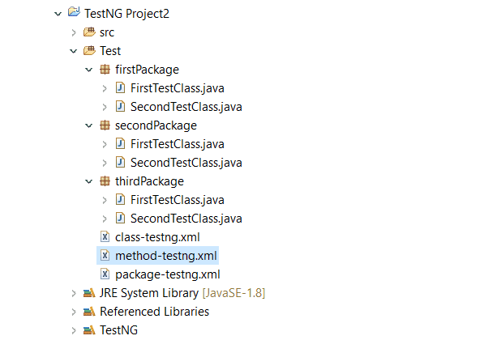

**TestNG XML File code: > 2 Tests in 1 suite**

<suite name="Suite">

<test name = "First Test">

<classes>

<class name = "multipleTests.FirstTestClass"/>

</classes>

</test>

<test name = "Second Test">

<classes>

<class name = "multipleTests.SecondTestClass"/>

</classes>

</test>

</suite>

**TestNG XML File code: > Different no. of classes in 1 Tests under 1 suite**

<suite name="Class Suite" verbose="1">

<test name = "Test">

<classes>

<class name = "firstPackage.FirstTestClass">

<class name = "secondPackage.FirstTestClass">

<class name = "thirdPackage.SecondTestClass">

</classes>

</test>

</suite>

## TestNG Test Suite using Packages > all classes within the packages specified in xml will be executed

<suite name="Package Suite">

<test name="Test">

<packages>

<package name = "firstPackage"/>

<package name = "secondPackage"/>

</packages>

</test>

</suite>

In case if you want to execute all sub-packages (that we refer as packages) inside a particular package(that we refer as folder), you will have to use .* ( dot star ) at the end of package name (as shown in the following code). Here in below eg the test in <package name =“test.*”/> refers to folder which contains all packages.

<suite name = "Package Suite" verbose = "1">

<test name = "Package Test">

<packages>

<package name = "test.* "/>

</packages>

</test>

</suite>

## TestNG Test Suite by Test Methods

<suite name="Method Suite" verbose = "1">

<test name="Method Test">

<classes>

<class name = "firstPackage.FirstTestClass">

<methods>

<include name = "firstTest"/>

</methods>

</class>

</classes>

</test>

</suite>

## Test Suite using Package, Class & Test Method

<suite name = "Combine Suite">

<test name = "Combine Test">

<packages>

<package name = "firstPackage" />

</packages>

<classes>

<class name = "secondPackage.FirstTestClass"/>

<class name = "thirdPackage.FirstTestClass">

<methods>

<include name = "firstTest" />

</methods>

</class>

</classes>

</test>

</suite>

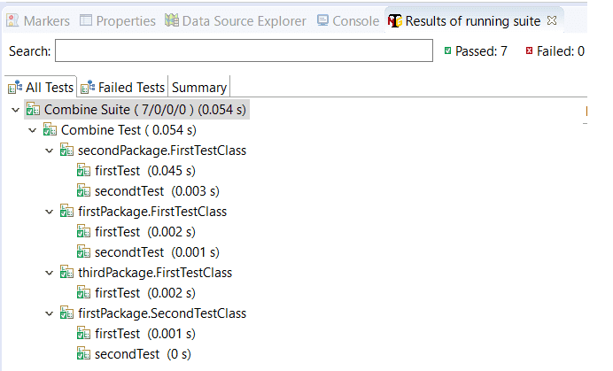

## Include/Exclude Package in TestNG Test Suite

<suite name = "Include-Exclude Suite">

<test name = "Include-Exclude Test">

<packages>

<package name = ".*">

<include name = "firstPackage" />

<exclude name = "secondPackage" />

</package>

</packages>

</test>

</suite>

Parallel testing/ execution

Parallel Testing is a testing technique in which multiple tests are executed simultaneously in different threads to reduce execution time.

1. **parallel = “methods“:**TestNG will execute all the methods annotated with @Test annotation in separate threads (i.e. parallel). Dependent methods will also run in separate threads in the order that we specified.

2. **parallel = “Tests“:** TestNG will run all the test cases/test methods in the same <test> tag in the same thread but each <test> tag will be run in different threads.

3. **parallel = “classes“:** TestNG will run all the test cases (test methods) in the same class in the same thread but each Java class will run in a separate thread.

4. **parallel = “instances“:** TestNG will run all test cases in the same instance in the same thread, but two methods on two different instances will be run in different threads.

The attribute “thread-count” specifies how many threads should be allocated for this execution.

----------------------------------------------------------------------------------------

**TestNG assertion in Selenium** is basically blocks of code that are placed in the test cases to check/verify the success of certain conditions in the test script and decide whether the test has failed or passed. Selenium does not provide any assertion

**Why to use Assertion**

An assertion in selenium is used to compare the actual result of an application with the expected result.

We mainly use assertions in selenium to verify the result or TestNG reports.

## Types of Assertion in TestNG

There are two types of assertions present in the TestNG framework. They are as follows:

1. Hard Assertion
2. Soft Assertion

## Hard Assertion in TestNG

Hard assertion is a type of assertion that does not continue with execution until the assertion condition is met.

That means when assertion condition does not satisfy and fails, hard assertions usually throw an assertion error and the test case is immediately marked as failed.

An example of hard assertion methods are assertEquals, assertNotEquals, assertTrue, assertFalse, assertNull, assertNotNull.

## Soft Assertion in TestNG

Soft assertion is a type of assertion that continues with test execution even if the assertion condition is not met.

That means soft assertions do not throw an exception when the assert statement (assertion condition) fails and would continue with the execution of the next statement.

## Assert Class in TestNG

TestNG framework supports the assertion of a test by using assert class which is present in org.testng.Assert class in TestNG under Selenium WebDriver.

Assert class extends Object class. The general syntax to declare assert class in TestNG is as follows:

public class Assert

extends java.lang.Object

This assert is also known as Hard assert. All methods present in the assert class are static. So, we can access all the methods using the class name. We do not need to create an object of Assert class.

## Hard Assert Methods/Commands in TestNG

TestNG Assert class defines the following methods/commands. They are as follows:

**1. assertEquals():** This assertEquals() command basically compares the expected result with that of the actual result.

a. public static void assertEquals(boolean actual, boolean expected) // It takes two boolean arguments.

b. public static void assertEquals(String actual, String expected) // It takes two string arguments.

c. public static void assertEquals(String actual, String expected, String message) // It takes three string arguments and checks that both are equal or not. In case both are not equal, this method fails the test with the given message.

String actualTitle = driver.getTitle();

System.out.println(actualTitle);

// Call assertEqals() method to verify the comparison between actual title and expected title.

Assert.assertEquals(actualTitle, "Google");

// Fail as below

Assert.assertEquals(actualTitle, "Gooooooogle", "Match not found");

System.out.println("Title not matched");

**2. assertTrue():** The assertTrue() command verifies that a specified condition is true or not. It takes one boolean argument and checks that a condition is true.

If the condition is true then assertion passes test cases. If boolean value is false, an assertion error is thrown and assertion aborts the test case.

a. public static void assertTrue(boolean condition)

// Overloaded method of assertTrue()

b. public static void assertTrue(String message, boolean condition) // It accepts one boolean argument and String message. If the condition is not true, an AssertionError, with the given message, is thrown.

Assert.assertTrue(5 > 2);

Assert.assertTrue("Selenium".equals("Java"), "Not matched"); // false

---FALSE--------

Assert.assertFalse(5 > 2); // Here, condition is true. So, test case will be marked as failed and the next statement will not be executed.

System.out.println("5 is greater than 2");

Assert.assertFalse("Selenium" == "Java", "Matched"); // Here, condition is false. So, test case will be passed by assertion.

1. **fail():** The fail() method of Assert class is used to fail the current test with the given message. We can set the error message and also set the exception which caused the failure.

Assert.fail("test purpose"); // Here, test case will be marked as failed and the next statement will not be executed.

System.out.println("Test case failed");

Output:

FAILED: testcasefail java.lang.AssertionError: test purpose

1. **assertNull():** The assertNull() method is used to verify that a specified object contains a null value or not. This method takes an object as a parameter.

a. public static void assertNull(Object object)

b. public static void assertNull(Object object, String message) // Overloaded version.

EXAMPLE

WebDriver driver = new FirefoxDriver();

Assert.assertNull(driver);

System.out.println("Test case executed successfully");

}

}

Output:

FAILED: testCase java.lang.AssertionError: expected [null] but found [FirefoxDriver: firefox on WINDOWS

**assertNotNull():** The assertNotNull() method is used to check that an object does not contain a null value.

WebDriver driver = new FirefoxDriver();

Assert.assertNotNull(driver);

System.out.println("Test case executed successfully");

}

}

Output:

Test case executed successfully

PASSED: testcase

**7. assertSame():** The assertSame() method is used to compare the address of objects.

## SoftAssert Methods/Commands in Selenium

In addition to methods inherited from Assertion class, SoftAssert class provides only two new methods. They are as follows:

1. **doAssert (protected method, we would not be using it)**  
2. **assertAll()**

Let’s take an example program based on soft assert and hard assert.

**Program source code 9:**

package assertionPrograms;

import org.testng.Assert;

import org.testng.annotations.Test;

import org.testng.asserts.SoftAssert;

public class SoftAssertExample

{

@Test(priority = 0)

public void softAssert()

{

SoftAssert sa = new SoftAssert();

System.out.println("Soft assertion started from here");

sa.assertTrue(false); // Test case failed here but next statement will be executed.

System.out.println("Soft assertion ended here");

}

@Test(priority = 1)

public void hardAssert()

{

System.out.println("Hard assertion started from here");

Assert.assertTrue(false); // Test case failed here and next statement will not be executed.

System.out.println("Hard assertion ended here");

}

}

Output:

Soft assertion started from here

Soft assertion ended here

Hard assertion started from here

PASSED: softAssert

FAILED: hardAssert java.lang.AssertionError: expected [true] but found [false]

As you can see in the coding, when the test case failed in softAssert, it did not throw any exception error and continue with execution of the next statement.

But in the case of hardAssert, when the test case failed, it has thrown an AssertionError and did not execute the next statement. Look at the output of the program.

**1. assertAll():** The assertAll() method of softAssert class is used to know the failure record when assertion failed. This method cannot be used alone in the test case. It must be used as the last statement along with some other assert methods.

Let’s modify the previous coding to know the behavior of assertAll() method.

**Program source code 10:**

package assertionPrograms;

import org.testng.Assert;

import org.testng.annotations.Test;

import org.testng.asserts.SoftAssert;

public class AssertAllExample

{

@Test(priority = 0)

public void softAssert()

{

SoftAssert sa = new SoftAssert();

System.out.println("Soft assertion started from here");

sa.assertTrue(false);

System.out.println("Soft assertion ended here");

sa.assertAll();

}

@Test(priority = 1)

public void hardAssert()

{

System.out.println("Hard assertion started from here");

Assert.assertTrue(false);

System.out.println("Hard assertion ended here");

}

}

Output:

Soft assertion started from here

Soft assertion ended here

Hard assertion started from here

FAILED: softAssert java.lang.AssertionError: The following asserts failed: expected [true] but found [false]

FAILED: hardAssert java.lang.AssertionError: expected [true] but found [false]

===============================================

**Apache POI**  Poor Obfuscation Implementation (POI) is an open-source Java-based library that can be used to handle the Microsoft Office Document by using Java-based programming language.

used to manipulate Microsoft Excel documents such as .xls and .xlsx file formats.

It is an extensive API (Application Programming Interface) used to automate Selenium Data-driven tests by which we can create, modify, read, and write excel data by using the Java program.

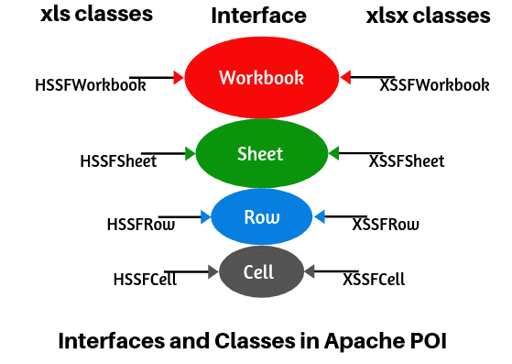

XSSFWorkbook stands for XML Spreadsheet Format. It is a class representation of XLSX file that is used to read and write xlsx file format of the MS-Excel file.

It is compatible with MS Office version 2007 or later.

XSSFWorkbook ws = new XSSFWorkbook();

**HSSFWorkbook**

HSSFWorkbook stands for Horrible SpreadSheet Format. It is a class representation of XLS file that is used to read and write xls file format of MS-Excel file. It is compatible with MS Office 97-2003 version.

HSSFWorkbook wb = new HSSFWorkbook();

XSSFSheet sheet = wb.createSheet("spreadSheet"); // Return type of the createSheet() method is an XSSFSheet. The sheet is a variable that is used to store the return value.

XSSFSheet sheet = wb.getSheet("spreadSheet");….to get sheet

XSSFRow rw = sh.getRow(i);

XSSFCell un = rw.getCell(0);

XSSFCell res = rw.createCell(2);

// Create the first row in a spreadsheet.

      XSSFRow row = spreadsheet.createRow(0);

// Create the first cell on a created row.

      XSSFCell cell = row.createCell(0);

Installation

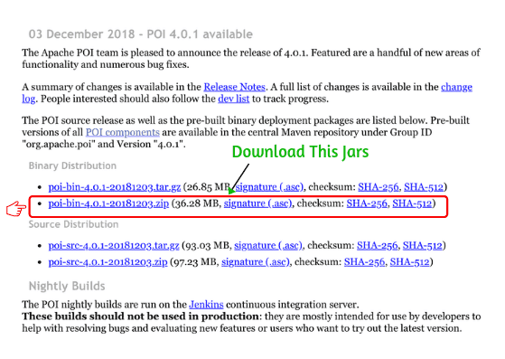

ADD EXTERNAL LIBRARIRES

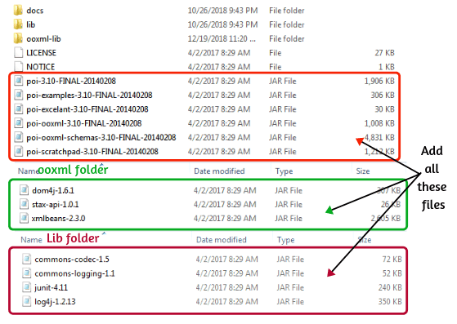

If you are using Maven in your project, we need to set the dependency on the maven project which helps to run the application. The dependency is given below:

<!-- https://mvnrepository.com/artifact/org.apache.poi/poi -->

<dependency>

<groupId>org.apache.poi</groupId>

<artifactId>poi</artifactId>

<version>5.2.2</version>

</dependency>

<!-- https://mvnrepository.com/artifact/org.apache.poi/poi-ooxml -->

<dependency>

<groupId>org.apache.poi</groupId>

<artifactId>poi-ooxml</artifactId>

<version>5.2.2</version>

</dependency>

**FileInputStream fis = new FileInputStream("C:\\Users\\Owner\\eclipse-workspace\\OrangeCred.xlsx");**

**XSSFWorkbook wk = new XSSFWorkbook(fis);**

**XSSFSheet sh = wk.getSheet("WriteOHRM");**

**---------------------------------------------------**

To get the cell type, use the getCellType() method where CellType represents the type of cell. We can use this method to compare the value of the cell type.

if (cell.getCellType() == XSSFCell.CELL_TYPE_STRING)

{

// Write your code here

}

For example:

if (cell.getCellType() == XSSFCell.CELL_TYPE_STRING)

{

System.out.print(cell.getStringCellValue() + " ");

}

Declare a variable 'filePath' with data type String to store path of file.

String filePath = "C:\ExcelSheet\DataSheet.xlsx";

// Create an object of the file class and pass "filePath" as a parameter to open xlsx based data file.

File file = new File(filePath);

// Create an object of the FileInputStream class and pass the reference variable "file" as a parameter to read excel data file.

FileInputStream fis = new FileInputStream(file);

// Create the object of XSSFWorkbook class and pass reference variable 'fis' as a parameter.

XSSFWorkbook wb = new XSSFWorkbook(fis);

System.out.println("DataSheet.xlsx file opened successfully");

// Call getSheet() method to read sheet name inside the workbook. The getSheet() method will return sheet name.

XSSFSheet sheet = wb.getSheet("Sheet1");

**FETCHING DATA FROM SHEET MTHD 1 > without testng dataprovider & to get values from multiple colmns (cells of a row) and pass them to multiple fields on website**

XSSFSheet sh = wb.getSheet("Sheet1");

**for** (**int** i=1;i<=sh.getLastRowNum();i++) //Note the result column in excel is initially kept blank ,

// there the result of our execution will be written automatically.

{

XSSFRow rw = sh.getRow(i);

XSSFCell un = rw.getCell(0); // the values of cells is fixed here i.e 0,1,2, as in each row, cells start from 0.

XSSFCell pw = rw.getCell(1);

XSSFCell res = rw.createCell(2); // although we are keeping result as blank, but we hv to create its cells,

// then only it will be psbl to write the result there.

System.***out***.println("Username = " + un + "Password" + pw);

wd.findElement(By.*id*("txtUsername")).sendKeys(un.toString());

wd.findElement(By.*name*("txtPassword")).sendKeys(pw.toString());

wd.findElement(By.*className*("button")).click();

}

fis.close();

FileOutputStream fos = **new** FileOutputStream("C:\\Users\\Owner\\eclipse-workspace\\OrangeCred.xlsx");

wk.write(fos);

wk.close();

whenever u hv to write to a file, u hv to use FileOutputStream & write() mthd.

* 1st close the fileInputStream

* then use FileOutputStream to specify the file path, where we hv to write

* now call the write() mthd to write to the file.

* and finally close the workbook.

*

* This write operation is written after for loop because, in for loop we are still using FileInputStream to fetch

* the data from the file and to pass it to the web elements.

------------------------------------------------

ITS NOT OPTIMIZED CODE , as code length will increase if no. of columns/cells for a row will increase

=========================================================

**FETCHING DATA FROM SHEET MTHD 2 > Using data provider & XL utlity > optimized BUT The Test Script class shld be TestNG class only**

**Using DP & XLUtility file together > It will b only psbl to read the data from xl sheet**

**DataProvider CLASS**

@DataProvider(name="Data")

**public** String[][] getAllData() **throws** IOException

{

String path=System.*getProperty*("user.dir")+"//graTestData//Userdata.xlsx";

XLUtility xl=**new** XLUtility(path);

**int** rownum=xl.getRowCount("Sheet1");…………Sheet1 has 2 colmns > username & password

**int** colcount=xl.getCellCount("Sheet1",1);

String apidata[][]=**new** String[rownum][colcount];

**for**(**int** i=1;i<=rownum;i++)

{

**for**(**int** j=0;j<colcount;j++)

{

apidata[i-1][j]= xl.getCellData("Sheet1",i, j);

}

}

**return** apidata;

}

**XLUTILITY CLASS**

**public** **class** XLUtility {

**public** FileInputStream fi;

**public** FileOutputStream fo;

**public** XSSFWorkbook workbook;

**public** XSSFSheet sheet;

**public** XSSFRow row;

**public** XSSFCell cell;

**public** CellStyle style;

String path;

**public** XLUtility(String path)

{

**this**.path=path;

}

**public** **int** getRowCount(String sheetName) **throws** IOException

{

fi=**new** FileInputStream(path);

workbook=**new** XSSFWorkbook(fi);

sheet=workbook.getSheet(sheetName);

**int** rowcount=sheet.getLastRowNum();

workbook.close();

fi.close();

**return** rowcount;

}

**public** **int** getCellCount(String sheetName,**int** rownum) **throws** IOException

{

fi=**new** FileInputStream(path);

workbook=**new** XSSFWorkbook(fi);

sheet=workbook.getSheet(sheetName);

row=sheet.getRow(rownum);

**int** cellcount=row.getLastCellNum();

workbook.close();

fi.close();

**return** cellcount;

}

**public** String getCellData(String sheetName,**int** rownum,**int** colnum) **throws** IOException

{

fi=**new** FileInputStream(path);

workbook=**new** XSSFWorkbook(fi);

sheet=workbook.getSheet(sheetName);

row=sheet.getRow(rownum);

cell=row.getCell(colnum); // not cellnum and colnum r same.

//DataFormatter contains methods for formatting the value stored in anCell.

//This can be useful for reports and GUI presentations when you need to display data,

//exactly as it appears in Excel.

//Supported formats include currency, SSN, percentages, decimals, dates, phone numbers, zipcodes, etc.

DataFormatter formatter = **new** DataFormatter();

String data;

**try**{

data = formatter.formatCellValue(cell); //formatCellValue(cell_value) Returns the formatted value of a cell as a String regardless of the cell type.

} //When passed a null or blank cell, this method will return an emptyString ("").

//Formulas in formula type cells will not be evaluated.

**catch**(Exception e)

{

data="";

}

workbook.close();

fi.close();

**return** data;

}

}

**TestNG Test Script CLASS that will use DP >**

@Test(dataProvider = "Data", dataProviderClass=DataProviders.**class**)

public void LoginFunctionality (String username, String password)

{

wd.findElement(By.id("txtUsername")).sendKeys(un);

wd.findElement(By.name("txtPassword")).sendKeys(pw);

wd.findElement(By.*className*("button")).click();

}

========================================================

**To write data to excel sheet u need to use the logic as per requirement only**

result=row.createCell(colnum);

result.setCellValue(data);

fo=**new** FileOutputStream(path);

workbook.write(fo);

workbook.close();

fi.close();

fo.close();

=========================POM-----==============

**Page object model (POM) in selenium** is an object design pattern that is used to create an object repository for web UI elements.

In this model, we create a separate corresponding page class for each web page in the application and store all locators to inspect elements on the page, respective methods to interact with those elements, and variables to use them.

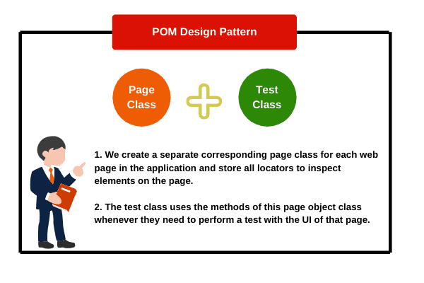

The main benefit here is that, if the UI of webpage some changes in the future then the tests need not to be changed, only the code within the page class needs to be changed.

1. Approach 1 > BY class

Web Elements of the application under test (AUT) and the method that performs operations on these Web Elements, are maintained inside a class file.

EXAMPLE >

First is Home Page, second is Login Page, and third is Portfolio Page that will come after login. Accordingly, we will create 3 page classes and one TestBase class.

1. Creating a Homepage class.

**Program source code 4:**

package com.pixabay.pages;

import org.openqa.selenium.By;

import org.openqa.selenium.WebDriver;

public class Homepage

{

WebDriver driver;

public Homepage(WebDriver driver)

{

this.driver = driver;

}

By loginButton = By.xpath("//a[text() = 'Log in']");

public void clickloginButton()

{

driver.findElement(loginButton).click();

}

}

2. Creating Login page class.  
**Program source code 5:**

package com.pixabay.pages;

import org.openqa.selenium.By;

import org.openqa.selenium.WebDriver;

public class Loginpage

{

WebDriver driver;

public Loginpage(WebDriver driver)

{

this.driver = driver;

}

By username = By.xpath("//input[@name = 'username']");

By password = By.xpath("//input[@name = 'password']");

By signIn = By.xpath("//input[@value = 'Log in']");

public void userName(String strUsername)

{

driver.findElement(username).sendKeys(strUsername);

}

public void passWord(String strPassword)

{

driver.findElement(password).sendKeys(strPassword);

}

public void signInButton()

{

driver.findElement(signIn).click();

}

}

3. Now, create Portfolio page class.  
**Program source code 6:**

package com.pixabay.pages;

import org.openqa.selenium.By;

import org.openqa.selenium.WebDriver;

public class PortfolioPage

{

WebDriver driver;

public PortfolioPage(WebDriver driver)

{

this.driver = driver;

}

By proImage = By.xpath("//img[@class = 'profile_image']");

By logout = By.xpath("//a[text() = 'Log out']");

public void profileImage()

{

driver.findElement(proImage).click();

}

public void logoutButton()

{

driver.findElement(logout).click();

}

}

4. Now, it’s time to create a TestBase class.  
**Program source code 7:**

package com.pixabay.tests;

import java.util.concurrent.TimeUnit;

import org.openqa.selenium.WebDriver;

import org.openqa.selenium.firefox.FirefoxDriver;

import org.testng.annotations.BeforeTest;

import org.testng.annotations.Test;

import com.pixabay.pages.Homepage;

import com.pixabay.pages.Loginpage;

import com.pixabay.pages.PortfolioPage;

public class TestBase

{

public static WebDriver driver;

@BeforeTest

public void setUp()

{

driver = new FirefoxDriver();

driver.manage().window().maximize();

driver.get("https://www.pixabay.com");

driver.manage().timeouts().implicitlyWait(10, TimeUnit.SECONDS);

}

@Test(priority = 0)

public void home()

{

Homepage hp = new Homepage(driver);

hp.clickloginButton();

}

@Test(priority = 1)

public void login()

{

Loginpage lp = new Loginpage(driver);

lp.userName("xyz@gmail.com");

lp.passWord("xyz123");

lp.signInButton();

}

@Test(priority = 2)

public void portFolio()

{

PortfolioPage pf = new PortfolioPage(driver);

pf.profileImage();

pf.logoutButton();

}

}

POM makes object repository independent of test cases so that we can use the same object repository for different purposes with different tools.

For example, the same POM can be used for acceptance testing and functional testing whereas both use a different mechanism for testing.

1. Re-usability: POM makes the code better optimized because of reusable page methods in the POM classes.  
   4. Easy to maintain.  
   5. Easy readability of test scripts.  
   6. Reduce or eliminate duplicate code.  
   7. Reliability.
2. building a layer of abstraction
3. hiding the inner implementation from tests.

=============================================

**Page Factory (@findBy)**

PageFactory class extends object class and It is present in org.openqa.selenium.support.PageFactory package.

@FindBy [annotation](https://www.scientecheasy.com/2020/07/testng-annotations.html/) to find WebElement :

* can accept id, name, tagName, className, partialLinkText, linkText, and advanced locator strategies like XPath, CSS selectors as attributes.

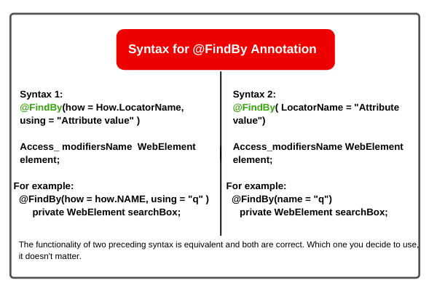

initElementts() method to initialize web elements automatically.

* to initialize WebElements declared in the page class. It is a static method.
* It is called inside a constructor that will automatically initialize all the elements in the page class when it is instantiated.
* two input parameters such as driver object declared in the test and current object page. The keyword “this” is used to pass the current page object. It returns nothing.
* Syntax :

public Class_Name( WebDriver driver ) //…..constructor

{

PageFactory.initElements( driver, this); ….driver from bas test class and this from current page class

}

* When we initialize page’s object (WebElements) using PageFactory class in the page class, the page factory class searches for the elements on the web page with id or name

attribute matching with the name of WebElement object declared in the page class.

//Example

public class GoogleSearchPage

{

// Create a WebDriver reference variable.

WebDriver driver;

// Declare a constructor and pass WebDriver reference as an input parameter.

public GoogleSearchPage( WebDriver driver )

{

this.driver = driver;

// Call initElements() method by using PageFactory reference and pass driver and this as parameters.

PageFactory.initElements( driver, this);

}

// Locate all elements using locators in the home page.

@FindBy(how = How.NAME, using = "q")

WebElement searchBox; @FindBy(how = How.NAME, using = "btnK")

WebElement submit;

// Declare methods to perform operations on the elements.

public void title()

{

String getTitle = driver.getTitle();

System.out.println("Title of Homepage: " +getTitle);

}

public void search()

{

searchBox.sendKeys("Selenium");

}

public void submit()

{

submit.click();

}

}

**Steps 2:**

a. Create another package named com.googlesearch.test.

b. Create a TestClass class. Here, we will create WebDriver object to launching the Firefox browser, maximize browser, implementing waits, launching URL and etc.

public class TestClass

{

static WebDriver driver;

@BeforeTest

public void setUp()

{

driver = new FirefoxDriver();

driver.manage().window().maximize();

String url = "https://www.google.com";

driver.get(url);

driver.manage().timeouts().implicitlyWait(10, TimeUnit.SECONDS);

}

@Test(priority = 0)

public void googleSearch()

{

// Create an object of GoogleSearchPage class.

GoogleSearchPage gs = new GoogleSearchPage(driver);

gs.title(); // Calling title method.

gs.search(); // Calling search method.

gs.submit(); // Calling submit method.

}

@AfterTest

public void closing()

{

TestClass.driver.quit();

}

}

**========================================**

**Selenium framework** is a code structure that is used to make code maintenance simpler and readability better.

It helps in dividing the entire code into smaller parts of the code in a systematic way, which tests a particular functionality.

## Why do we need Selenium Framework?

1. Without a framework, a single test case may have a million lines of code and it will test the entire functionality of the application.

Now, suppose you need to modify any particular functionality later time so is it possible to read the entire code again for a particular functionality?

Hope that your answer will be No because reading such a huge test case will be tough and boring and you also need lots of time to analyze the entire code.

But when we use selenium framework structure, it breaks the entire code into small parts. These smaller parts can be easily readable if we need to modifying and can perform a particular function.

2. Using selenium framework structure, we can easily find and fix bugs or defects in a million lines of code in a short time.

3. Selenium framework is easy to use and also provides flexibility in our code.

4. It makes our code simple, understandable, and readable.

For these reasons, we need to use selenium framework.

## Types of Framework in Selenium

There are several types of automation testing frameworks available to use in selenium, but the three most commonly used selenium frameworks designed are shown in the below figure:

1. Data-Driven Framework > In data-driven framework, importance is given to Test Data in comparison to multiple functionalities of the application. login webpage by different sets of Test Data. Test data storage done in excel file, CSV file, XML, or any database table. In simple words, we need to implement a Data-Driven Framework when we have to execute the same test script with different sets of test data.
2. Keyword Driven Framework > In the keyword-driven framework, importance is given to multiple functionalities of the application in comparison to Test Data.

For example, suppose we have a railway reservation application that provides many features such as:

1.log in to the application by entering credentials.  
2. Search Trains.  
3. Book Train tickets  
4. Cancel tickets.

Keyword Driven Framework:-

1] which is driven by a keyword is KDF

2] Keywords has some predefined meaning

eg:- int a--> can store integer type of data

3]Keywords are used to represent actions/steps which

are involved in script writing

4]This sheet is created by Sr. OR Exp. testers & will be

given to JR. tester for testing purpose only

5] Keywords in excel file & no. of methods in repository

should be same & name also should be same

It is a technique in which we represent the test scenario in terms of keywords and corresponding parameters.

A keyword-driven framework in Selenium is a collection of keywords that are used to write test scripts step-wise in the form of table and functions are called based on keywords to complete an end-to-end flow.

For each keyword, we write a particular code that will be executed when the specified keyword is called to perform a particular action.

 also known as table-driven testing or action based testing because a sequence of test steps and their corresponding inputs are implemented by using a set of keywords in tabular format.

## Why do we perform Keyword Driven Testing ?

There are the following reasons to perform keyword-driven testing. They are as follows:

1. Keyword-driven framework helps to separate test scrip and test data individually which minimizes script modification and maintenance efforts.

2. By separating it, a non-technical person or manual tester can also easily understand automation process and write automation script to automate the functionality of the application.

3. Test execution can be performed automatically by non-technical person or manual tester based on the keyword lists.

4. Using this approach, we can make all the common components files individually which help to handle easily and increase the reusability of common components.

5. In keyword driven testing approach, the bug report and its graphical representation are generated automatically which reduces the effort and time of testers.

So, these are some common reasons for performing keyword driven testing framework.

## Advantage of Keyword Driven Framework

Some of the advantages of keyword-driven framework are as follows:

1. We don’t need expertise in automation to maintain or create new test scripts. Once the keyword functionalities of application are ready, minimal specific scripting skills are needed for automating test cases.

2. Keywords can be reused across multiple test scripts or even different software.

3. Easy maintenance of test scripts.

4. Keyword-driven framework is not dependent on a specific programming language or tool

5. It is compatible with any automation tools available in the market.

## Disadvantage of Keyword Driven Framework

Some of the disadvantages of keyword-driven framework are as follows:

1. To create keyword driven automation framework, we need a higher knowledge of scripting knowledge.

2. Test scripts in keyword driven framework are longer and more complex, taking more time to create and maintain.

1. Hybrid Framework > **:** This framework is a combination of data-driven and keyword-driven frameworks. A hybrid framework is designed for those applications where we want to test multiple functionalities of application with different sets of Test Data.

## What is Object with respect to Selenium?

An object is a graphics user element in a web application. For example, a button, edit box, image, link, etc. An object basically consists of Data and Functions.

Data within an object are known as properties of the object. Functions within an object are known as methods that can be performed on an object

Example : consider a button on a web page. A web button is an object in AUT. The properties or data of button can be name, width, height, visible, etc whereas, the functions or methods of a button can be clicking on the web button.

**OBJECT REPOSITORY**

An object repository is a common storage location where we store a collection of all required application objects and their properties.

In other words, object repository is a central location where data is stored and managed. In context of Selenium WebDriver, object repository is mainly used to store element locator values in a central location to avoid hard coding within scripts.

* + **Property file**

Property files are used to store any data (drivers,url's,locators,inputs etc) in Key and value format,which we can use to perform our actions on web.

* + - 1. public Properties prop;
      2. prop = new Properties();
      3. prop.load(new FileInputStream("src\\test\\resources\\PropertyFile\\Demo.property"));........to load or get the property
      4. fileprop.getProperty("browser").....to get the contents of property file using keys stored there.
      5. String browsername = prop.getProperty("browser");............will return value (name of browser) with key as browser

Example of Property file :

chrkey=webdriver.chorme.driver

cpath=src\\test\\resources\\Drivers\\chromedriver.exe

geckokey=webdriver.gecko.driver

gpath=src\\test\\resources\\Drivers\\geckodriver.exe

url=https://opensource-demo.orangehrmlive.com

uname=username:=name

unamevalue=Admin

pword=//body/div[@id='app']/div[1]/div[1]/div[1]/div[1]/div[2]/div[2]/form[1]/div[2]/div[1]/div[2]/input[1]:=xpath

pwordvalue=admin123

login=button[type=submit]:=cssSelector

**Test class**

WebDriver wd ;

@Test

**public** **void** AllProp() **throws** Exception

{

Properties prop = **new** Properties();

prop.load(**new** FileInputStream("src\\test\\resources\\PropertyFile\\Orange.property"));

System.*setProperty*(prop.getProperty("chrkey"), prop.getProperty("cpath"));

wd = **new** ChromeDriver();

wd.get(prop.getProperty("url"));

getLocator(prop.getProperty("uname")).sendKeys(prop.getProperty("unamevalue")); //sendkeys is not written inside getlocator() mthd.:)

getLocator(prop.getProperty("pword")).sendKeys(prop.getProperty("pwordvalue"));

getLocator(prop.getProperty("login")).click();

}

**public** WebElement getLocator(String element) // eg. element = txtUsername:=id

{

WebElement e = **null**;// username:=name

String locvalue = element.split(":=")[0]; // username

System.***out***.println(locvalue);

String locType = element.split(":=")[1]; // name

System.***out***.println(locType);

**if** (locType.equalsIgnoreCase("id"))

e=wd.findElement(By.*id*(locvalue));

**else** **if** (locType.equalsIgnoreCase("name"))

e=wd.findElement(By.*name*(locvalue));

**else** **if** (locType.equalsIgnoreCase("cssSelector"))

e=wd.findElement(By.*cssSelector*(locvalue));

**else** **if** (locType.equalsIgnoreCase("xpath"))

e=wd.findElement(By.*xpath*(locvalue));

**return** e; // ie getLocator(prop.getProperty("uname")) = e = wd.findElement(By.id(locvalue));

// in other words LINE 29 will look as our normal stuff > wd.findElement(By.id(locvalue)).sendKeys(prop.getProperty("unamevalue"));

}

======================JDBC================================

Selenium Webdriver is limited to[Testing](https://www.guru99.com/software-testing.html)your applications using Browser. To use Selenium Webdriver for Database Verification you need to use the JDBC (“Java Database Connectivity”).

JDBC (Java Database Connectivity) is a[SQL](https://www.guru99.com/sql.html)level API that allows you to execute SQL statements. It is responsible for the connectivity between the[Java](https://www.guru99.com/java-tutorial.html)Programming language and a wide range of databases. The JDBC API provides the following classes and interfaces

* Driver Manager
* Driver
* Connection
* Statement
* ResultSet
* SQLException

ADD SQL Connector jar file to selenium

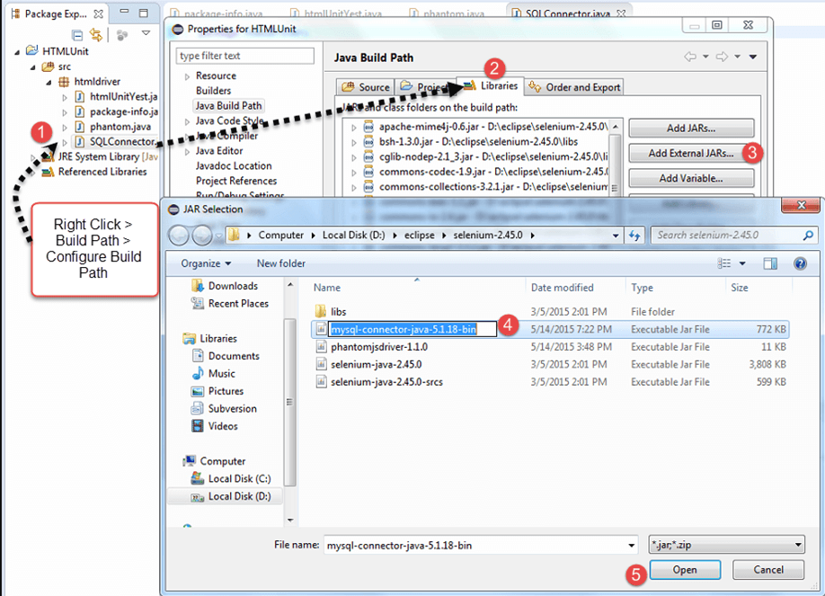

## Step 1) Make a connection to the Database

In order to make a connection to the database the syntax is

DriverManager.getConnection(URL, "userid", "password" )

Here,

* Userid is the username configured in the database
* Password of the configured user
* URL is of format jdbc:< dbtype>://ipaddress:portnumber/db_name”
* <dbtype>- The driver for the database you are trying to connect. To connect to oracle database this value will be “oracle”For connecting to database with name “emp” in MYSQL URL will be jdbc:mysql://localhost:3036/emp

And the code to create connection looks like

Connection con = DriverManager.getConnection(dbUrl,username,password);

You also need to load the JDBC Driver using the code

Class.forName("com.mysql.jdbc.Driver");

## Step 2) Send Queries to the Database

Once connection is made, you need to execute queries.

You can use the Statement Object to send queries.

Statement stmt = con.createStatement();

Once the statement object is created use the executeQuery method to execute the SQL queries

stmt.executeQuery(select * from employee;);

## Step 3) Process the results

Results from the executed query are stored in the ResultSet Object.

Methods to process the result: 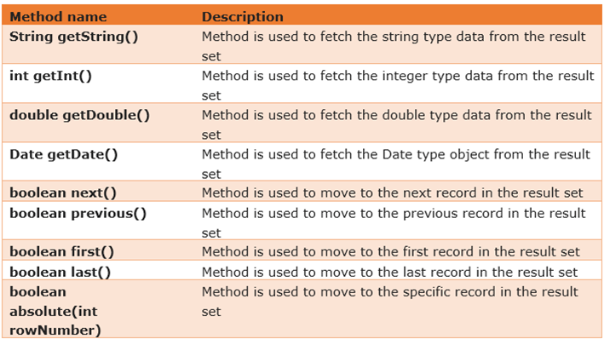

ResultSet res = st.executeQuery("select * from OHM62"); // all the data is fetched and stored from db to res.

String un,pw;

**while**(res.next()) // it means > perform while operation of fetching data , while u get the data in the next row of db.,

// if no data then exit the loop

{

un = res.getString(1);

pw = res.getString(2);

System.***out***.println(un + " " + pw);

wd.findElement(By.*id*("txtUsername")).sendKeys(un);

wd.findElement(By.*name*("txtPassword")).sendKeys(pw);

wd.findElement(By.*className*("button")).click();

}

// while is used to read or get each data stored in res , in order to pass it to web elements one by one.

// we cant use for loop to fetch the data like that in excel sheet, as we dont know the exact location

// of the data stored in the database , since db has no indexing format like that in excel sheet.

// data storage position in db always start with 1, so we start from 1 in getString() mthd.

=====================MULTIPLE WINDOWS HANDLE IN SELENIUM================

When you open any website, the main page where you will perform any operation is the **Parent Window**. This is the same webpage that will open when the Selenium automation script is executed.

Now, all the other windows that open inside your main window are termed as **Child Windows**. It is important to note that there can be single or multiple child windows inside your parent window.

A window handle stores the unique address of the browser windows. It is just a pointer to a window whose return type is alphanumeric.  Each browser window has a unique window handle value through which it can be identified.  Window Handle (or ID) helps to switch the Selenium WebDriver context to the corresponding window and perform any operation.

Selenium WebDriver provides us with various methods for handling windows. Below are a few of them:

* **getWindowHandle()**: With this method, we get a unique ID of the current window which will identify it within this driver instance. This method will return the value of the String type.
* **getWindowHandles( )**: With this method, we get the IDs of all the windows opened by the web driver. Its return type is Set .
* **switchTo()**: Using this method, we can perform switch operations within windows.

**//String PID = wd.getWindowHandle() this cmnd will provide us an id that is unique for each window (main or sub),**

**//we can then use this ids to perform whatever actions we require to perform on any of those windows**

**// Set<String> allwin = wd.getWindowHandles() >>>>> used store ids of multiple windows if exists.**

String PID = wd.getWindowHandle();// to get unique id of current tab

Set<String> allwin = wd.getWindowHandles(); // get ids of all sub tabs/wins and will store them in allwin set variable.

**for** (String W:allwin) // for each loop will fetch ids of all tabs form allwin set, one by one ,and will store in W

{

wd.switchTo().window(W);

System.***out***.println(wd.getTitle());

**if**(!(W.equals(PID))) //this logic will vary from website to website

{

Select s = **new** Select(wd.findElement(By.*name*("customer_id")));

s.selectByVisibleText("Donald Easter");

wd.manage().window().maximize();

wd.close();

}

}

=========================================================================

# What is Selenium Grid?

* Selenium Grid can be used for remote execution of the testcases, where the test cases that r written on our local machines, can be executed on the remote machines that may use diff os using diff
* Also supports parallel execution, where test scripts can be executed parallely on remote machines that too on different browsers

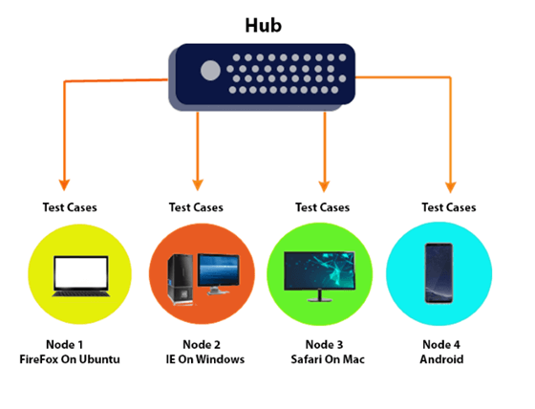

HUB

* The machine which actually triggers the test case known as Hub
* There can be only one hub in a selenium grid.
* The machine which is containing the hub triggers the test case, but you will see the browser being automated on other machines.

### Node

Nodes are the selenium instances which will execute the test cases that you loaded on the hub. Nodes can be launched on multiple machines with different platforms and browsers.

Selenium Grid is useful because of the following reasons:

**Run on different platforms:**

**Parallel execution:**

SETUP OF GRID

* Download the Selenium Standalone Server to run Remote Selenium webdriver. It is available in a single jar file.
* Enter the command **java -jar selenium-server-standalone-3.8.1.jar -role hub**. This command will treat the machine as a hub.

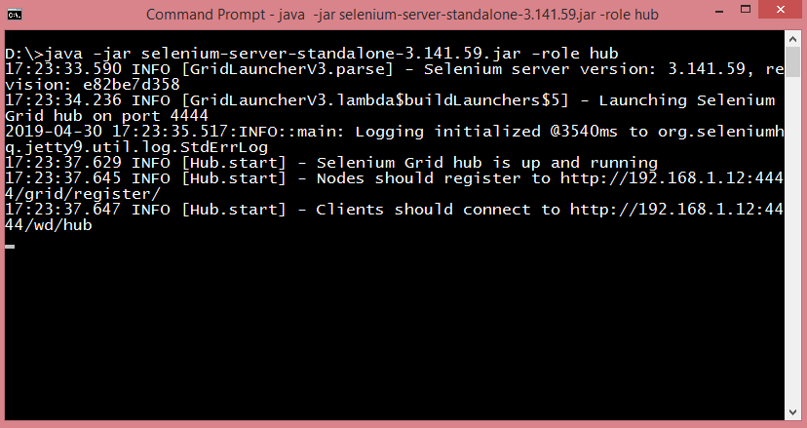

The port number is 4444 where hub resides and we need to register the hub with these nodes.

* Open the link, i.e., <http://192.168.1.12:4444/grid/console> where the server resides. Hub is the server only.

-=========================EXTENT REPORT====================

Extent Report is an open-source reporting library used to create visually attractive reports for Selenium tests using JUnit and TestNG.

Extent reports produce HTML-based documents that offer several advantages like pie charts, graphs, screenshots addition, and test summary.. It has features as below

* Extent reports are more customizable than others.
* Captures screenshots at every test step
* Displays the time taken for test case execution within the report.
* Extent API can produce more interactive reports, a dashboard view, graphical view, and emailable reports
* You can easily track multiple test case runs that occur within a single suite.
* It can be easily integrated with frameworks like JUnit, NUnit, & [TestNG](https://www.softwaretestingmaterial.com/testng-tutorial/) (specify extent report class in testng.xml)

**For maven projects**

<!-- https://mvnrepository.com/artifact/com.aventstack/extentreports -->

<dependency>

<groupId>com.aventstack</groupId>

<artifactId>extentreports</artifactId>

<version>5.0.9</version>

</dependency>

**For normal prj > add external jars**

INTEGRATE EXTENT WITH TESTNG (if extent report classes are written in different class file than TestNG test script class file.)

* <?xml version="1.0" encoding="UTF-8"?>
* <!DOCTYPE suite SYSTEM "https://testng.org/testng-1.0.dtd">
* <suite name="Suite">
* <listeners>
* <listener class-name="gra.Utilities.ExtentReportManager"/>
* </listeners>
* <test thread-count="5" name="GItHubRestAPITestOnRepoOperations">
* <classes>
* <!--class name="gra.Tests.GraTestWithFakerAndPropertyFile"/!-->
* <class name="gra.Tests.GraTestWithFaker"/>
* <!--class name="gra.Tests.GraTestWithDataDrivenTest"/!-->
* </classes>
* </test> <!-- GItHubRestAPITestOnRepoOperations -->
* </suite> <!-- Suite -->

There are three classes that are used for generating and customizing the Extent Reports in Selenium. They are:

* The ExtentHtmlReporter class is used for creating the HTML reports.
* The ExtentReports class is used for creating the tests.
* The ExtentTest class is used for generating the logs in the Extent Report.

1. ExtentHtmlReporter

a> The ExtentHtmlReporter is used for creating an HTML file, and it accepts a file path as a parameter.

In Java, the getProperty(String key) method returns the system property specified by the key, which is passed as the argument. Here we have specified “user.dir” as the key, and System.getProperty(“user.dir”) returns our current working directory. So instead of specifying the full path, we can use this to fetch the value of our directory and add the path where we want our Extent Report in Selenium to be saved.

String timeStamp = **new** SimpleDateFormat("yyyy.MM.dd.HH.mm.ss").format(**new** Date());

reportName="Test-Report-"+timeStamp+".html";

ExtentHtmlReporter htmlReporter =  new ExtentHtmlReporter(System.getProperty("user.dir")+"/Reports/reportName");

OR

new ExtentHtmlReporter (".\\graReports\\"+reportName);

ExtentHtmlReporter is also used to customize the extent reports. It allows many configurations to be made through the config() method. Some of the configurations that can be made are described below.

htmlReporter.config().setDocumentTitle("RestAssuredAutomationProject");

htmlReporter.config().setReportName("GITHUB REST API testing for operation on Repo");

htmlReporter.config().setTheme(Theme.***DARK***);

To set the title of the extent report, we can use setDocumentTitle(“YOUR_TITLE”).

To set the report name, we can use setReportName(“YOUR_REPORT_NAME”).

We can also specify the time format in our extent report by using the setTimeStampFormat() method.

Extent Reports in Selenium can also be customized with dark themes using the setTheme() method.

We have two themes – STANDARD and DARK for customizing the look and feel of our extent reports.

1. ExtentReports - The ExtentReports helps for starting reporters and building reports. ExtentReports itself does not build any reports, but allows reporters to access information, which in turn create the reports.

* **=>provide diff mthds like attachReporter()- to attach the reporter, setSystemInfo()- to set sys related info if any, createTest()- to set test name (usually written in testng test class ), flush()-Erases any previous data on a relevant report and creates a whole new report**

ExtentReports extent = new new ExtentReports();

extent.attachReporter(htmlReporter);

extent.setSystemInfo("Application", "GITHUB REST API");

extent.setSystemInfo("Operating System", System.*getProperty*("os.name"));

extent.setSystemInfo("User Name", System.*getProperty*("user.name"));

extent.setSystemInfo("Environemnt","QA");

extent.setSystemInfo("user","Rudra");

**tc1 = extent.createTest("BlazeDemo Test");**

extent.flush();

1. ExtentTest > The ExtentTest class saves the test steps to a previously created HTML report.

=>This steps r generally written inside ur @Test mthds

=>uses mthds like info()- to provide descriptions for the steps written in test scripts , log()- Record the status of each test step in the HTML report being generated.

ExtentTest tc1 = extent.createTest("BlazeDemo Test");

tc1.info("Starting of Browser");

tc1.info("Opening URL");

tc1.log(Status.PASS, "Navigated Successfully");

tc1.info("close Browser");

* + Finally if u have not included those extent report classes in ur Test class ie if u hv created a seprate utility class for Extent Reports then u need to include that class to ur TestNG.xml file under Listener Tag as shown above.
  + Here our extentreport class file implement ITestListner Interface as, **public** **class** ExtentReportManager **implements** ITestListener

=>Also we pass ITestContext & ITestResult as parmas to the mthds of ExtentReportManager (reffered as override mthds, as ExtentReportManager implements ITestListner) in extent file class as **public** **void** onStart(ITestContext testContext), **public** **void** onTestSuccess(ITestResult result)

ExtentReportManager CLASS

----------

**package gra.Utilities;**

**//Extent report 5.x**

**import java.text.SimpleDateFormat;**

**import java.util.Date;**

**import org.testng.ITestContext;**

**import org.testng.ITestListener;**

**import org.testng.ITestResult;**

**import com.aventstack.extentreports.ExtentReports;**

**import com.aventstack.extentreports.ExtentTest;**

**import com.aventstack.extentreports.Status;**

**import com.aventstack.extentreports.reporter.ExtentSparkReporter;**

**import com.aventstack.extentreports.reporter.configuration.Theme;**

**public class ExtentReportManager implements ITestListener**

**{**

**public ExtentSparkReporter sparkReporter;**

**public ExtentReports extent;**

**public ExtentTest test;**

**String repName;**

**public void onStart(ITestContext testContext)**

**{**

**String timeStamp = new SimpleDateFormat("yyyy.MM.dd.HH.mm.ss").format(new Date());//time stamp**

**repName="Test-Report-"+timeStamp+".html";**

**sparkReporter=new ExtentSparkReporter(".\\graReports\\"+repName);//specify location of the report**

**sparkReporter.config().setDocumentTitle("RestAssuredAutomationProject"); // Title of report**

**sparkReporter.config().setReportName("GITHUB REST API testing for operation on Repo"); // name of the report**

**sparkReporter.config().setTheme(Theme.DARK);**

**extent=new ExtentReports();**

**extent.attachReporter(sparkReporter);**

**extent.setSystemInfo("Application", "GITHUB REST API");**

**extent.setSystemInfo("Operating System", System.getProperty("os.name"));**

**extent.setSystemInfo("User Name", System.getProperty("user.name"));**

**extent.setSystemInfo("Environemnt","QA");**

**extent.setSystemInfo("user","Rudra");**

**}**

**public void onTestSuccess(ITestResult result)**

**{**

**test=extent.createTest(result.getName());**

**test.assignCategory(result.getMethod().getGroups());**

**test.createNode(result.getName());**

**test.log(Status.PASS, "Test Passed");**

**}**

**public void onTestFailure(ITestResult result)**

**{**

**test=extent.createTest(result.getName());**

**test.createNode(result.getName());**

**test.assignCategory(result.getMethod().getGroups());**

**test.log(Status.FAIL, "Test Failed");**

**test.log(Status.FAIL, result.getThrowable().getMessage());**

**}**

**public void onTestSkipped(ITestResult result)**

**{**

**test=extent.createTest(result.getName());**

**test.createNode(result.getName());**

**test.assignCategory(result.getMethod().getGroups());**

**test.log(Status.SKIP, "Test Skipped");**

**test.log(Status.SKIP, result.getThrowable().getMessage());**

**}**

**public void onFinish(ITestContext testContext)**

**{**

**extent.flush();**

**}**

**}**

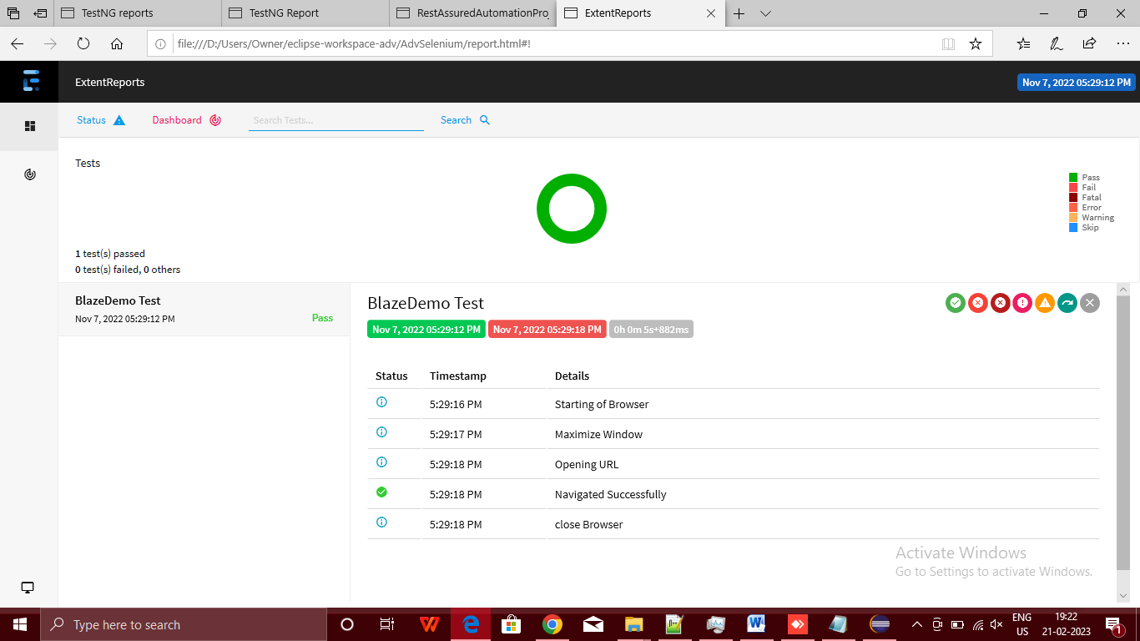

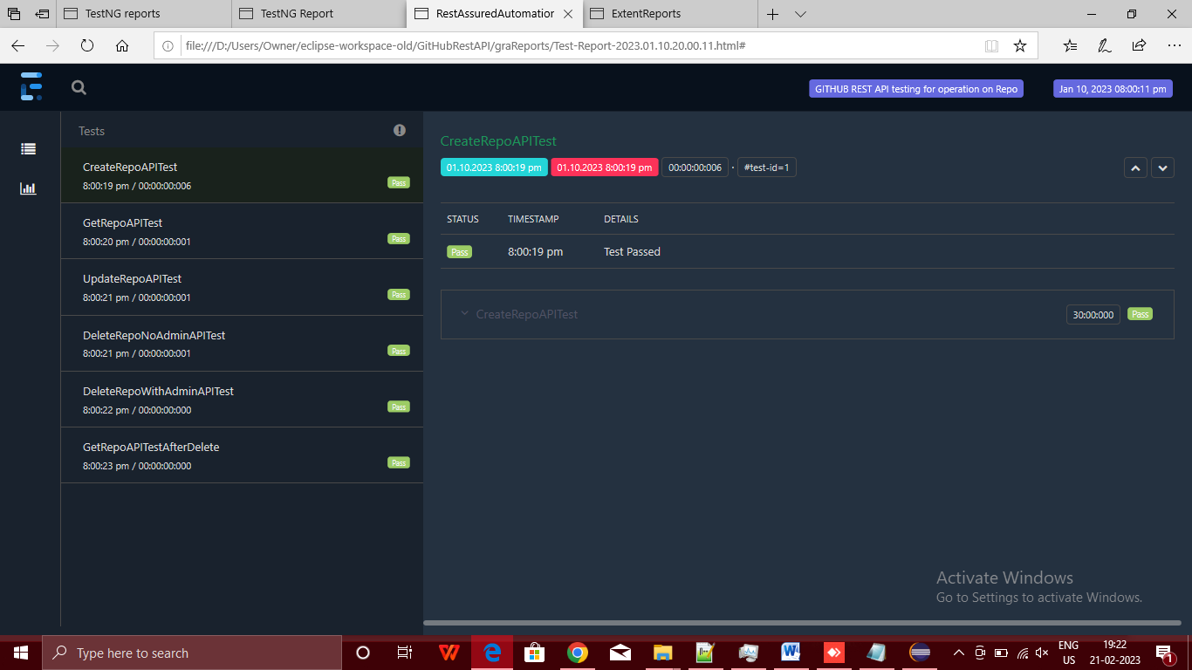

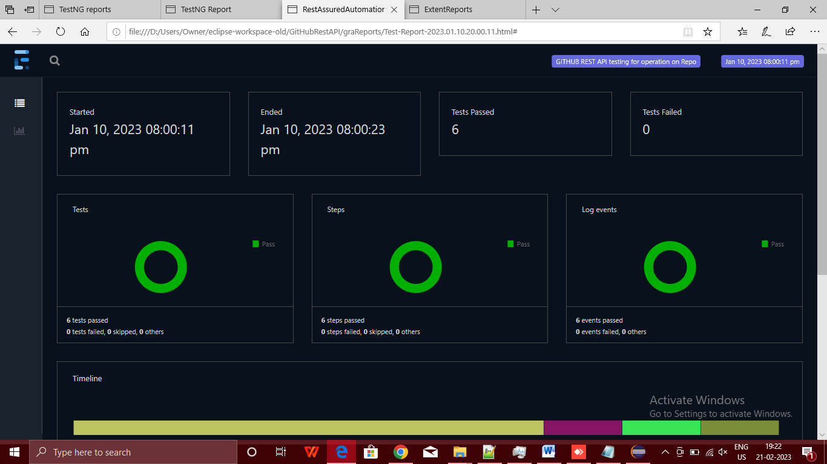

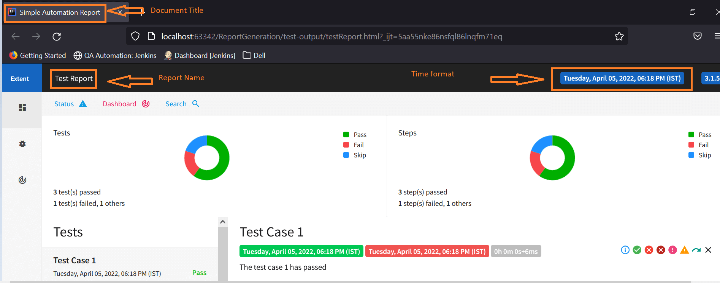

**=============================AUTOIT=================================**

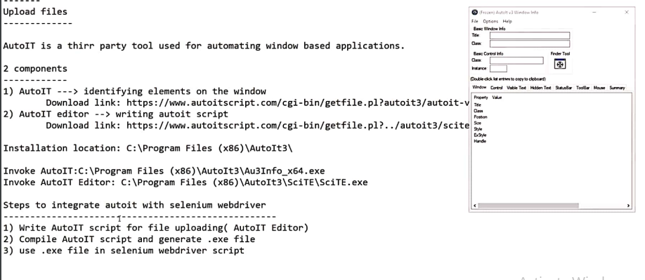

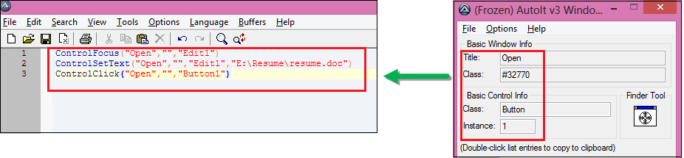

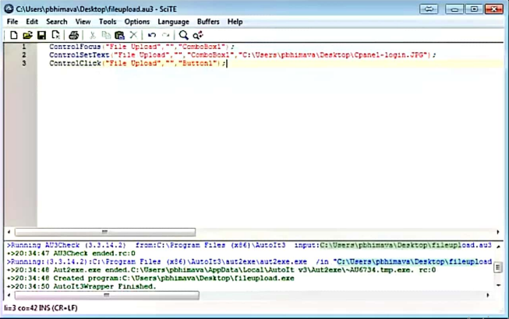

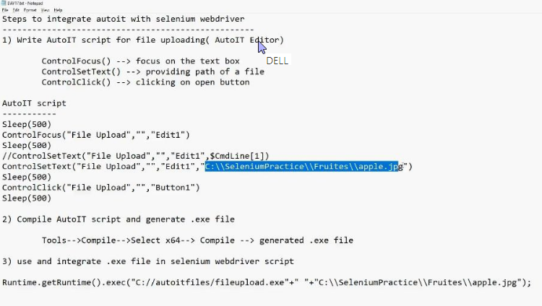

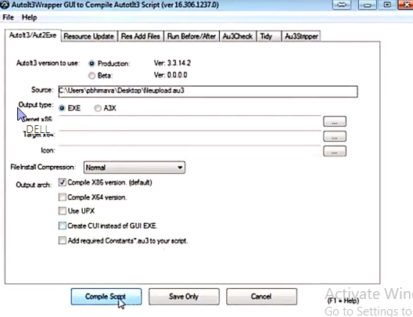

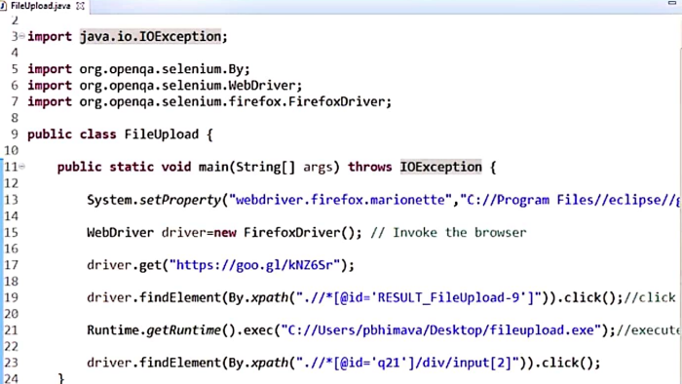

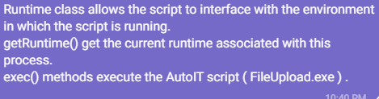

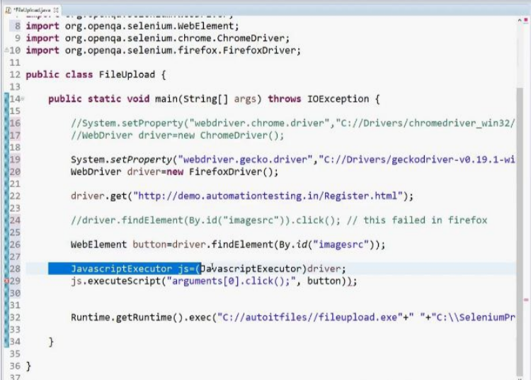

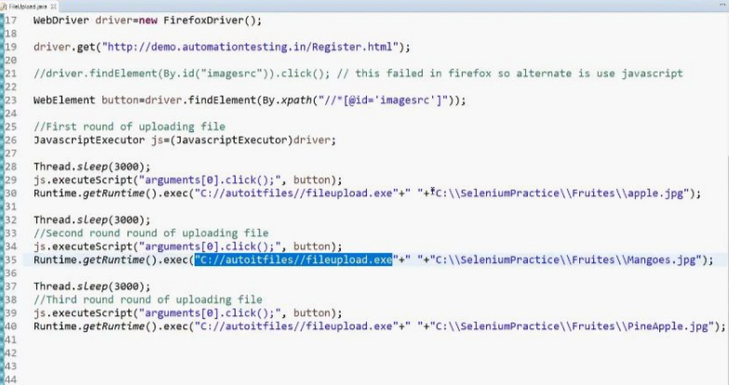

The another use of AutoIt script in Selenium is to handle Windows-based pop-ups like Username & Password Authentication.

**=============================SIKULI=================================**

Sikuli Automates anything you see on the screen using the image recognition method to identify GUI elements. Sikuli script allows users to automate GUI interaction by using screenshots.

* It can be useful to automate the Window based application. We can automate, what we are seeing on the screen.
* It provides, simple API. i.e. all methods can be accessed using screen class objects.
* It can be easily integrated with Selenium and all other tools.
* Using Sikuli we can automate desktop applications.

**#1) Creating Object for Screen Class**

The screen is a base class provided by Sikuli. We need to create an object for this screen class first, then only we can access all the methods provided by Sikuli.

**Syntax:**  
***Screen s=new Screen();***

**#2) Click On An Element**

This method used to Click on the specific image present on the screen.

**Syntax:**  
s.click(“<<image name>>”);

**For Example,**  
s.click(“test.png”);

**#3) Right Click On An Element**

This method used to right-click on the specific image present on the screen.

**Syntax:**  
s.rightClick(“<<image name>>”);

**For Example,**  
s.rightClick(“test.png”);

**#4)** **Find An Element**

This method used to find a specific element present on the screen.

**Syntax:**  
s.find(“<<image name>>”);

**For Example,**  
s.find(“test.png”);

**#5) Double Click on An Element**

This method used to trigger a double click event on a specific image present on the screen.

**Syntax:**  
s.doubleClick(“<<image name>>”);

**For Example,**  
s.doubleClick(“test.png”);

**#6) Check whether an Element present on the Screen**

This method is used to check whether the specified element is present on the screen.

**Syntax:**  
s.exists(“<<image name>>”);

**For Example,**  
s.exists(“test.png”);

**#7) Type a string on a Textbox**

This method is used to enter the specified text on the Text box.

**Syntax:**  
s.type(“<<image name>>”,”String to be typed”);

**For Example,**  
s.type(“test.png”,”HI!!”);

**#8) Wheeling on a particular image**

This method is used to perform wheeling action on the element image.

**Syntax:**  
s.dragDrop(“<<source image name>>”,”<<target image name>>”);

**For Example,**  
s.dragDrop(“test.png”,”test1.png”);

**Syntax:**  
s.paste(“<<image name>>”,”test”);

**For Example,**  
s.paste(“test.png”,”test”);

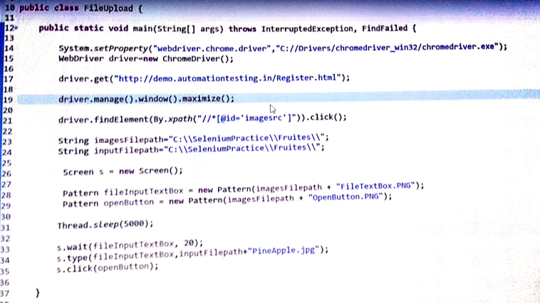

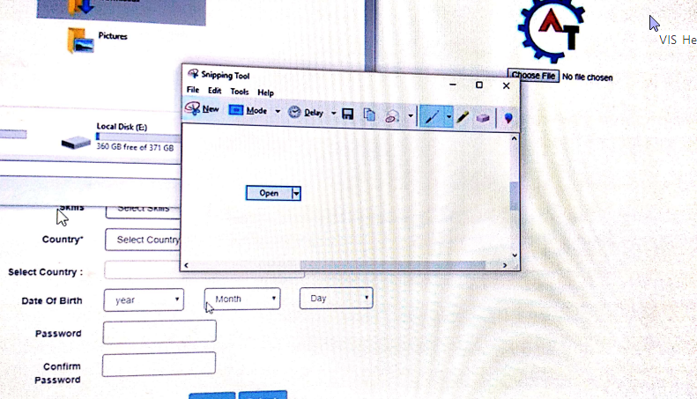

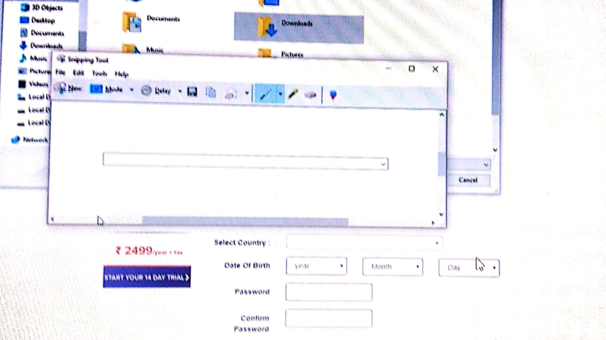

=========================JMeter=============================

**Performance testing** of any application helps in identifying the performance bottlenecks in the application. In performance testing, we not only measure the response time of the application but also several other quality attributes like – stability, reliability, robustness, scalability, resource utilization, etc.

*Performance testing is a type of*[*non-functional testing*](https://artoftesting.com/non-functional-testing)*technique in which the performance of an application is evaluated by applying expected workload or workload higher than higher than expected workload.*

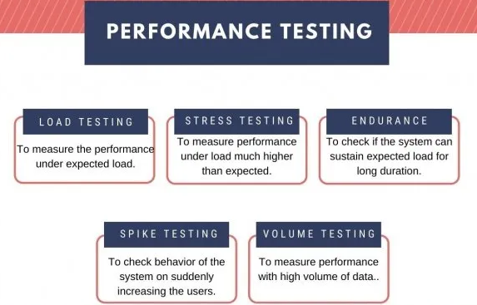

## What is Load Testing?

**Load testing is one of the types** of performance testing using which we evaluate the performance of an application under expected real-world load.

A typical load test includes determining **the response time, throughput, error rate, etc** during the course of the load test.

**Example**– For a newly developed application with an anticipated load of around 1000 concurrent users. We will create a load test script and configure it with 1000 virtual users and run it for say 1-hour duration. After the load test completion, we can analyze the test result to determine how the application will behave at the expected peak load.

The virtual user creation is performed by tools like – JMeter and LoadRunner.  
These performance testing tools allow us to create scripts that make different requests to the server, just like real-world users.

## Stress testing

Stress testing is a type of performance testing where we evaluate the application’s performance at a load much higher than the expected load. Another aspect of the stress testing is to determine **the break-point of the application**, the point at which the application fails to respond in the correct manner.

For an application with an anticipated load of 1000 users we will run the test with 1200 users and check if the application is robust enough to not crash.

Application’s quality attributes determined during stress testing-  
Breaking point  
Robustness  
Recoverability  
Stability, etc.

**In this type of testing, we measure the robustness and stability of an application by subjecting it to extreme load conditions, beyond the expected real-world operational load.**   
  
With Stress testing, we aim to find a breaking point of the application. A load beyond which the application fails to respond or starts behaving abnormally.

1. **Education Board’s result website**  
   Stress testing of such websites is very much a requirement as on the day of some result, a huge number of users/applicants/students will login to the application to check their results.  
     
   This peak load happens in a short duration also, just at the time when the result is out. So, stress testing can help in finding the breakpoint of the application and analyzing the behavior of the application and recoverability in case of a crash.

## ****What is Endurance Testing?****

*Endurance testing is a type of*[*performance testing*](https://artoftesting.com/performance-testing)*of the software to check system performance under specific load conditions* for a prolonged period of time. Endurance testing is also known as ‘Soak Testing’.

Endurance testing is done at the last phase of the performance run cycle.

It helps in finding out any memory leaks in the system. It also helps in checking the response time of the system over a longer period.

The simple definition of memory leak is “**a failure to release the memory by objects that are no longer used”**. This occurs due to a weak code written by a programmer”.  
  
In the event of a memory leak, due to memory used by unused objects, available memory reduces gradually which slows down the system, and eventually, the system stops working.

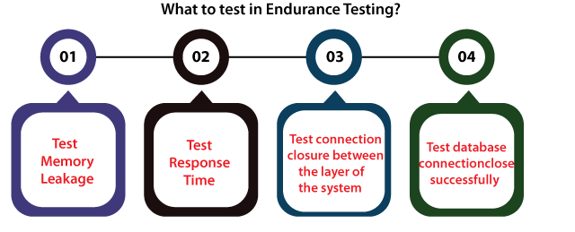

Some of the most frequent tools used for Endurance test are **Apache JMeter, LoadUI, LoadRunner, WebLoad**, **IBM Rational Performance Tester**, etc.

## Spike testing

In spike testing, we analyze the behavior of the system on suddenly increasing the number of users. It also involves checking if the application is able to recover after the sudden burst of users.  
  
**Example** – For an e-commerce application running an advertisement campaign, the number of users can increase suddenly in a very short duration.

## Volume testing

The volume testing is performed by feeding the application with a high volume of data. The application can be tested with a large amount of data inserted in the **database** or by providing a large file to the application for processing. Using volume testing, we can identify the bottleneck in the application with a high volume of data. It is also known as flood testing   
  
**Example** –

If the system deals with large data frequently, volume testing becomes a necessary testing process. In this type of testing, database size is increased to the size as per the requirement and multiple queries can be fired simultaneously.(eg validator n ggs appln both using same DB ).

For example, for any e-commerce website. Let’s assume that a couple of new brands are introduced on the platform that is very famous in the market and they have a large number of products. Now, the system should be able to support this new set of data without any failure.

Volume testing is also done to check the volume of data that is projected for future usage. Let’s say any new banking application generates x GB of data and in the next 2 years it is predicted that the generated data volume will exceed x*10 GB of data, and in 5 years it will generate x*50 GB of data.

Tools > HammerDB, JdbcSlim, DbFit

**Apache JMeter**  is a Java-based desktop application that can be used for performance testing of different kinds of client-server applications like websites, web services, databases, FTP servers, etc.

## Types of applications that can be tested by JMeter

* Websites – HTTP and HTTPS
* Web Services – REST and SOAP
* Database Servers
* FTP Servers
* LDAP Servers
* Mail Servers – SMTP, POP3, IMAP
* Shell Scripts
* TCP Servers

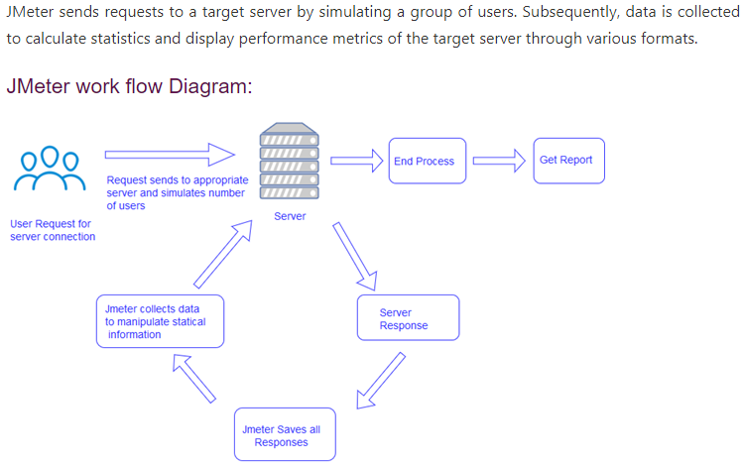

testPlan > Thread grp > http reqst (sampler), >listener can be under test plan/thread grp. > u v=can read single thread grp or all tg by running u test plan

* + Jmeter proxy is used to capture the diff params from reqst n responses send to n recvd from server on which then performance testing of that appln is carried out.
  + Local host config for jmeter proxy > Internet properties > connections > Lan settings > 8888 (global setting not practised usually ) . Also set this proxy in ur browsers setting as well
  + TestPlan > Test Script Recorder > setup jmeter proxy locat port
  + To remove unwanted stuffs from requests > go to Http Test recorder > reqst filtering near test plan creation>add suggested excludes > add as jpg|csv|css|png|txt etc
  + HTTP/HTTPS
  + U can access http websites by directly starting ur proxy server (I s start http recorder in Jmeter), but to access HTTPs u need to add certificate under that browsers setting under 3 lines > options > privacy > view certi > import > fom jmeter bin folder( if u don’t hv u can dwnld from net and keep kit under bin)

BlazeMeter > used to record script just like sel ide.(ssl certificate n all not reqd b4 starting recording, also no need to configure user defined variables seperately)

Doc on blazemeter.com > create accnt

Add chorem extension of blazemeter

Give test name & add lables to the steps that u will perform by starting recording > stop rec >extract or save rec as jmeter script with .jmx to ur local sys (select only ur rqd domain eg if accessing rediff the select rediff only) > then simply drag n drop it under test plan in Jmeter > modify scripts as red then save

Now b4 runu can add various listeners > ryt clk prj/test plan > Listener > View test results/ aggregate eetc then RUN

Rampup period > time period betn reqst sent by 2 users

You might used "ramp-up" or similar approaches to avoid a spike at the test start. For instance, if you configure [Thread Group](https://jmeter.apache.org/usermanual/component_reference.html#Thread_Group) to have 100 threads, **and set Ramp-up Period to 0 (or to a small number), then all the threads would start sending there requests at the same time**, and it would produce an unwanted spike of the load. If rampup = 1 then it works as when 1 st user has sent his 1st reqst then after specified rampup time 2nd user will start then after 1st reqst sent by 2nd user waiting for rampup 3rd will send n so on.

Loop count > how many time user will send reqsts. Applicable to all reqsts in a grp. To execute a single reqst multiple time we put that reqst under loop controller. Here the loop count specified at thread level will also be applicable for the reqst that runs multiple time in loop controller. Listener can also b included inside loop cont.

Timer > can be added at diff levels (test plan/ thread grp/ http reqst level), each thread(user) will send diff reqsts but in real time there will b some dealy betn those reqsts which is simulated using timers

Constant timer > delay is added b4 each reqst is processed

**Test plan > add NON TEST element > Http Recorder** Is added under test plan > under TEST PLAN CREATION section select Use RECORDING CONTROLLER drop down in Target controller. Also set proxy as 8888

To set proxy on browser > go to chrome setting > adv set > system > proxy setting > Under Inter option tab select LAN setting >> select chk box of proxy set> set addr localHost & 8888 port where ur Jmeter Is running…..after completion of script recording reset this setting

Recording controller > basically used to show the diff. recorded steps like login, registration etc of a test scenario , which is added under thread grp.

So in http Test script recorder u can select ur defined recording controller step under target controller dropdown one by one n start n stop recording, then those steps can be seen under defined controllers.

Simple cont & Test Fragment > to keep reqsts in an order or grp them/simply use to store multiple reqsts/sampler

MODULAR CONT > TO CALL other reqsts single or multiple times eg from simple controller we call login

THROUGHPUT CONT > create multiple throughputs under single thread grp n assign different samplers under them to distribute the load on this smaplers. Try to distribute the load by adding percentage in each THROUGHPUT CONT. so that u will only req to chng the no. of users in thread grp nxt time , and the load will be distributed automatically

RANDOM CONT > the reqsts/samplers kept under random cont will be selected **randomly** **only one** at a time during execution

RANDOM order CONT > Normally the reqss r executed in the order we save them that is one below the other, but here in ROC we can excute **all those reqsts** **randomly** irrespective of there order.

INTERLEAVE CONT > **ONLY 1 reqst** will be selected during execution in a **sequential order** ie if there r 3 reqst n loop count = 3 then in 1st execution (loop1) 1st reqst will be exuted in 2nd execution (loop2) 2nd reqst will be excuted n so on.

Include CONT > u can save anyof ur reqst which is reqd to be called frequently as .jmx file in ur local system, n then u can browse it in ur include controller. Then u can keep ur include controller above other reqsts as per the reqd sequence in which execution is to be done.

===================JDBC=========================

JDBC Connection and rquest > Used for load testing of a database server, to chk the behaviour of db server when multiple users try to use it simultaneously.

Steps For JDBC connection , request and load test.

Kindly refer apache jmeter official docx for details of each fields for this configuration setup & also for the JDBC reqst to be sent.

1.Include JDBC jar files in lib folder of JMETER n restrt JMETER

2.Create JDBC thread grp > ryt click > ADD > Config element > JDBC Connection Configuration.

3.Within JDBC Connection Configuration.

1.Assign variable name for pool to uniquely identify the db connection (u may chng name of configuration)

2.In DB connection configuration give DB url > Jdbc:mysql://148.72.215.41:3306/testingdb

3.JDBC Driver class as > mysql

4.Username & password

4.Ryt click JDBC Thread group > ADD > Sampler > JDBC request

1.Give Variable name as assigned in config.

2.Select ur type of query u want to perform on db

3.Type the query below > cntrl + s

4.U cannot write multiple query in same JDBC request u hv to create another JDBC request for another query.

5.Neither u can perform same query on multiple tables in a db within a same JDBC request.

5.Create a View result tree and Run here.

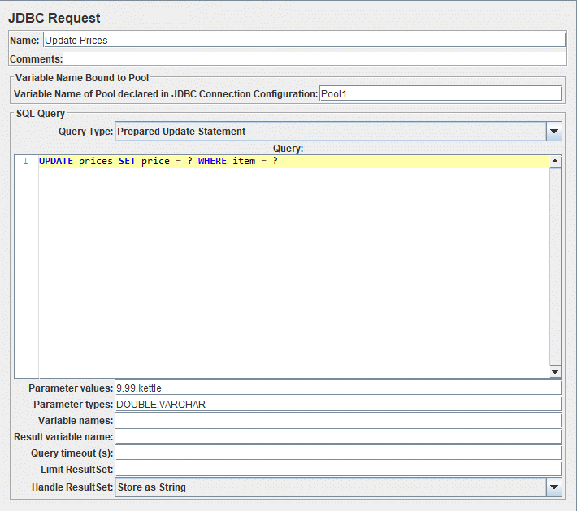

* U CAN ALSO add response assertion to validate diff fields from response obtain on execution of ur db query in view result tree. Also u can add assertion result to chk the the assertion valdn.

**JMeter Variable Name to use** - assertion is to be applied to the contents of the named variable > to chk specific data from db

Execution of jmeter script thru GUI,

Go to jmeter bin folder in cmd > jmeter –n –t(locn of ur jmeter test scipt.jmx) –l(locn of result file.csv)

-n = non gui

-t = save ur jmeter test plan as .jmx file

-l = make a .csv or .jtl file where ur result will b stored and specify its locn.(even if not specified it will create a one).

jmeter –h > to get help on jmeter cmnds

jmeter -? > to get info on jmeter cmnd optns.

For graphical result > use .jtl as result locn file……………..note it is “L” in jtl & -l

U can view ur .jtl file in Jmeter > create any type of listener ass reqd in ur test plan > Inside that Listener browse ur .jtl file.

Pre processor > params or stuff which is reqd to be executed b4 actual reqst gets executed

Post processor> params or stuff which is reqd to be executed after actual reqst gets executed

Plugin manager > A plugin use to manage all other jmeter plugins > dwnld jmeter plugin manager jar file > save it to jmeter /lib/ext folder > restsrt jmeter > options > plugin manager > u will see installed, avlbl n upgrade plugins. U can also c docx for plgins

Corelation , reg expression extracter

To fetch a data from the response recvd after sending a reqst n then using that data into next step or next reqst is basically co relation…………

Http reqst > Add a post processor as reg expression extractor to extract reqd data from 1st reqst > add 2nd http reqst by specifying only reg expr varb name in path of the reqst , here no need to specify url or protocol, as reg expr has both > Add view result tree > Run plan

How to use reg expr > copy the entire response data to <https://regexr.com/> > Build ur expression under Expression > under Tools select List to see ur reqd data’s that ur build expression will return.

Eg for finding registration link on login pg of blaze demo >

Expression => <a href = “(.*)”>……………….. (.*) will basically return the grp of links

Now under reg expression extractor in Jmeter >

1. Give reg expr varb name which will b then used in 2nd http reqst

2. Sepcifu ur reg expression = <a href = “(.*)”>

3. Sepcify $1$ under template as the grp u r using in ur reg exprn is the 1st grp ie u hv only 1 grp in ur reg exprm

4. Now ur reg exprn grp can hv multiple links so specify which number link u wish to use in Match no. eg if I want to use 2nd link from grp then match no. = 2

**Parameterization in Jmeter**

1. **Internal params** > used to define the values which r frequently used throughout the diff reqsts, or thread grps in USER DEFINED VARIABLES of Add > Config Elements. U can create this varbs at test plan level or thread grp or reqst level and accordingly the scope of those varbs will exist.

To use those varbs we use > $ { varb_name }

**2. Using CSV or Excel file**

1. Specify the data along with the column name to b passed in a csv file

2. Add > Config elements > CSV DATA SET CONFIG > browse ur csv file there, also set ur http reqsts

3. In CSV DATA SET CONFIG use “,” as delimiter which Is then used to separate the colmns. (, space etc can also b used)

4. Also note the param varbs u r using shld hv the same name as column names in csv file.

5. To fetch all sets of data from csv file u need to set loop count in thread grp accordingly > eg if u hv 4 sets of data in ur csv file the loop count = 4

6. This is the adv of using csv file ie u can pass multiple sets of data for the same varbs. Which u cant do in 1st approach where u hardcode the data in Jmeter.

Jmeter TEMPLATES >

Predefined > Under File > Templates > It Can b used as a new jmeter user where it shows how diff elements in jmeter works in diff templates (test plan, thread grp, sampler etc). U can use those templates n modify a bit to create ur own test plan as per ur requirement.

User defined > Make ur test plan > Save it under Jmeter template folder > Open a file there reffered as template.xml > copy an existing template structure there > paste n modify it by specifying ur template name and filename.jmx (if ur testplan is saved in template folder or else u need to specify complete path of ur test plan) > keep “isTestPlan” flag = true if ur template is a test plan. > save n restart Jmeter to see ur created template under templates.

**Jmeter functions** > refer official website

***Through JMeter we can do performance testing on web appls, dbs, apis etc. so in all above topics we hv simply learn how we can handle those web appls, dbs, apis etc. thru Jmeter n we hv not done any kind of performamnce testing on them…………….To do performamnce testing u can set all apllicable performance testing params viz no. of threads, rampup , loop count, adding assertions, listners etc.***

**JMETER REAL TIME PRJ**

Select recoding template > set proxy details in jmeter n on browser n also import certi in browser if reqd. by dwnlding it > select target controller where rec will b saved > In grouping Do not grp sampler

HTTP SAMPLER NAME > TXN NAME OR PREFIX > give name to ur each n every sampler steps after starting rec (no need to stop b4 performing next step)

Stop rec after performing reqd steps n assigning step names to them in recorder.

Now u create diff thread grps like 1 for login, 2nd for flightbookin, 3rd for sign off > and copy the corresponding valid steps from recording controller to each of those thread grps (now u can del ur rec cont n http recorder)

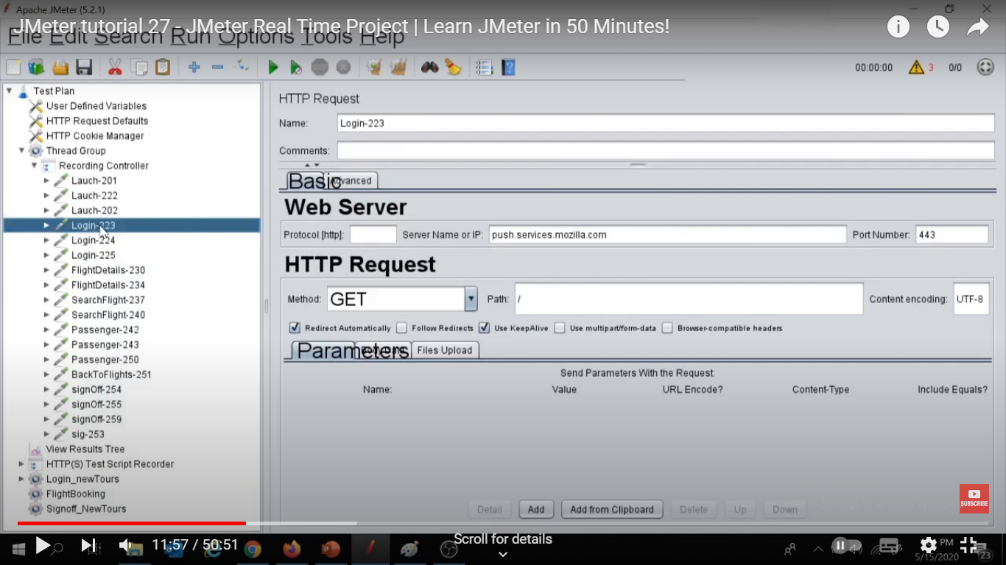

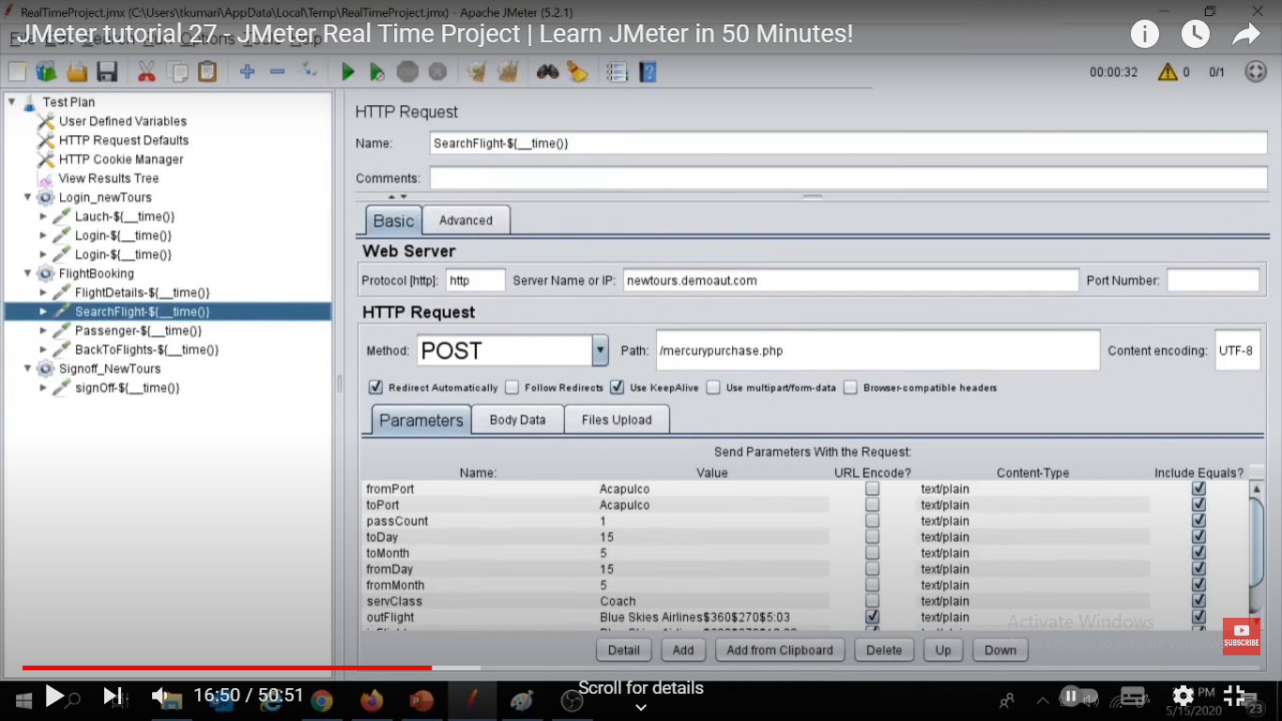

Assign sampler names as timestamp

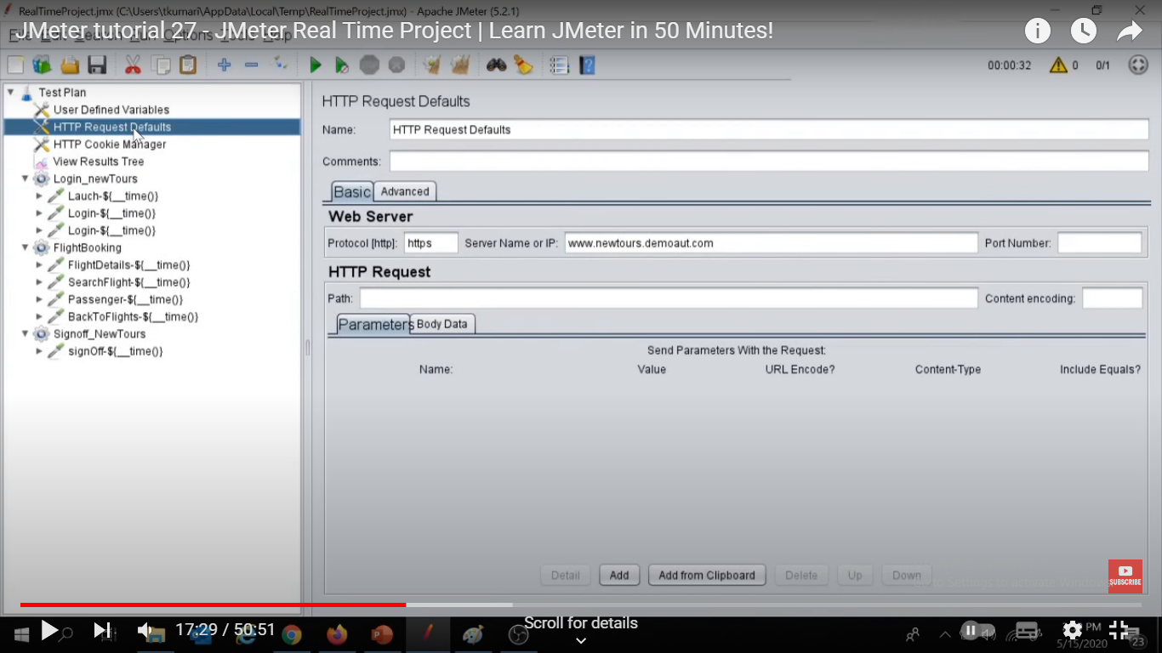

ADD url to HTTP REQST DEFAULTS as common to all reqst u no need to chng that separately in each reqst in future

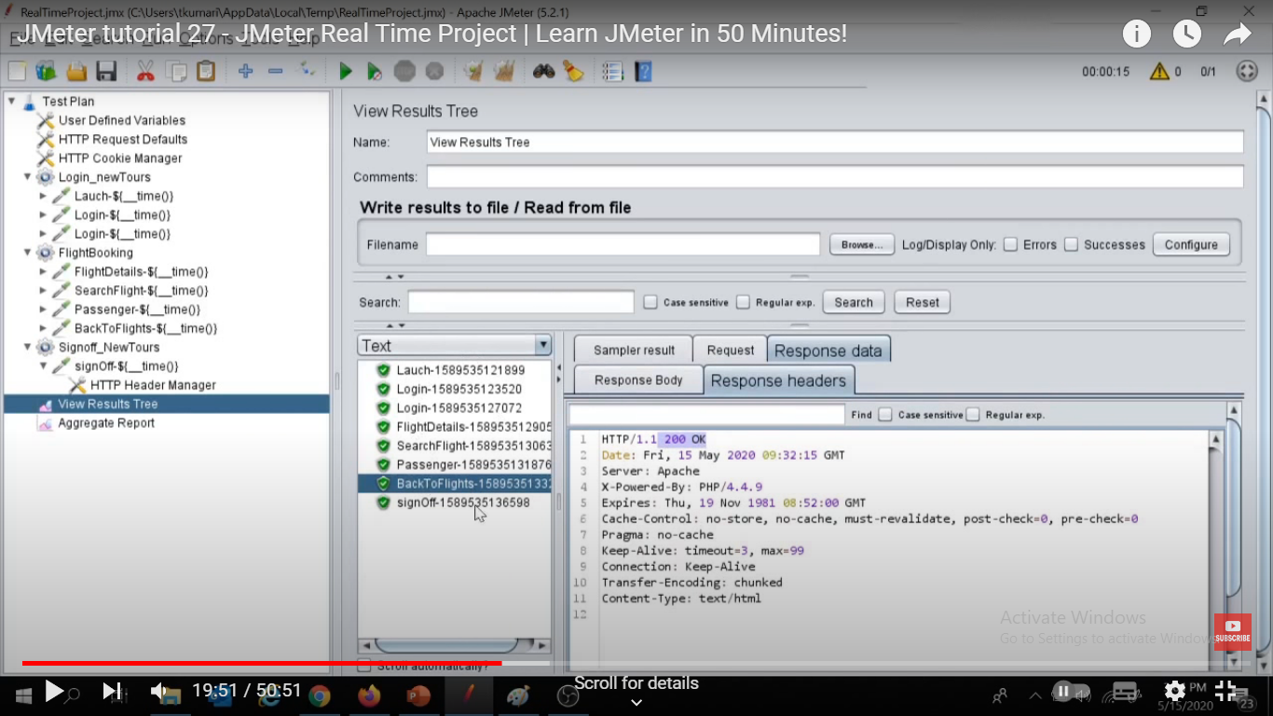

ADD LISTNERS

Here all reqsts r showing same resp n they r not navigating to nxt pgs, as they req an additional path param ie oscsid which get generated in the response of 1st launch reqst n we hv to pass it dynamivcally to all those subsequent reqsts so we hv use **co reln funda** below of adding reg exr

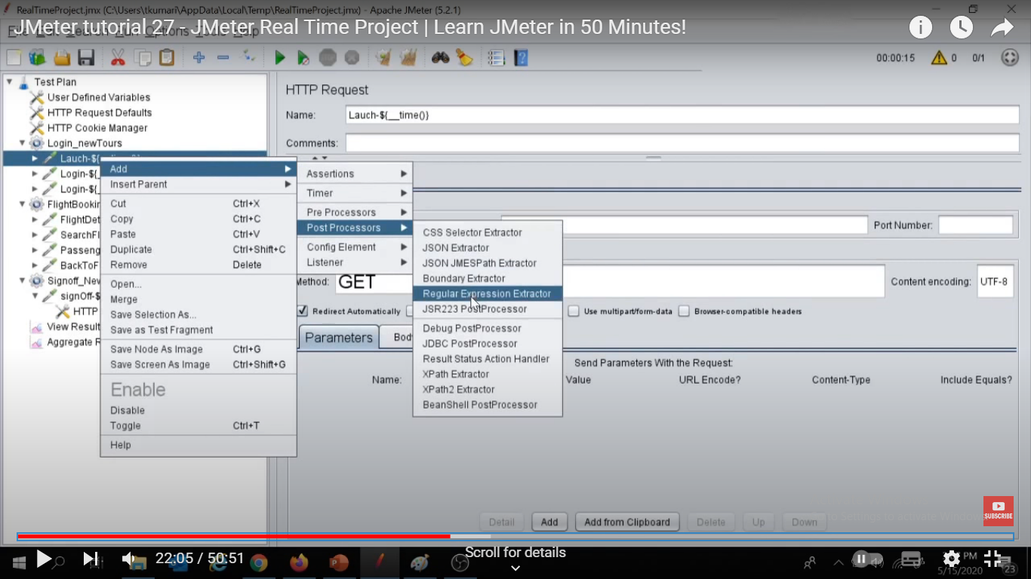

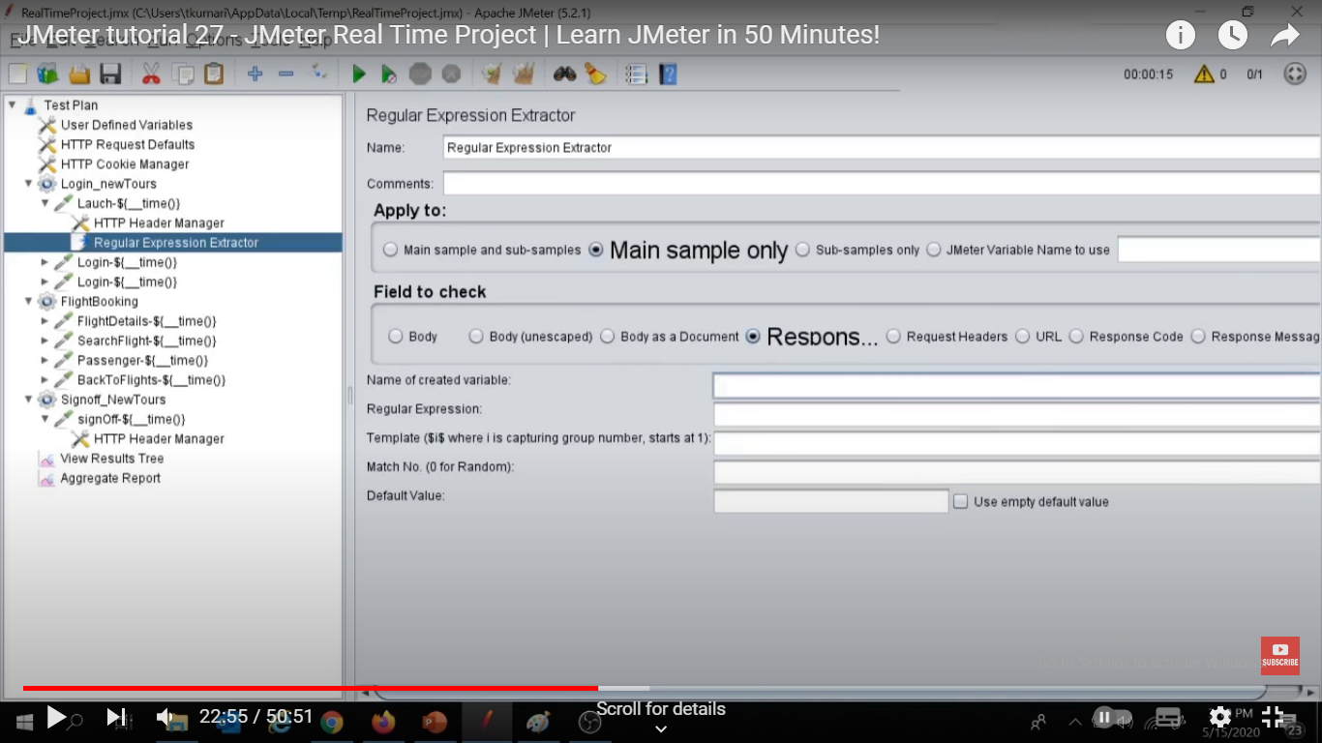

Select Main sample and Response header radio buttons since oscsid is in the response header of Launch reqst as below

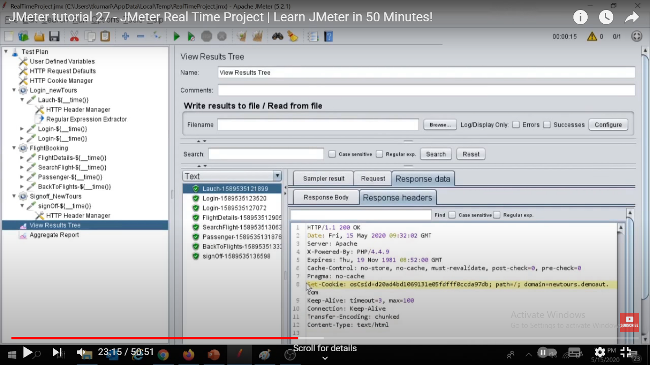

How to create reg expr for dynamically cnging values

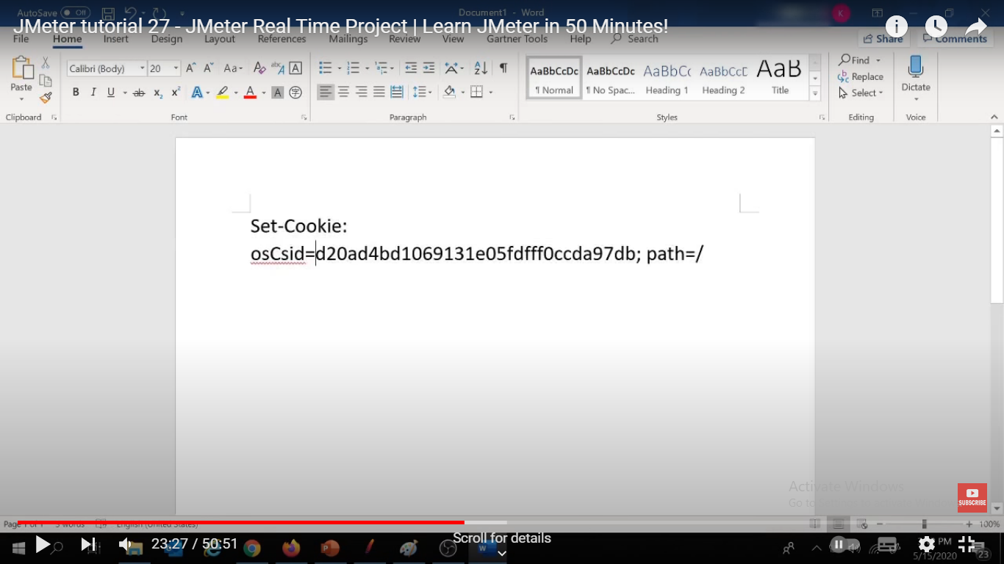

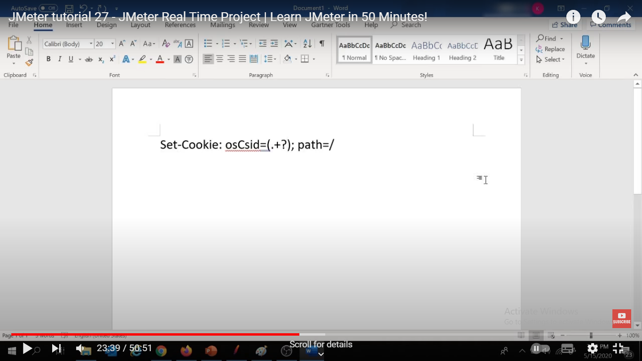

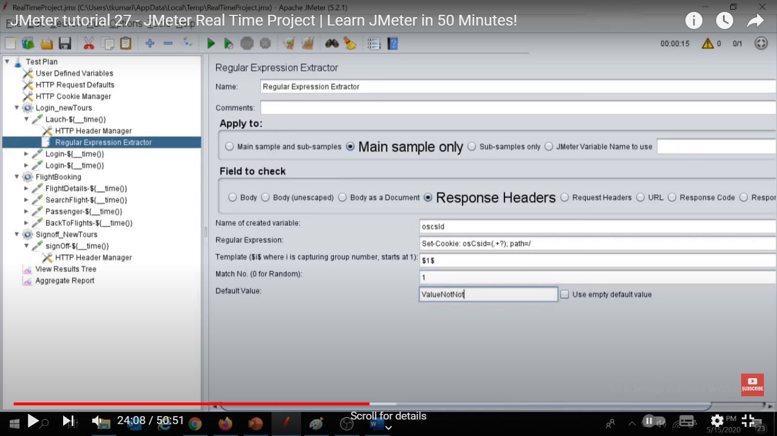

Assign reg expr varb to all the samplers where reqd as below

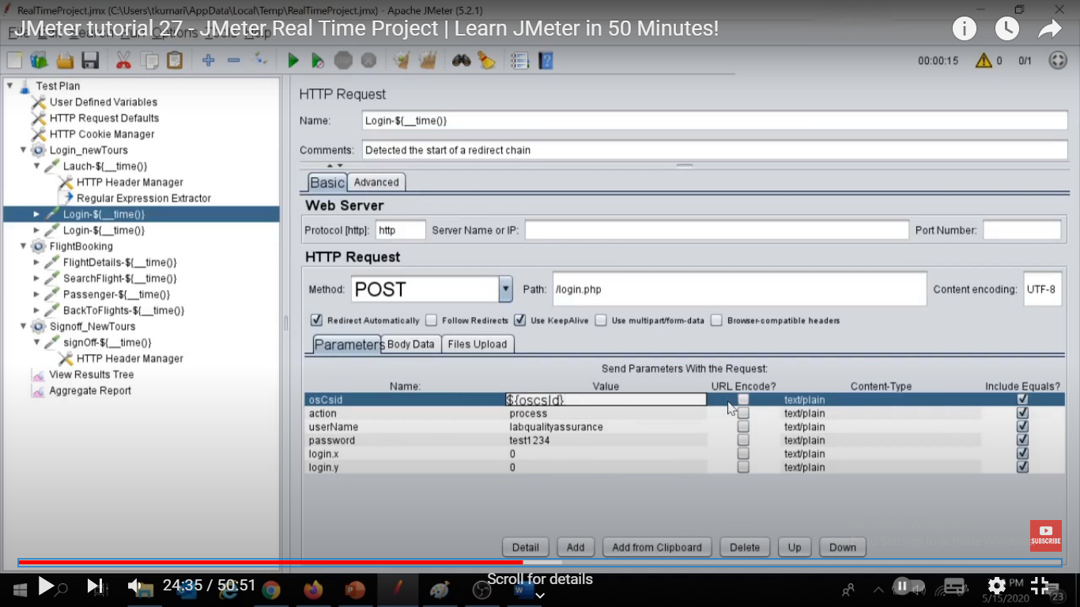

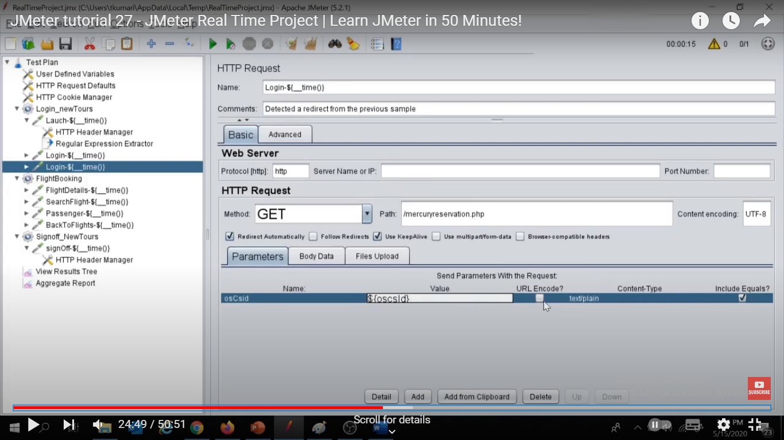

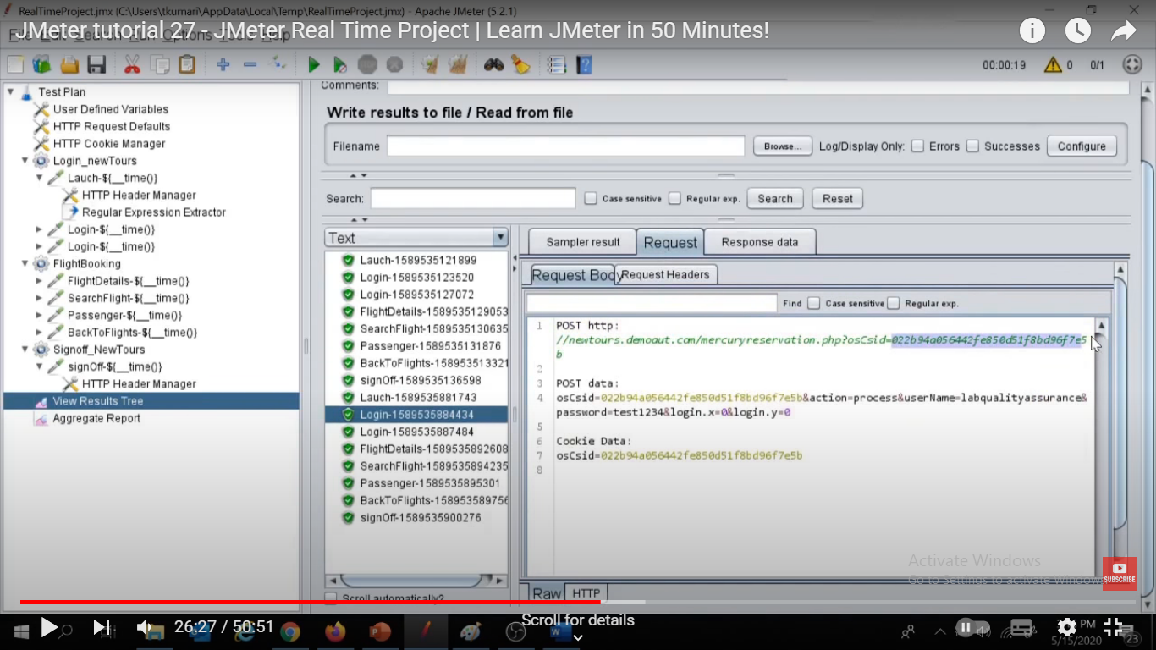

Oscsid passed succefully in nxt sampler thru coreln

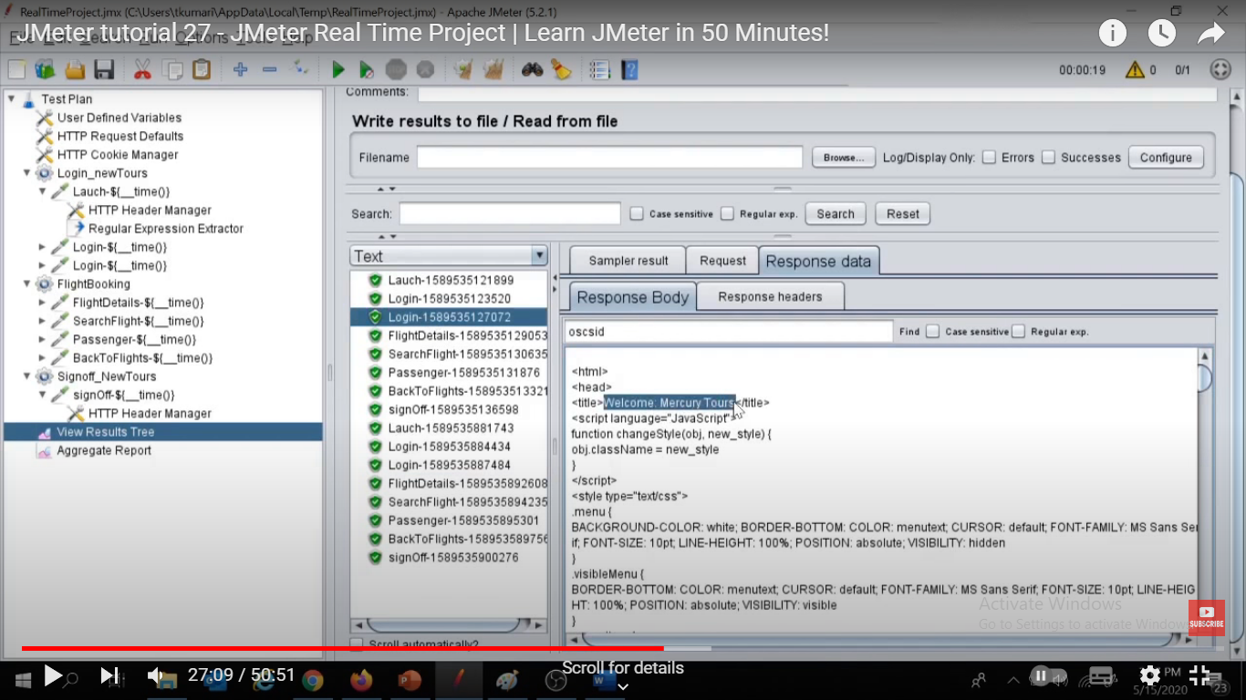

B4 corlen title on login pg was still that of launch pg

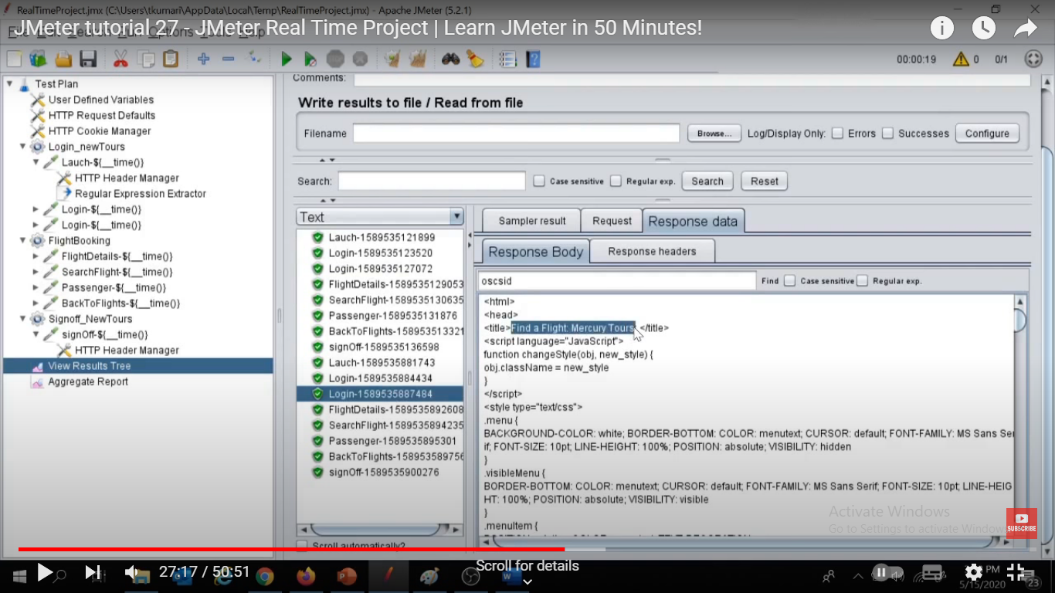

After coreln it has fetched proper title or rather navigated to nxt pg

But for some reqsts like flight booking we don’t hv oscsid param but still it is present in its url

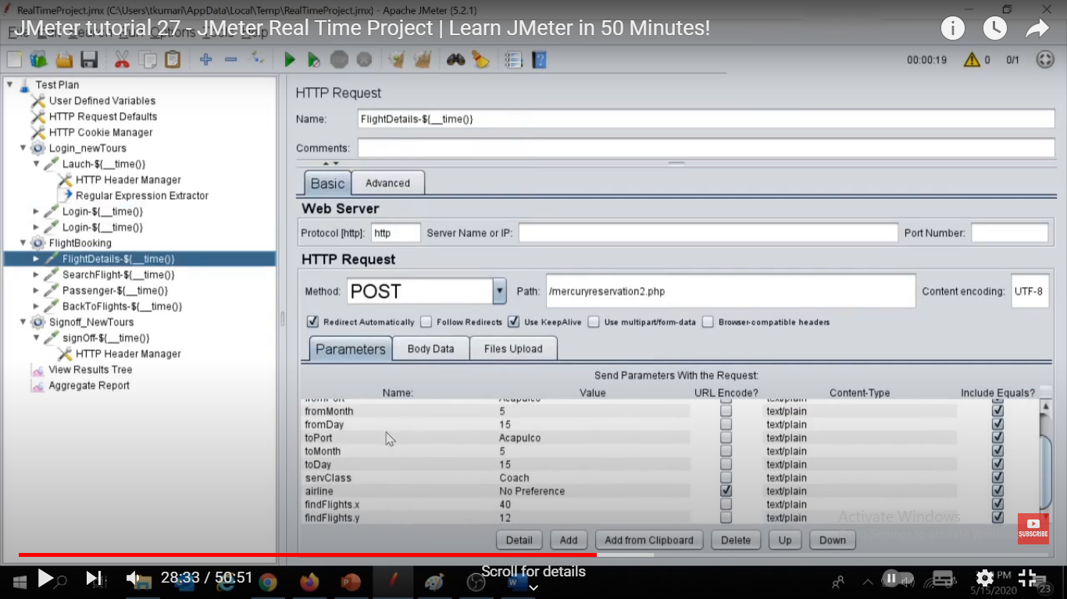

Oscsid not present in param to set varb

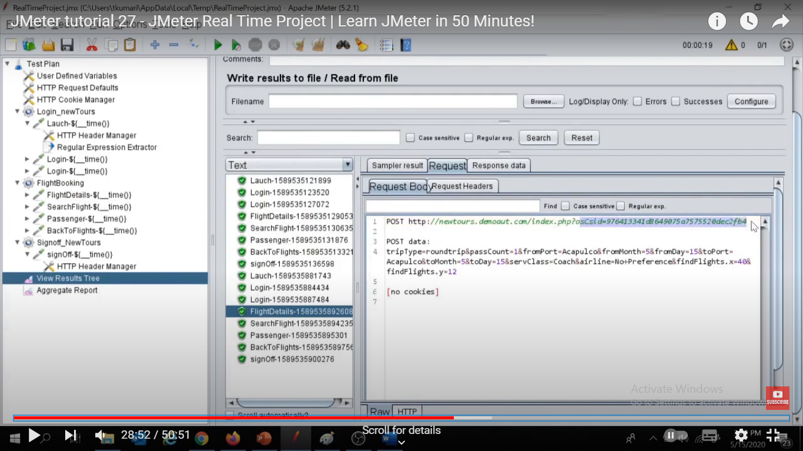

But still getting pass in the reqst, as it is commiing fromcookie of launch resp as below,

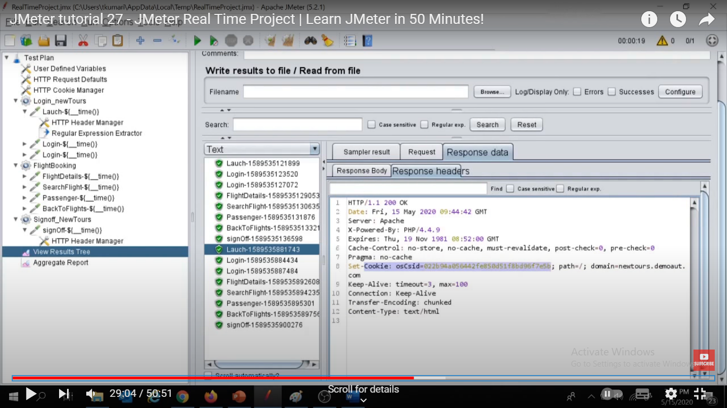

It can be handle using http cookie manager which will store the cookie frm the resp of a reqst n will use that in all nxt reqsts, but it can be done if all reqsts r within a thread grp only . To pass that cookie value to the reqsts in another thread grps we hv to do some scripting using **beanshell** . Add it after the reqst which generate cookie Here Launch

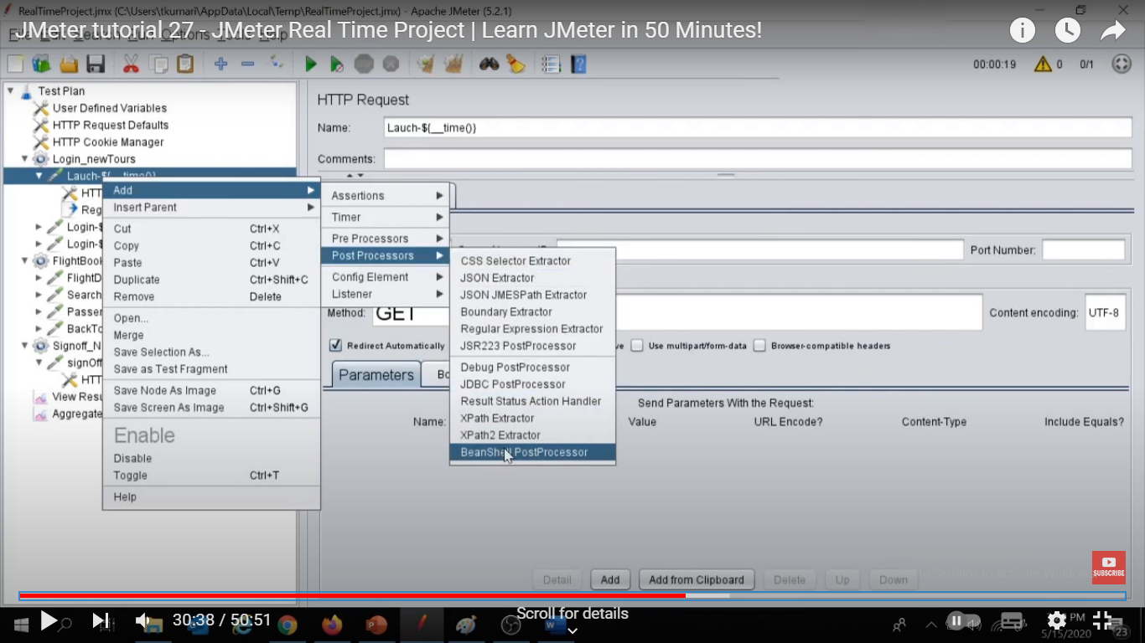

Use Props fun to store oscsid cookie value in Mycookie varb

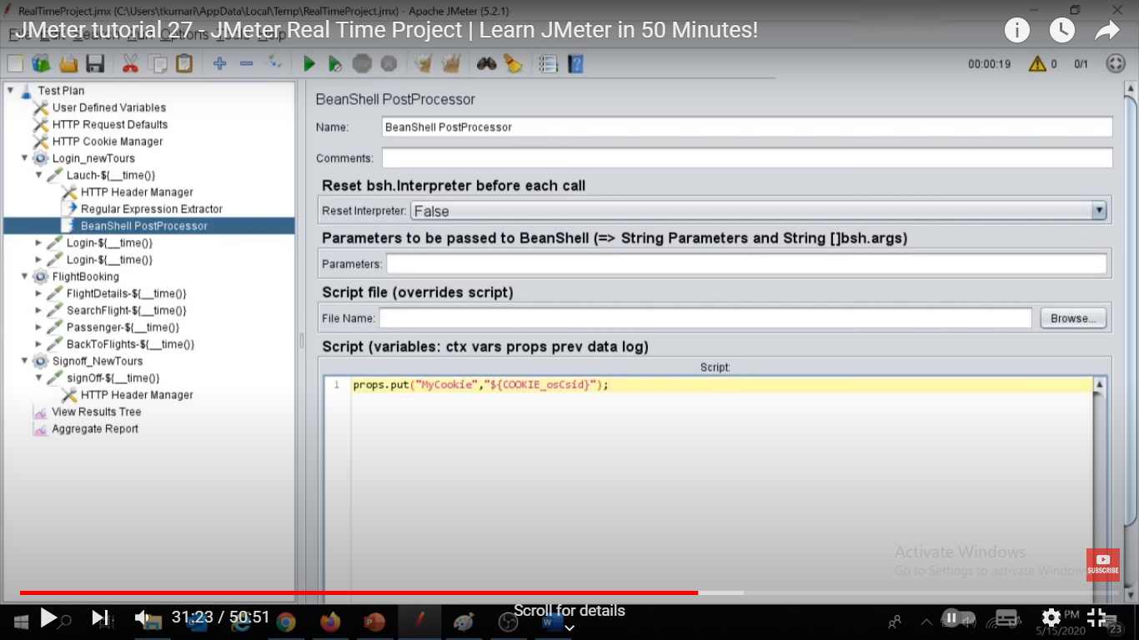

Now to use tis Mycookie in next reqsts we hv to add beanshell pre processor there

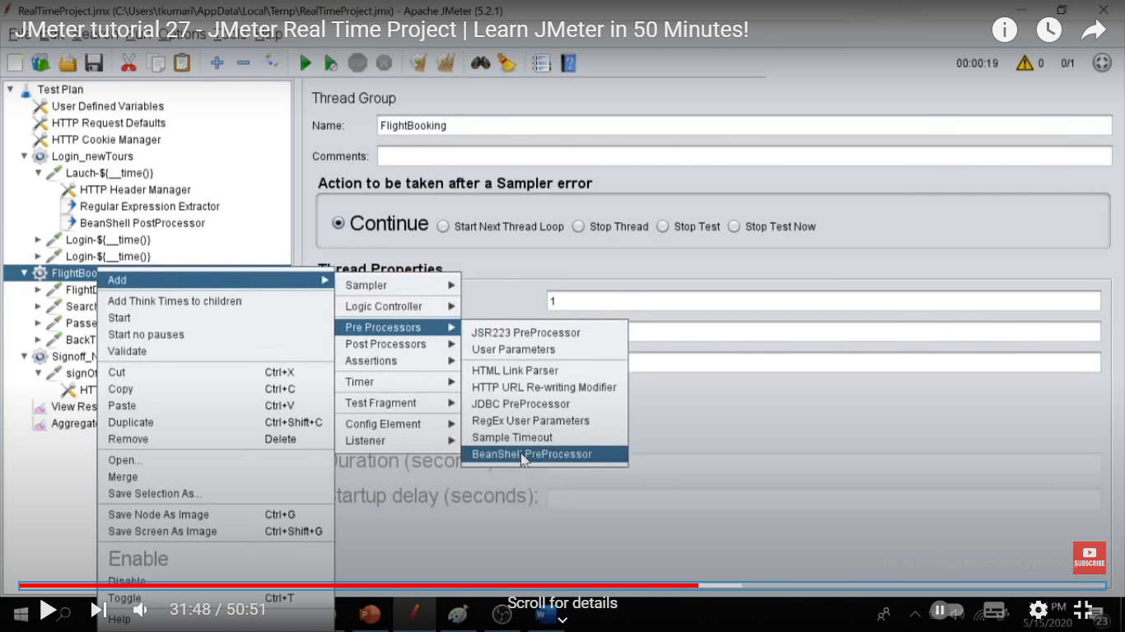

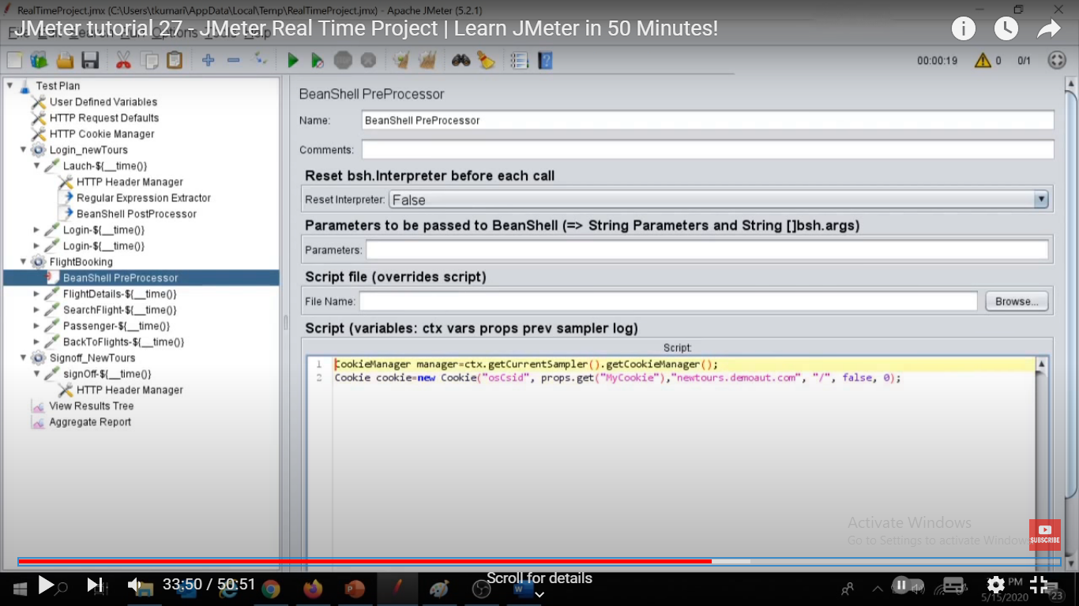

/ - path , false – flag value to handle cookie as secure or not, 0 –expiry time in sec

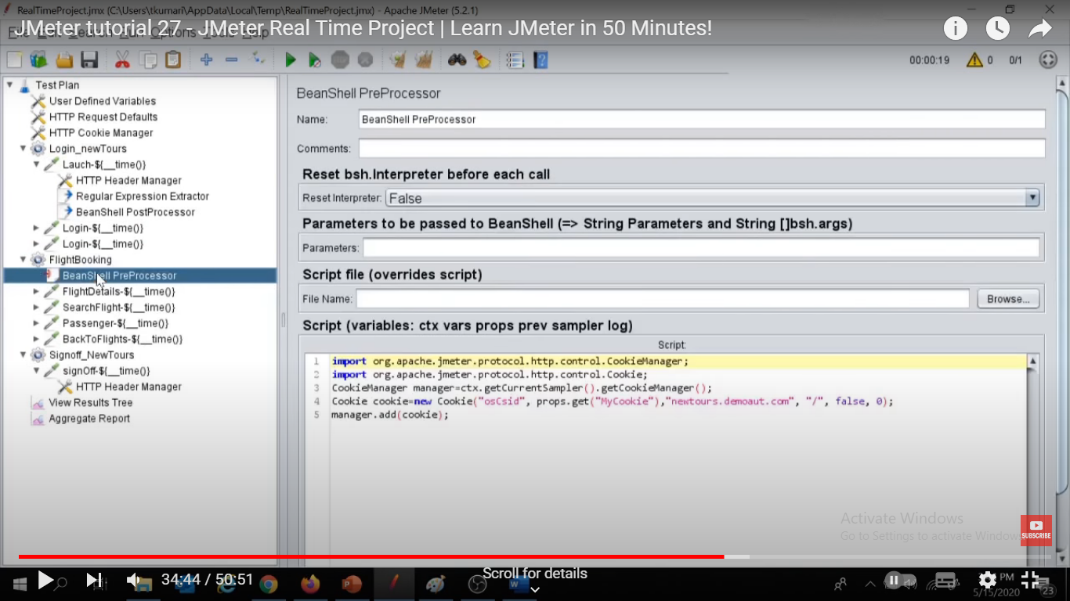

Import classes n add() mthd

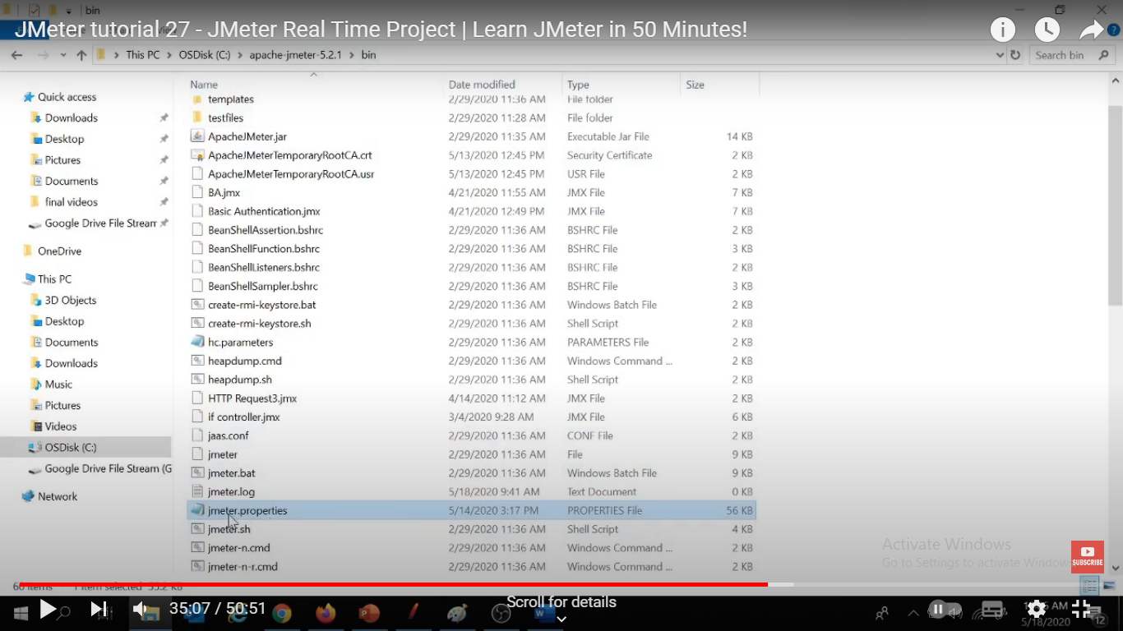

Go to jmeter.properties file > search below content

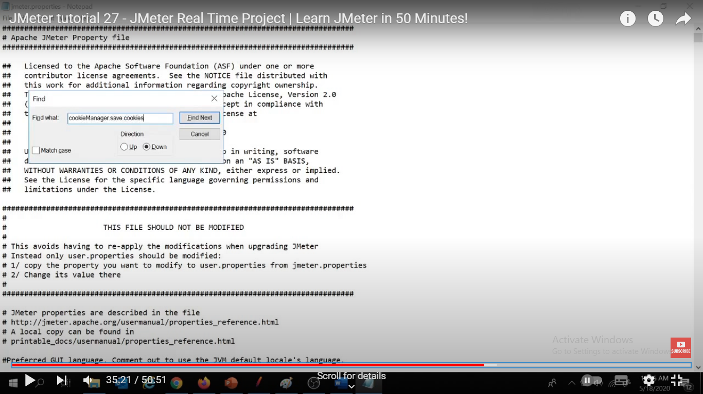

And maket it true

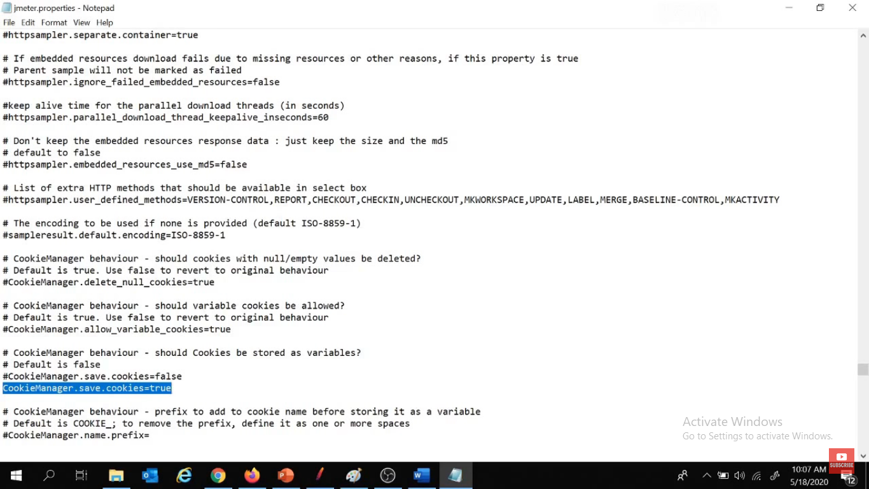

Save n restart jmetr if reqd

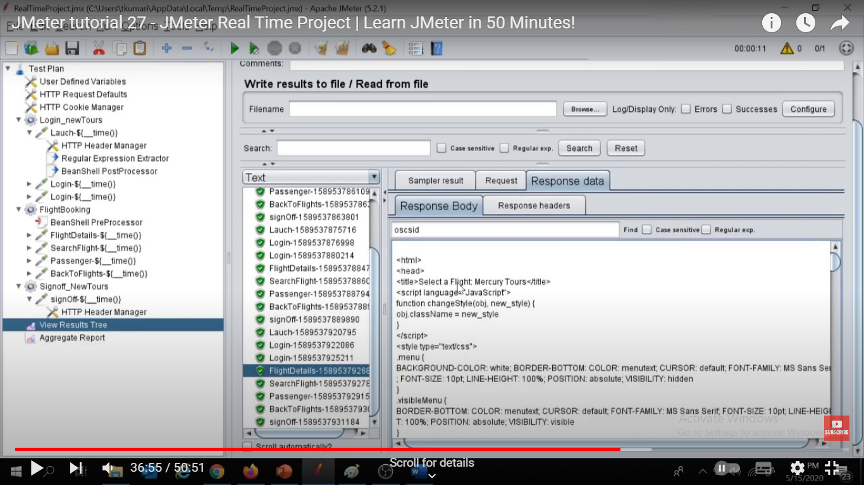

Now flight book n other reqst hv got their appropriate pg title due to beanshell pre n post processor

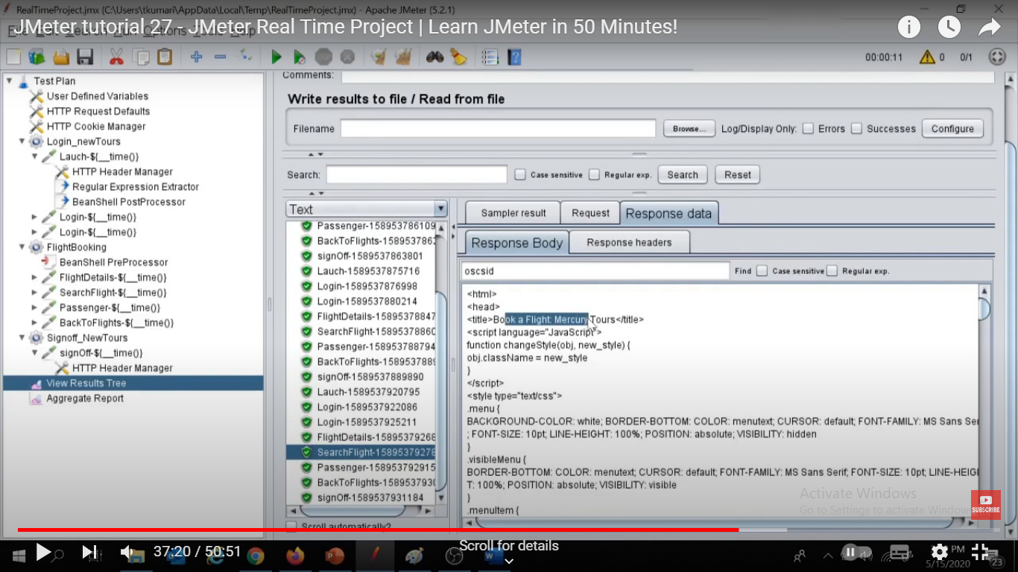

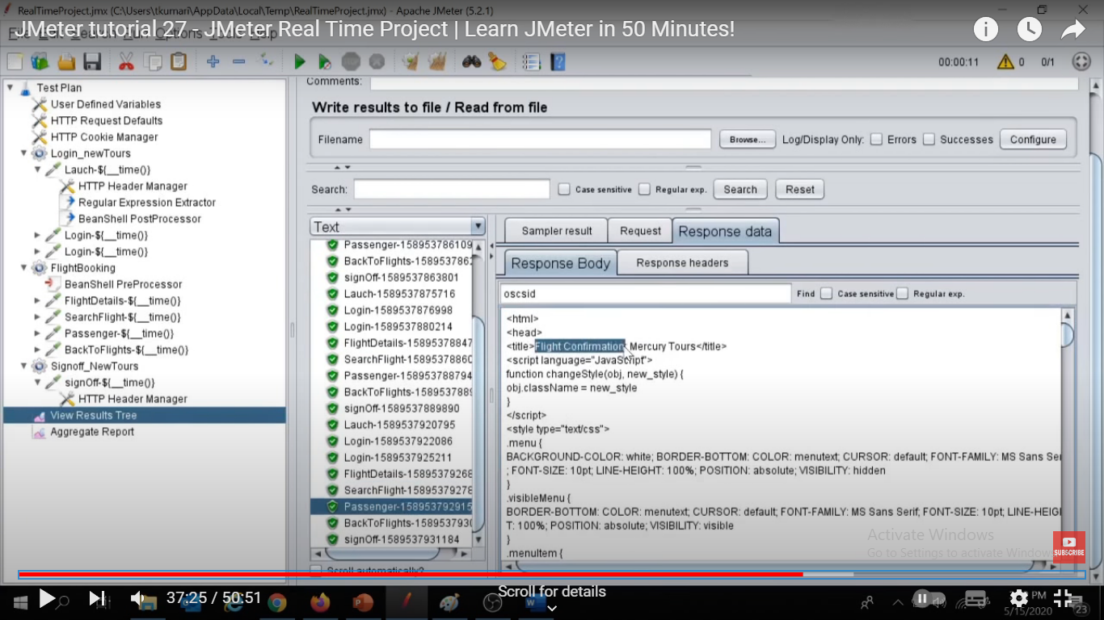

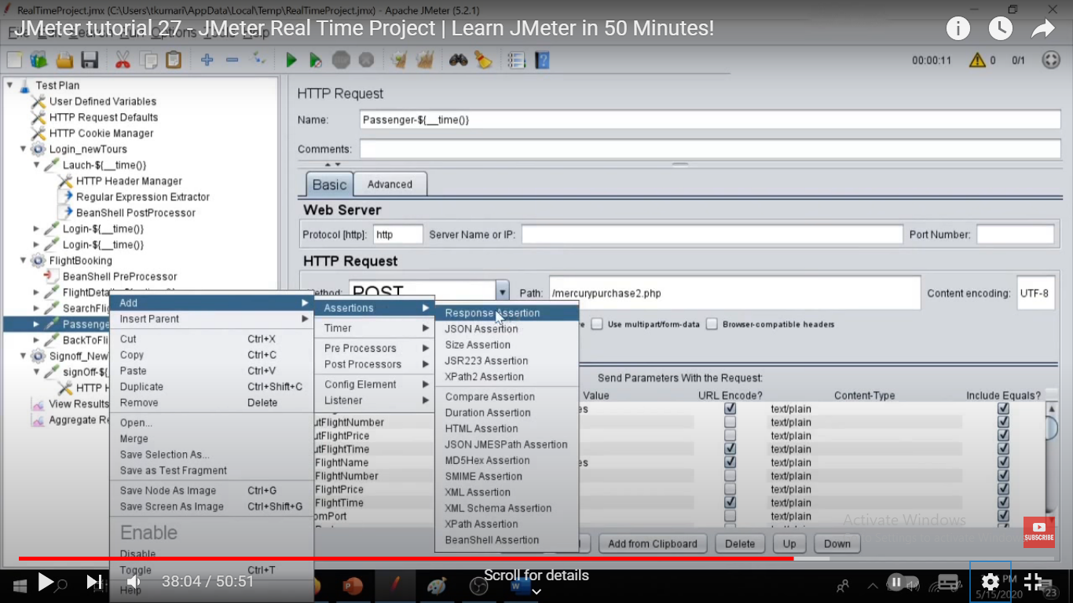

ADD ASSERTIONS TO FINAL REQST AS REQUIRED

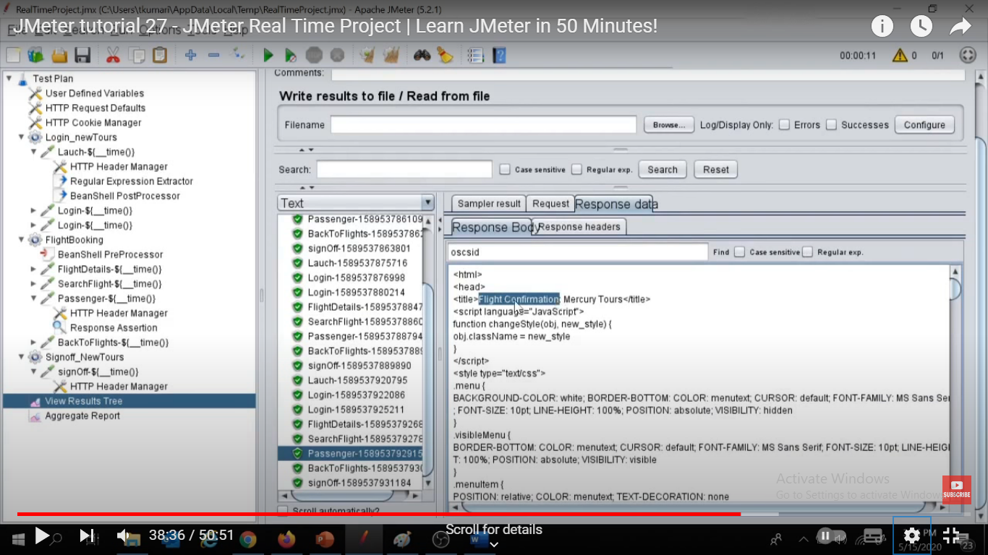

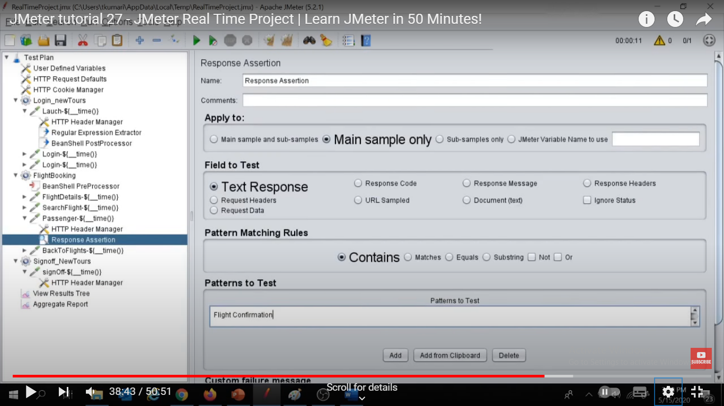

Now since we hv pass sensitive data as hardcoded durinf step recording as below, so we use csv file to store them ,ie during runtime it will pass those sensitive info thru csv file

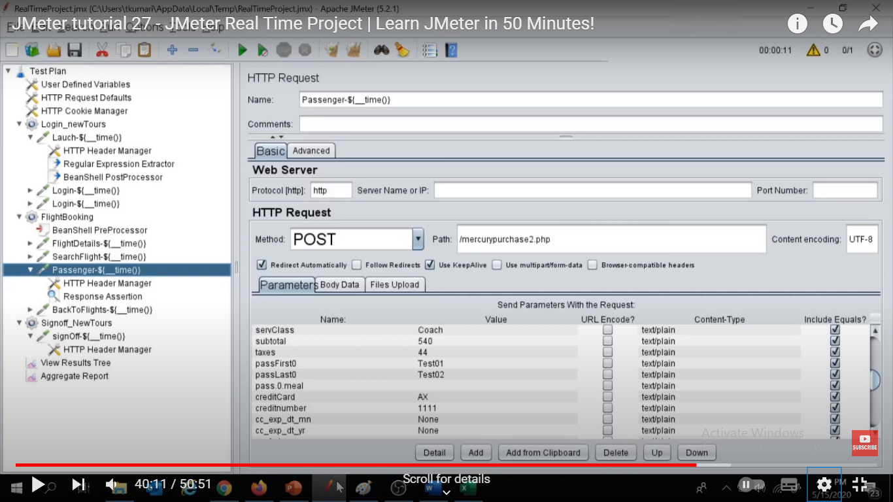

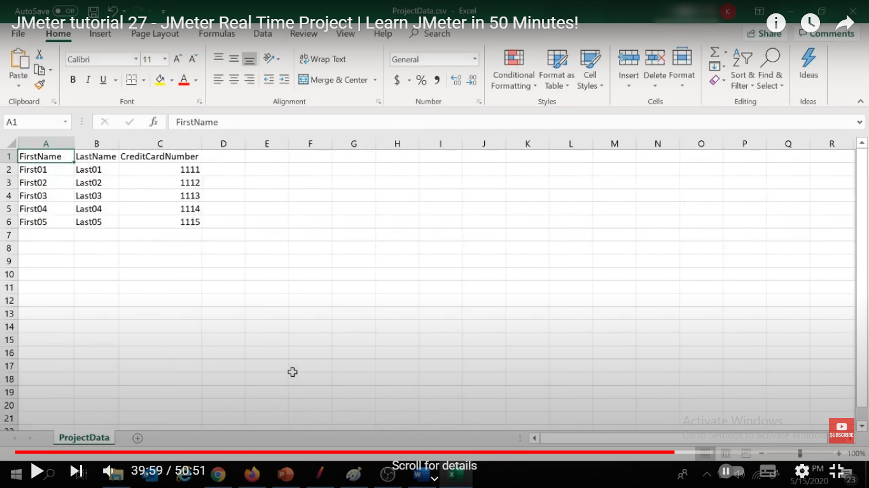

Use parameterization concept of jmeter

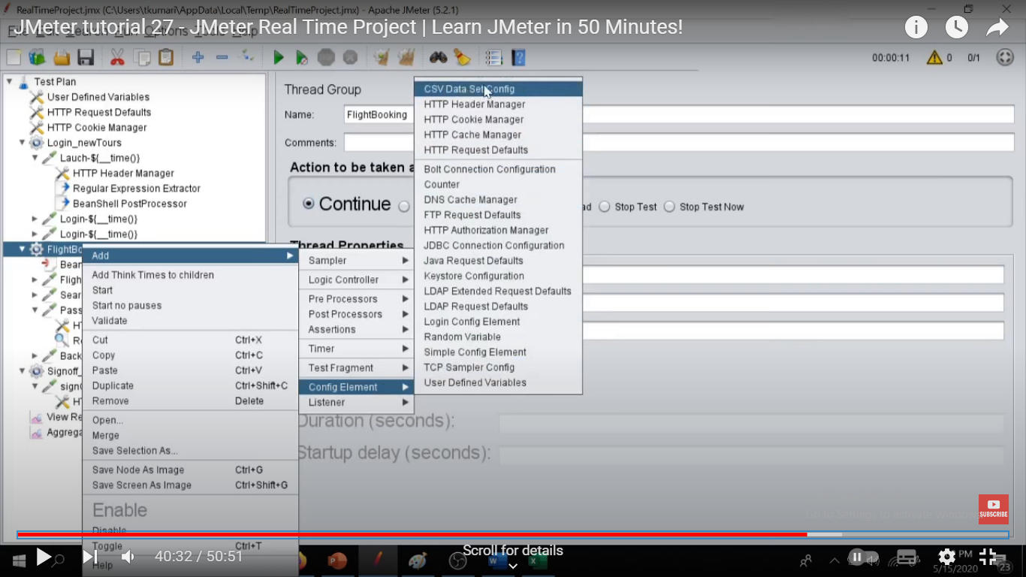

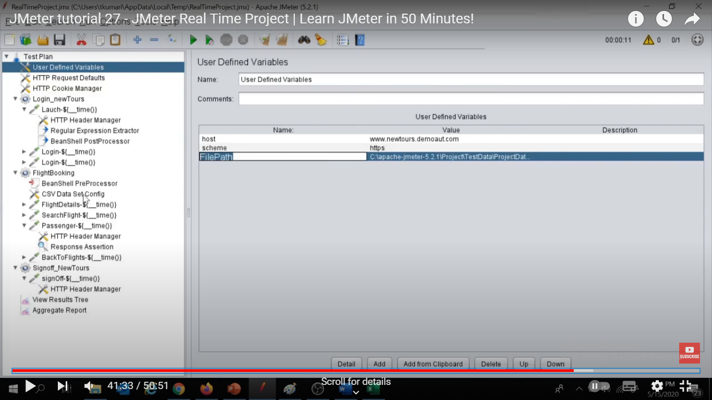

Under UDV u can specify file path in a varb which u can use later in csv data config to browse the file

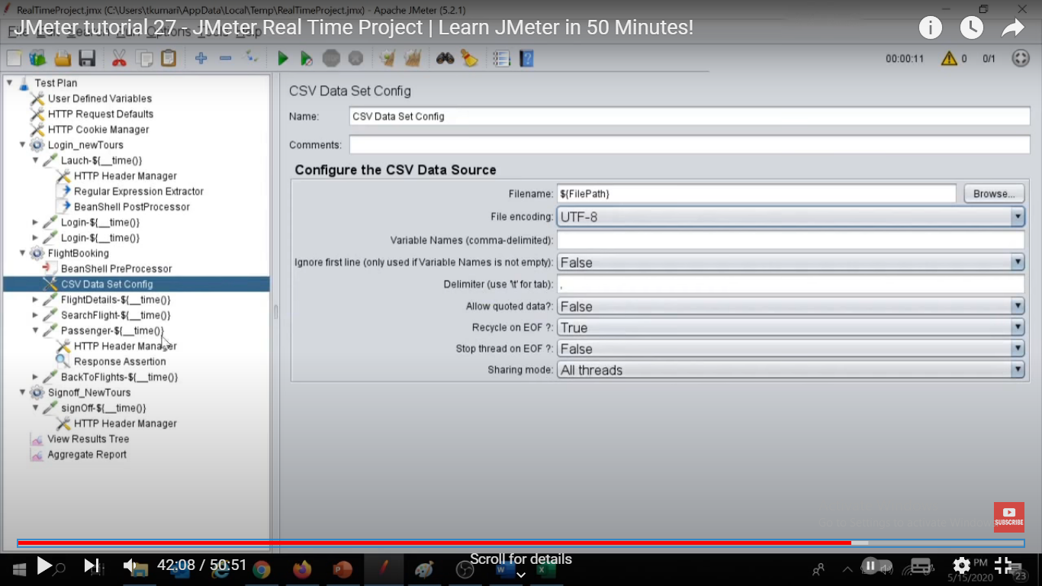

Variables name r column names

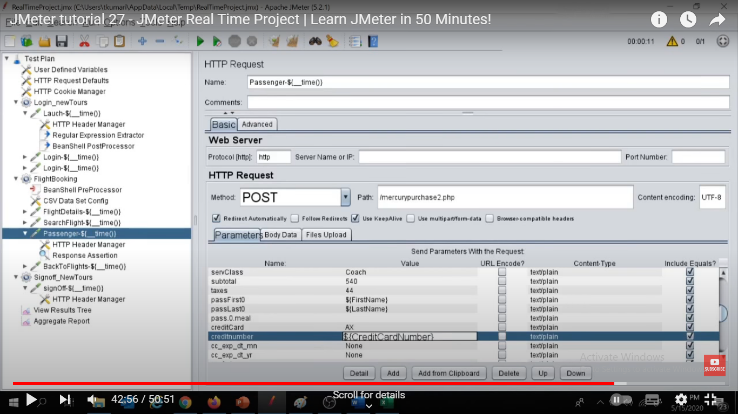

Chng the hardcoded value in http reqst para with the varbs or column names in csv file

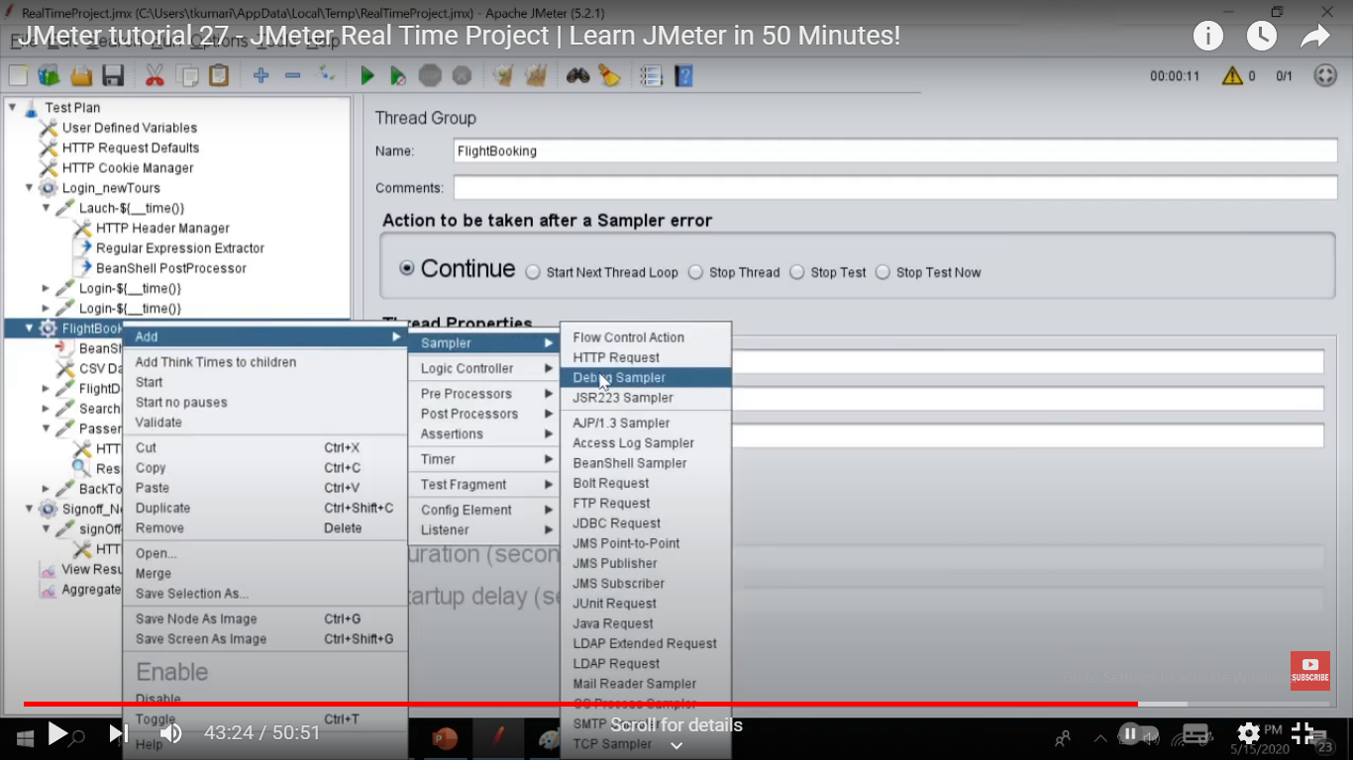

Add debug sampler to see varbs values in debug sampler response

NOW MAIN PART COMES OF SETTING THREADS & other params which r reqd to do PERFORMANACE TESTING

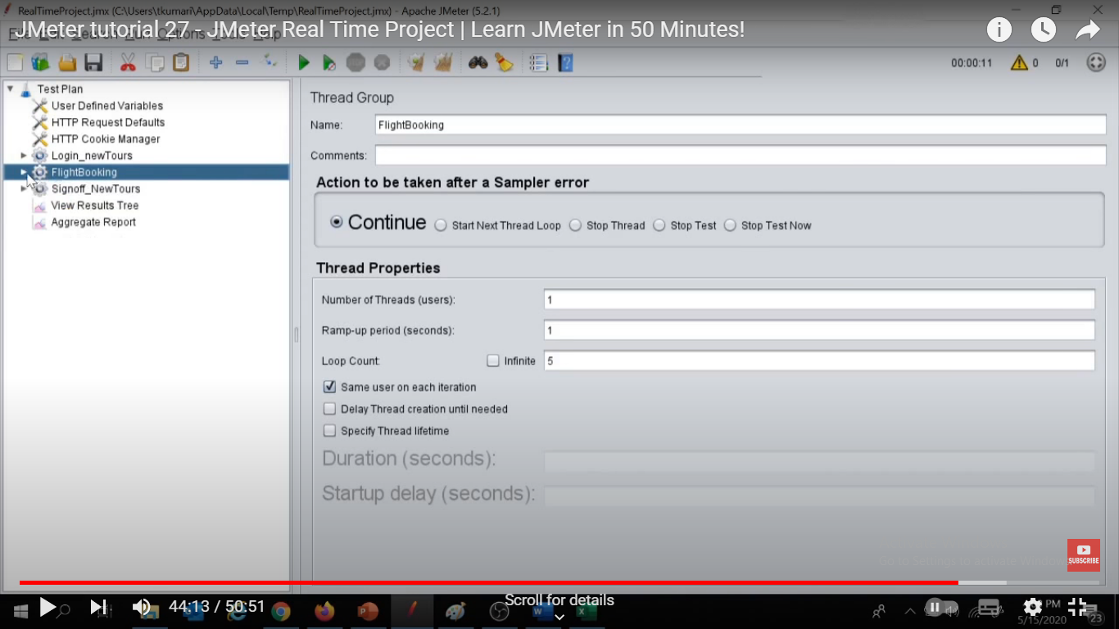

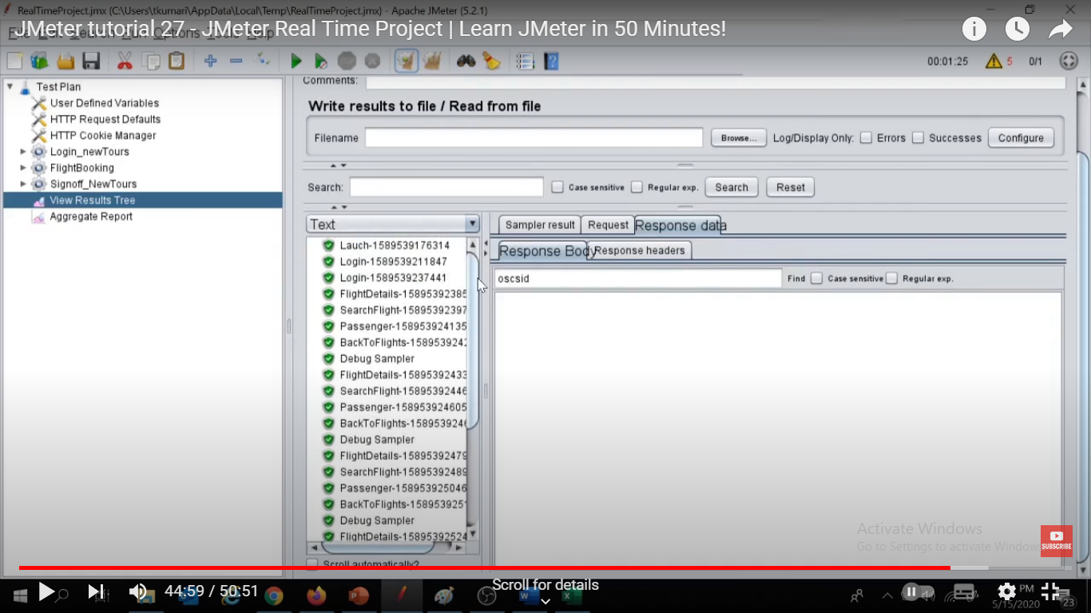

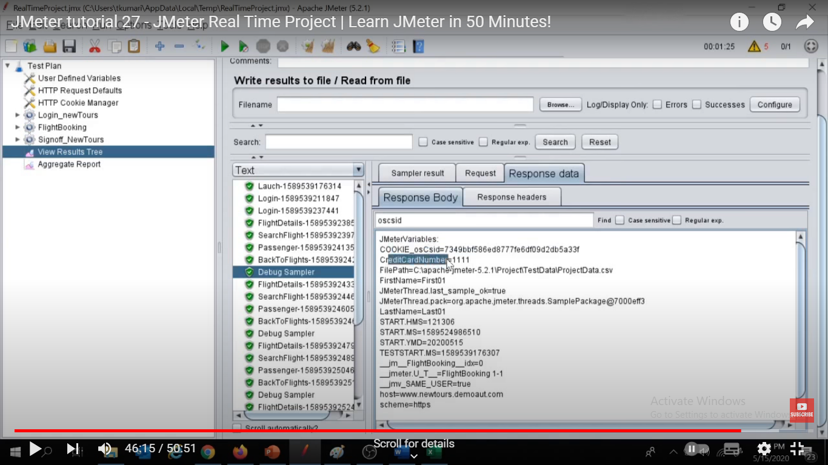

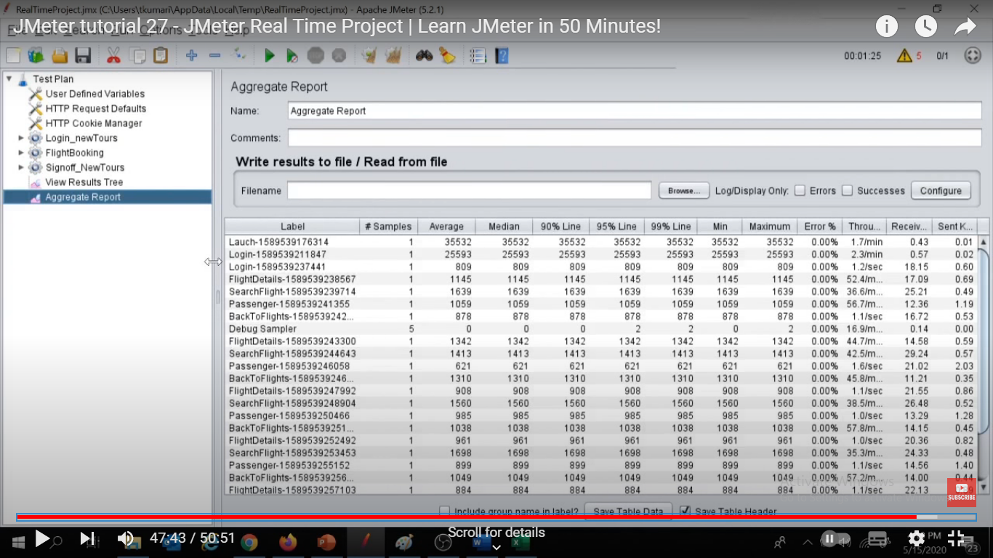

NOW as per the requirements that u hv recvd u need to chk the diff above params values n that they meet the expected values or not, if not then u need to report the same.

Also as we know we usually don’t use GUI mode for load testing as it will consume much more time to execute the tests n generate the result n will also consume memory for graphical results etc.

Do final execution thru CMD line

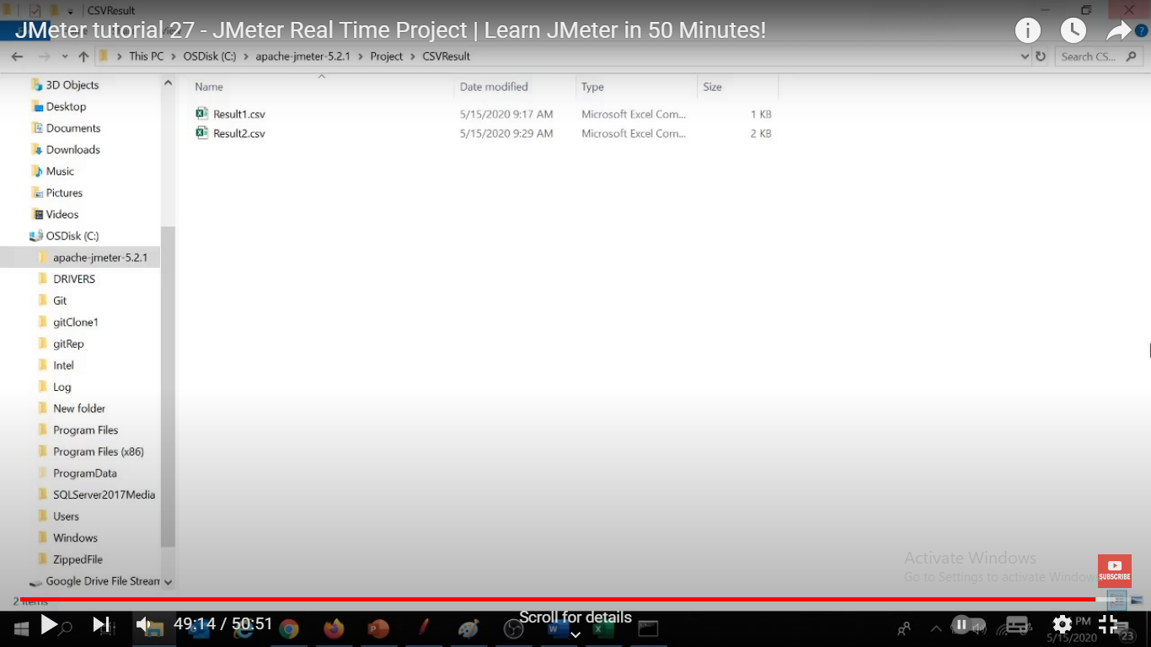

NO result 3 file exist, but will b created after execution or if exist then it shld be empty

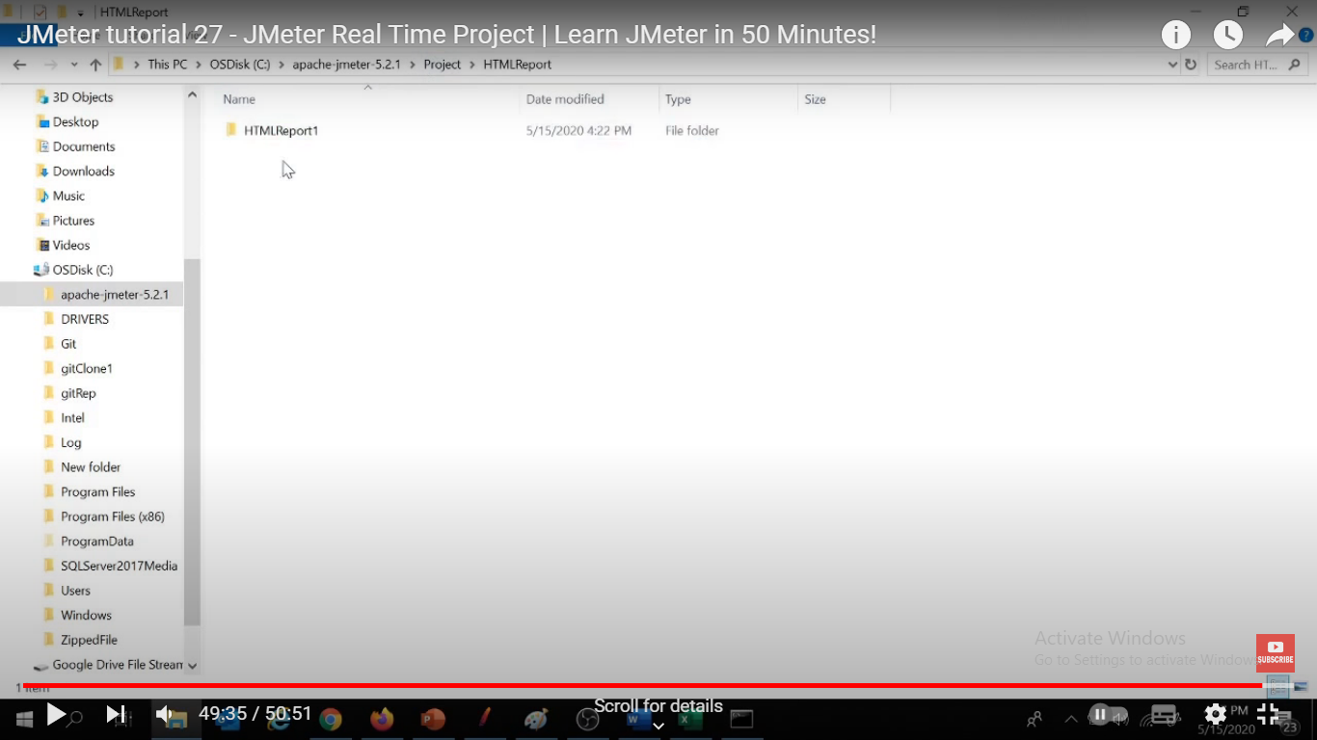

Also add html path for html file that will b generated automatically

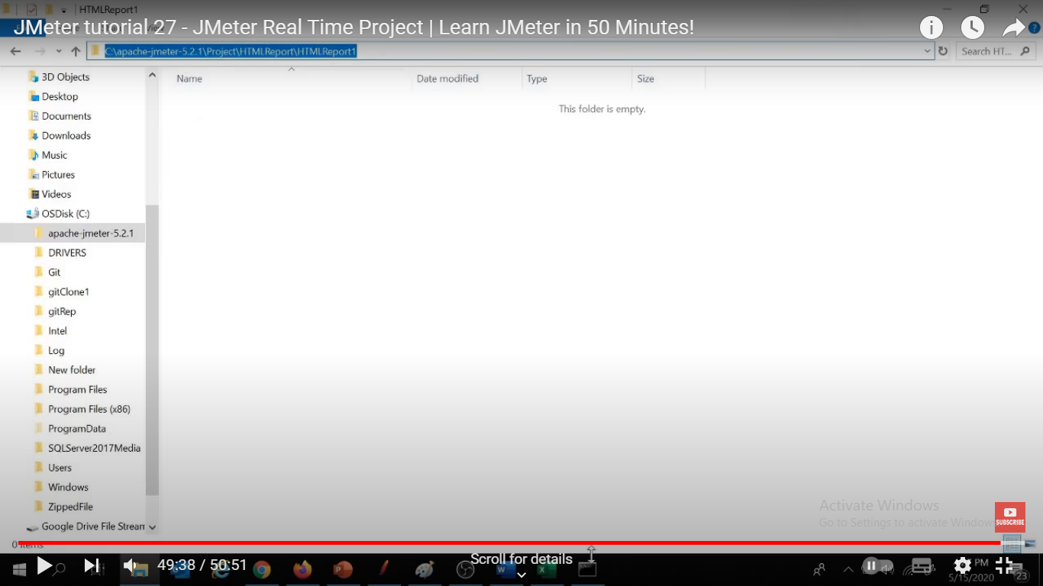

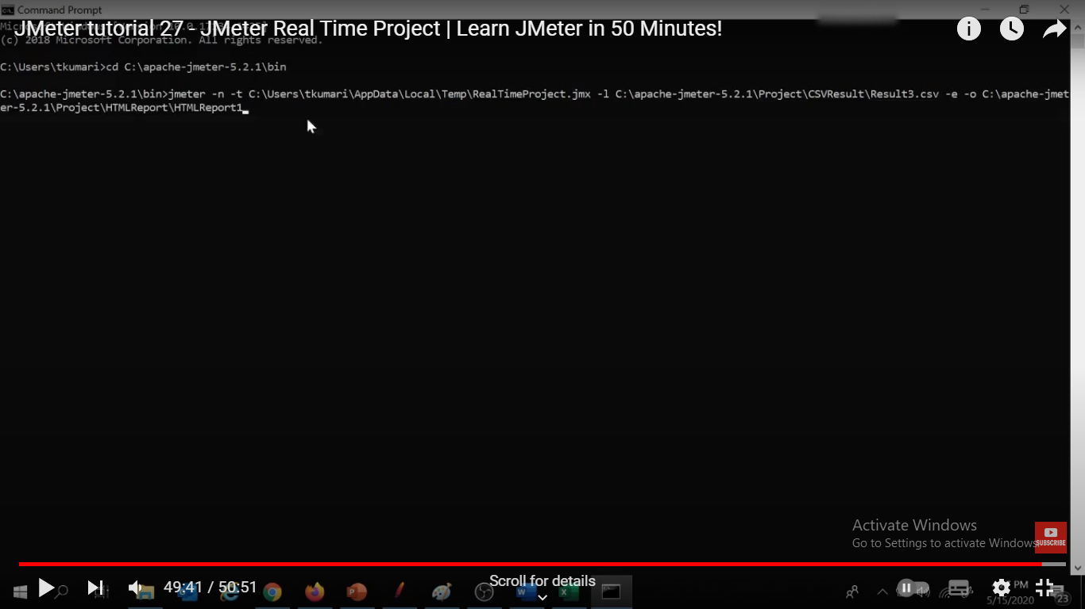

Go to bin folder n tyoe cmnd

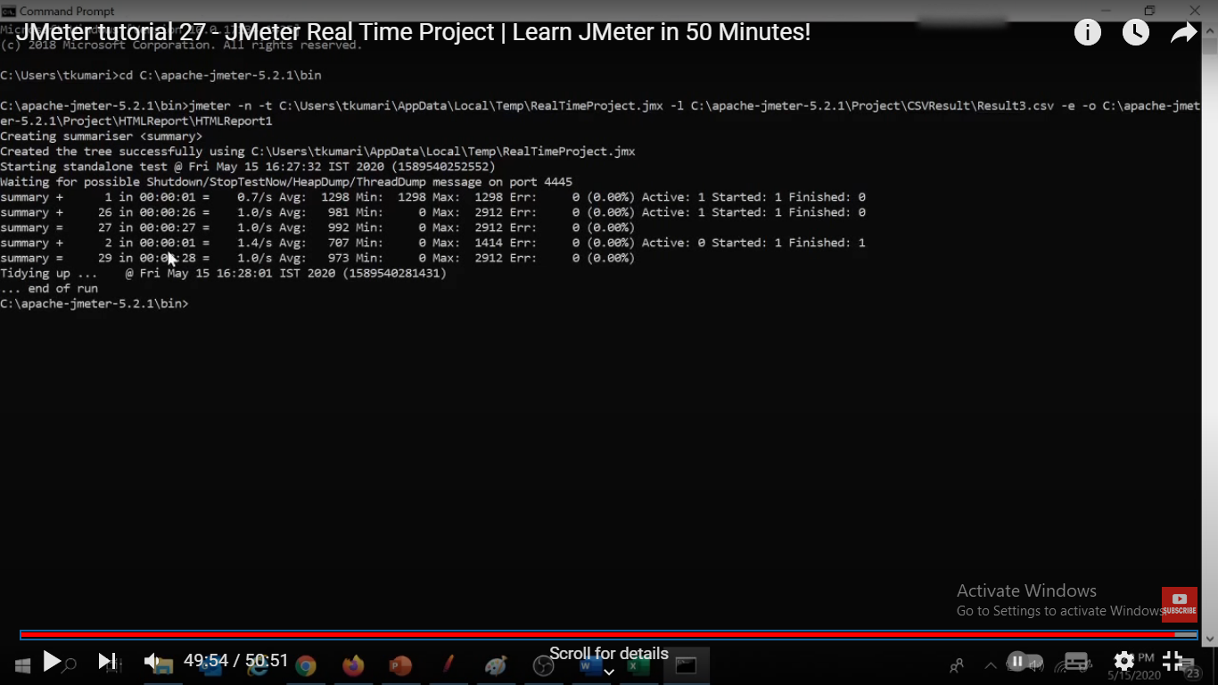

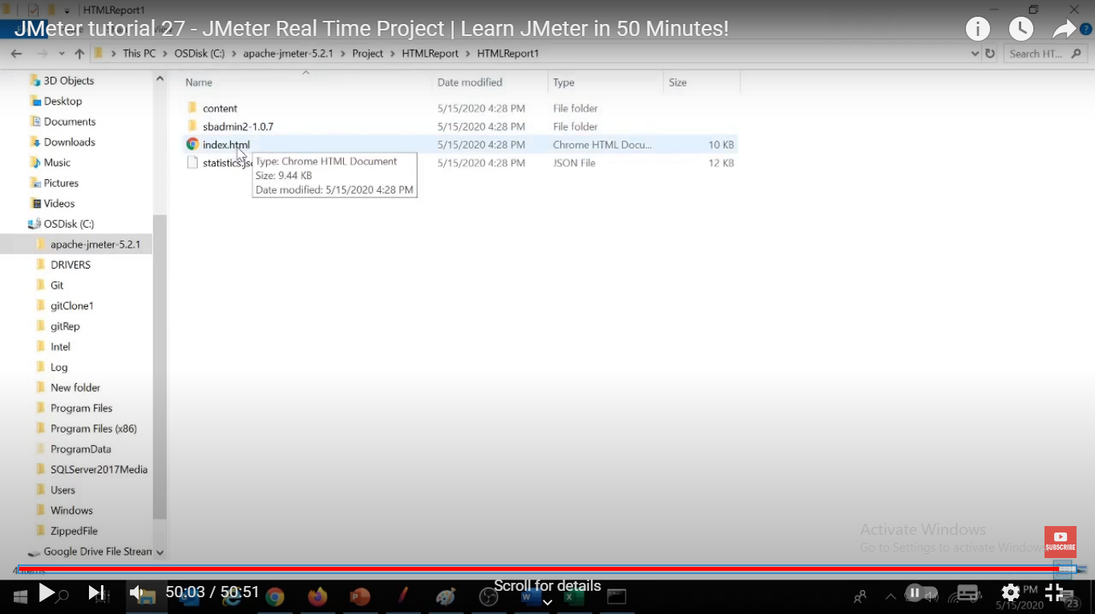

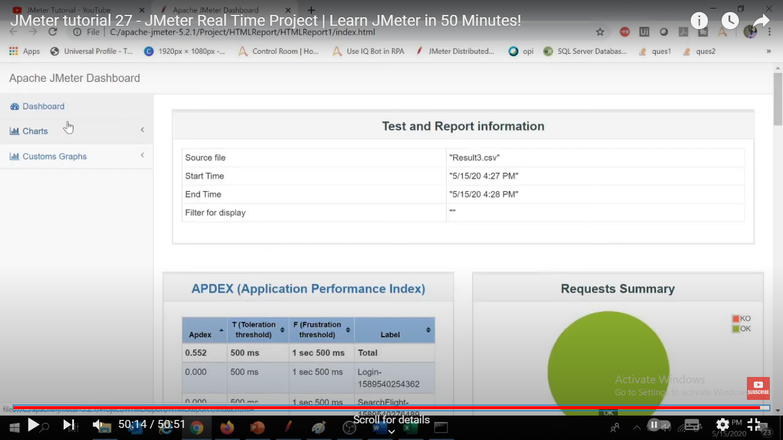

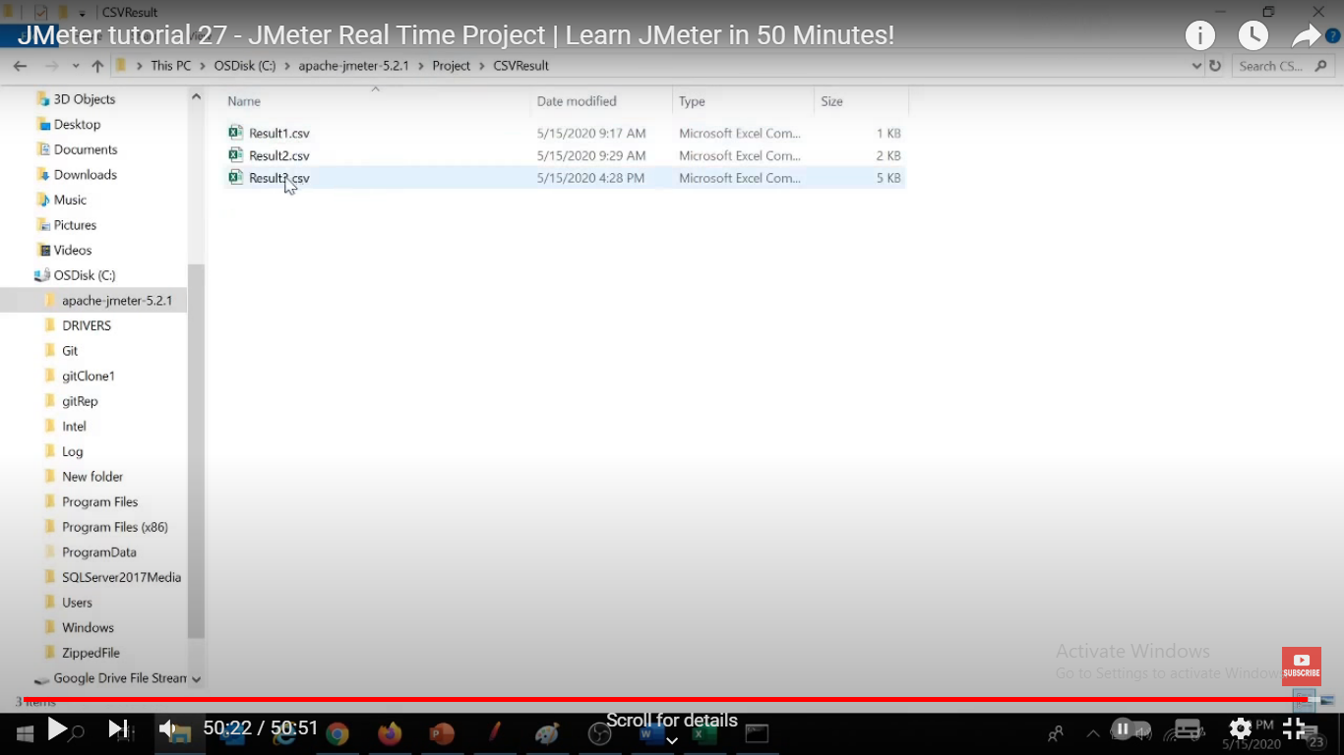

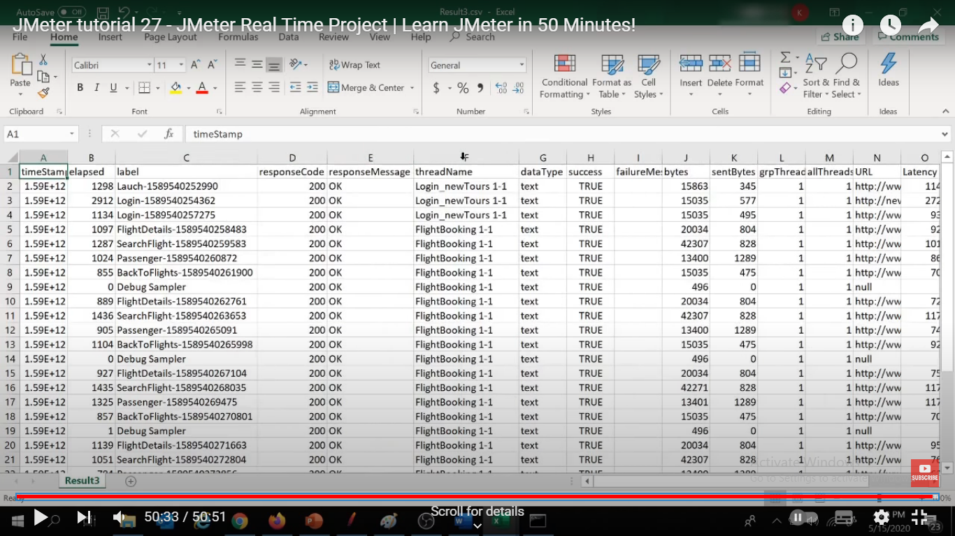

U can use above results to verify ur business requirements

==============================JMETER ADD ON =====================================

## What is a Test Plan?

A Test Plan is a logical container that contains different requests or operations required to create a performance test script

## Thread Group

A Thread Group in JMeter represents a pool of virtual users performing a set of operations. considering Google search scenario, one set of users will be using the search by text functionality, others will be using News Search, some other smaller section of users might be using search by image functionality.

* **Number of Threads(users)** – The number of virtual users to be simulated.
* **Ramp-up Period(in seconds)** – The total amount of time taken to get all the thread started. For example – if we want each thread to be active in 0.5 seconds and there are a total of 20 threads, then Ramp Uptime should be 20*0.5 i.e. 10 seconds. We will see the benefit of using the Ramp-Up period in our coming posts.
* **Loop Count** – This is the count of the number of loop iteration performing a set of operations defined inside a thread group.
* **Loop Count Forever** – When checked, it disables or overrides the loop count value and causes the loop to run infinitely until manually stopped.
* **Delay Thread Creation until needed** – This is used to delay the thread creation till a value specified in this field(in seconds).
* **Scheduler** – When checked, the scheduler configurations are enabled(explained below) and considered for scheduling of test at a particular time. Otherwise, the test runs as soon as we run the test.

Samplers

Once, the sampler request is processed by the server, its response is returned to JMeter and the same can be viewed and analyzed in terms of different performance parameters like response time, Hits per second, throughput, etc.

Widely used samplers

* **HTTP Request** – Used to send HTTP/HTTPS requests to server. This is the most widely used sampler for testing Web-based applications.
* **JDBC Request** – Used to send SQL queries to a database server.
* **SOAP/XML-RPC Request** – Used to send SOAP requests to a SOAP web service.
* **Test Action** – This is a special type of Sampler, which doesn’t send a request to the server instead it is used to introduce pauses in a test.
* **FTP Request** – Used to send file put and get requests to an FTP server.

## Logic Controllers

Logic Controllers are the Test Plan elements that are used to customize the order of processing of Samplers and other elements added as child. Primarily, Logic Controllers are used with Sampler requests to perform various customization like – altering their order of processing, grouping them as a single transaction or running the requests in loop etc.

### Critical Section Controller

This is a newly added controller in JMeter. It ensures that the child elements of this controller are accessed by only one thread at a time.

### ForEach Controller

This controller is used to perform the requests in a loop, based on the values of a set of related variables.

### If Controller

Using If Controller, we can specify a condition whether the child element inside it will run or not based on a condition that should evaluate to true or false.

### Include Controller

The Include Controller can be used to provide modularity in JMeter. Using this controller we can add an external .jmx file(a test fragment) to our existing script by loading the jmx file in the Include Controler’s control panel.

### Interleave Controller

Interleave Controller allow us to pick and execute a single child element out of multiple child in each loop iteration

will execute only one request at a time in sequential order a nd follow top to bottom approch

Add one more controller as Interleave controller which has Registration and flight booking reqs

In this scenario we have one random controller has admin and user login and one interleave controller has registration and flight booking

Set loop count as 3

so for 1st round , from random controller either admin login or user login randomly executes then from Interleave controller Registration req will execute

For 2nd round, from random controller either admin login or user login randomly executes then from Interleave controller 2nd req Flight booking req will execute

For 3rd round, from random controller either admin login or user login randomly executes then from Interleave controller return Registration req will execute

### Loop Controller

It allows to execute the operations specified as child elements in a loop with iteration value specified in its control panel. makes the user request runner specified number of times or run forever

### Module Controller

Using Module Controller, we can reuse a test fragment(e.g. a sampler) into our script again by selecting the module from the Module Controller’s control panel.

Modular controller is basically providing a feature where we can execute the same request or multiple request multiple times whenever we can execute them

under thread group click on right click> add> logic controller> Module controller ( Disable simple controller)

currently simple controller has logins script and now we need to call these simple controller inside the module controller ==> just select that in module controller

so first module controller executes mean simple controller login script execute then Registration and then Flight booking

### Once Only Controller

The once only controller is used in situation where we would like to perform an operation only once even if the operation is executed in a loop.

### Random Controller

It is similar to a random controller and picks a single child element in each iteration but unlike the Interleave controller it picks the child element randomly.

will execute only one request at a time randomly. one thread group having some random controller which has admin login request and user login request , at the time of execution it's selects randomly like either admin login and user login req will executes ; these two are chains of random controller; further registration and flight booking req are executes

### Random Order Controller

The Random Order controller is used to execute each of its child element at most once in random order.

### Recording Controller

This controller acts as a placeholder where the scripts recorded using HTTP Proxy Server are recorded by default

### Runtime Controller

Runtime controller is used to limiting the time of execution of its child elements. For example, if we have specified the value of ‘Runtime’ as 100 seconds then the elements inside the Runtime controller will run for 100 seconds with as much iteration as possible.

### Simple Controller

This controller is just a placeholder for grouping and ordering the different elements of the test plan.

### Switch Controller

This controller is used to pick one element for processing out of its multiple child elements. The element is picked not in sequential order or random order instead it is based on a switch value defined in its control panel. The switch value can be a variable with value evaluated to its index(position) of the element or name of the element.

### Throughput Controller

* The Throughput Controller is used to control the processing of its child elements in terms of the total number of executions or the percentage of execution specified in its control panel.
* used to build a distributed load test
* for example I have a home page, welcome page, registration page; send multiple loads/virtual users will send request to those pages; for say 10 Virtual user hit all pages
* If want to just distribute these virtual users multiple pages means two users to hit the home page,three users to hit the welcome page and five different virtual users
* for registration ==>this is called basically distributed load
* one test plan, one thread group with 10 user threads, three HTTP request as home page, welcome page, registration page, aggregate report
* add add> logic controller> throughput controller crete 3 controll ;add three HTTP request as home page, welcome page, registration page in throughput controllers
* go to throughput controller 1 ; two options
* total execution: specify how many number of virtual users will be executed this particular homepage
* percent execution: specify how many number of virtual users in percentage
* for the home page 20% of the load, throughput controller 2: for the welcome page 30% ,throughput controller 3: for the reg page 50% =>distributed entire load
* so now we can have any number of users , need to just change no of users

### Transaction Controller

The Transaction Controller is one of the widely used controller in JMeter scripts. It is used to group multiple sampler requests into one. The response time and other performance metrics of the test result are evaluated for the whole transaction. For example – while checking the performance of home page of an application, we can notice that launching the home page generates numerous requests at the backend. Hence, this requires grouping all these request into one transaction, for this, we have a transaction controller in JMeter. Once we run the script, we can find the overall response time of the whole transaction.

### While Controller

The While controller is used to run the child elements inside it till the value specified in its control panel is evaluated to false.

## What are Listeners in JMeter?

JMeter Listeners are the test plan elements that are used to view and analyze the result of performance tests in tabular or graphical form

### Response Time Graph

The response time graph is used to provide the graphical representation of response time with time elapsed during the test run.

### Save Response to a file

The save response to a file listener is used to store the sampler response in a file. This listener is used while functional testing or debugging the test script.

### Simple Data Writer

The simple data writer listener is used to save the sampler response to a file after with different configurations to remove several unnecessary overheads.

### Summary Report

The summary report is used to store and display the test result in tabular form just like an aggregate report listener but consumes less memory(as per Apache JMeter).

### View Results Tree

This listener is used to provide and store test results for each and every individual sampler.

### View Results in Table

The view results in a table listener are used to display the sampler response header and response body.

### Aggregate Graph

The Aggregate Graph listener is used to display the test results in both tabular form(reports) and graphs.

### Aggregate Report

The Aggregate Report listener is used to display and store test results in the form of reports.

### Assertion Results

The assertion results listener is used to display the assertion result for each erroneous sampler response. It is advised to not use this listener during the performance test as it is very resource-intensive. It should be used while debugging and functional testing only.

### Graph Results

The Graph results listener is used to display each sampler request’s response time graph in terms of average, median, deviation, and throughput.

What are Timers?

Timers in JMeter is the test plan elements used to pause the execution of test for a certain specified amount of time.

timers

jmeter sends request without applying any delay between each sampler or request

if you perform load or stress testing on your server without any delay, it will be overloaded.

then, it won't be able to give you realistic result and fail to simulate real-world user traffic experience.

Timer element can be added in a test plan to apply weight between each sampler or request

different types of timer like constant timer, uniform random timer, gaussian random timer, beanshell timer, BSF timer, JSR 223 timer

one test plan, one thread group with one user thread, three HTTP request, listner like view result in table, add a timer on thread group level = constant timer with 5000

first request will execute after 5 seconds then second request executes after 5 seconds and so on..

If we took two timers first timer for the first HTTP request and the second timer on thread group level with five seconds,

in this case first request will execute after 10 seconds because it will take 5 seconds of the thread group level and five seconds of the first HTTP request

and then second request executes after 5 seconds and third request executes after 5 seconds..

Uniform random timer : The uniform random timer is used to pause the test execution for a random time. The maximum value for random time can be specified

along with the additional constant time with each wait.

It has two terms like random delay Max (100) and constant delay offset(0)==> (0 to 99 milliseconds)

formula : 0.X*Random delay max +constant delay offset

X means digits between 0 to 9

Add uniform random timer on thread group level 5000:300 for 3 users

It will executes by taking random time

### Constant Throughput Timer

The constant throughput timer is a special type of timer used to create pauses with variable amount of time while maintaining the overall throughput i.e. samples/minute.

## What are Assertions?

Assertions in JMeter are the test plan elements that are used to validate the response received from server for a particular sampler request.

## What are Config Elements in JMeter?

Config elements in JMeter are used to configure or modify the sampler requests made to the server. These elements are added at the same or higher level of the samplers that we want to configure.

### CSV Data Set Config

The CSV Data Set Config is used to read data from CSV file, put the data into variable(s) and then use the variable(s) in the sampler requests. Check our tutorial on [Parameterization in JMeter](https://artoftesting.com/config-elements-in-jmeter) for details.

### HTTP Cache Manager

The HTTP Cache manager is used in test scripts to add the Caching functionalities of web applications. This element is just required to be added at the same level or higher than the sampler request where caching functionality is required.

### HTTP Cookie Manager

The HTTP Cookie manager is required for session handling by providing the functionality of storing and sending of cookies.

### User Defined Variables

As the name suggests, the User Defined Variable config element is used to create variables with a value (key-value pairs) that are used across the test script.

### JDBC Connection Configuration

JDBC Connection Configuration is used with JDBC request sampler to create JDBC connection settings.

### HTTP Header Manager

The HTTP Header Manager is used to override the HTTP request headers.

## What are Pre Processors in JMeter?

The Pre Processor elements are used to modify the sampler requests before their processing(hence the name pre-processor).

### BeanShell PreProcessor

The BeanShell preprocessor is used to perform some operation using beanshell scripting before a sampler request.

### User Parameters

The User parameters are used to specify values for User variables used within Thread Groups.

## What are Post Processors in JMeter?

The Post Processors are the test plan elements that are used to perform certain actions after the processing of a sampler request. These post processors are usually used for extracting certain values from the response of a sampler request e.g. we can extract the value of session variables from an HTTP request and pass the session variable’s value to the subsequent requests.

## Different Types of Post Processors in JMeter

### Regular Expression Extractor

Regular Expression Extractor is the most frequently used post-processor. It is used to extract values from HTTP response using regular expression and to store the values to a variable. Then the variable can either be used as a request parameter to other samplers or can be used for other purposes like assertions, debugging, storing in the file, etc.

### BeanShell PostProcessor

The BeanShell PostProcessor is used to perform some operation using BeanShell scripting after a sampler request processing.

### Debug PostProcessor

The Debug PostProcessor is used to create a subSample having properties of previous sampler requests, JMeter properties, JMeter variables or system properties.

### What is correlation and why it is required?

Correlation is the most important aspect of scripting. It usually includes fetching dynamic data from preceding requests/calls and posting it to the subsequent requests.

Regular expressions are used to fetch data from a string based on a search pattern. Basically, in order to extract any value (generally a dynamically created value) from a string response, we define a left bound of the variable then some wildcard characters and then a right bound-

**(Left Bound)(Wildcard Characters)(Right Bound)**

E.g. if we have text response like-…__EVENTVALIDATION”value=”weriudflsdfspdfusdjhsdihffgdfgpdfjsdjfpj” />…

And we need to extract the value of Event validation variable using regular expressions; the regular expression for the same will be-

**__EVENTVALIDATION" value="(.+?)" />**

where, Left Bound = __EVENTVALIDATION" value="

Wildcard characters = (.+?)

Right Bound = " />

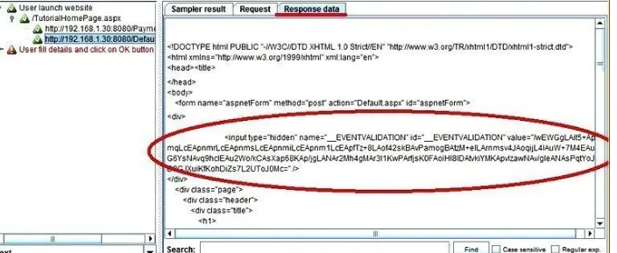

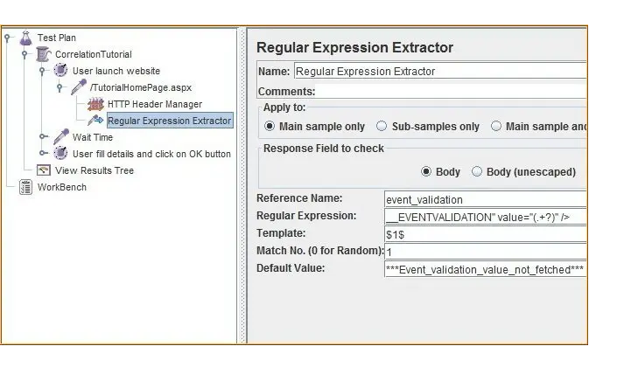

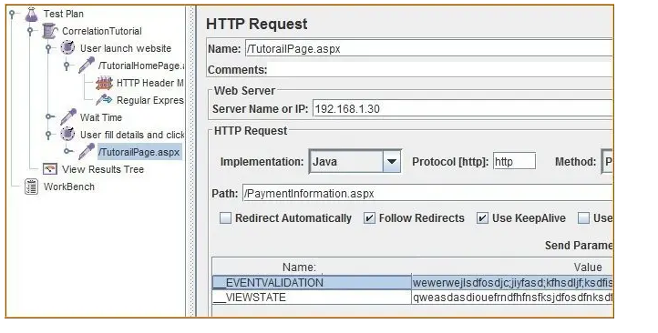

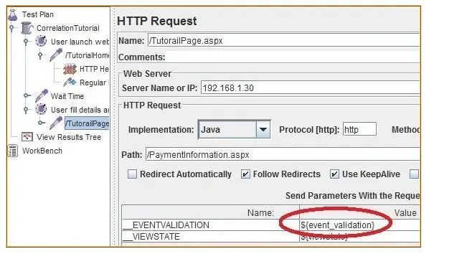

### What is Parameterization and why it is required?

Parameterization is the technique using which we can execute a test plan multiple times with a different sets of data. This helps in creating a load test script that closely simulated real-world scenarios where different users use different test data.

A BeanShell is light-weight scripting language. It has Java like syntax and being a scripting language it is interpreted instead of compiled.